
Pastoral letter #38
Rosters
29 October Greeter Andy & Herman
Sound Lisa
Computer Terri
Morning Tea Trevor & Joe
Worship leader Chris & Lynette
Kidzone Frances H & Betty
----------------------------------------------------
My only concession to the Rugby World Cup this Sunday, will be that we start the worship service at 10.15am, with tea and coffee at 10am
-----------------------------------------------------
What’s on this week (Wednesday 25 October to Tuesday 31 October)

Wednesday 10am Women’s Group @ Church (lounge)
2pm Home group @ church
7pm Church Council meeting
Thursday 9.30am Intercessors group in our auditorium
12.15pm New believers’ group
Friday 28th 10am Aglow meeting Parawai Rd
Sunday 29th 9.30am Preservice prayer in 305
10am Worship service
Tuesday 31st 10am Tararu home group
Midday Tasty Tuesday
5.30pm Praying and War-faring for the Nation Paeroa Bible Chapel
7pm Coast home group
7pm Hillbillies home group
---------------------------------------------------------
Thames Aglow

Next meeting at the old Church of Christ building in Parawai on Friday 28 October 10am – 12. Shared lunch. Speaker is Trevor Reith from Westside Church in Hamilton
----------------------------------------------------------
Coming Home project
Project for establishing a home for homeless people, who are ready for a new life without addiction,
hopelessness, and poverty.
Vision:
• A community project in Thames.
• A house with house parents on-site.
• A support team and network in place.
• A place of love, connection, help and support.
• Continuous teaching and learning.
• Collaboration with counsellors and therapists.
• Recovery, healing and wholeness.
• Restoration of relationships to self, others and God.
• Reintegration into society.
You are welcome to join the planning team!
Meetings: Monday, 13. November 2023 from 7-9 pm
Monday, 11. December 2023 from 7-9 pm
At the Thames Baptist Church, 303 Mary Street
Any questions, please contact :
Chris (Baptist Church) 07 868 6274
Sonja 027 370 5001
-----------------------------------------------------------
Hospice Waikato remembrance service.

Sunday 26 November 2023, 2pm Thames Union Parish (St James church), Thames.
We encourage you to bring photos or other mementos to place with our candles as we remember our loved ones. Refreshments will be served following the service.
To register your attendance please phone Hospice on 07 859 1260 by Wednesday 15 November.
-----------------------------------------------------

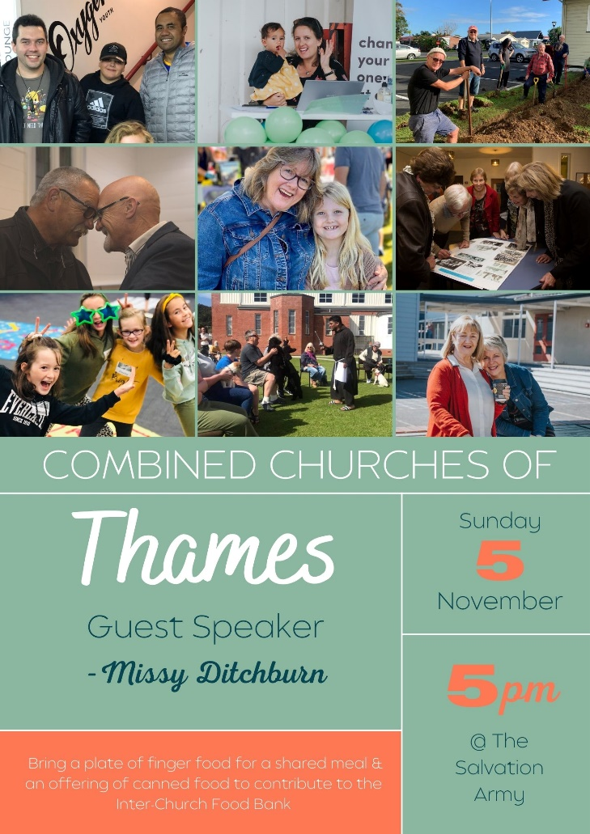
-------------------------------------------------------
A big thank you for those who went out to help Peter at their lifestyle block, labouring on Labour Day. Josh and the boys, Samanda, Lisa, Karlene and Chris, David G.
There are still some jobs to do out there, so if you have time during the week or weekend, pop out and give them a hand for an hour or so.
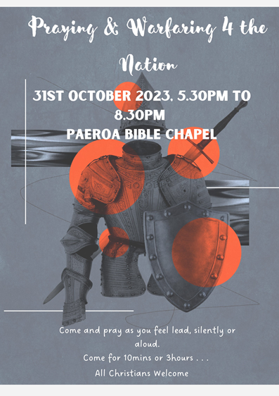

“Within each of us is a divine treasure, and if we hope to discover it, we need to go deep into the heart of who we are.”

“To find that treasure requires that we work like a wood carver who does not work by adding but by cutting away, removing what is rough to reveal what shimmers from within.”

-Meister Eckhart (translated from
Meister Eckhart’s Book of Darkness and Light)
----------------------------------------------------------
Pastoral Visiting Team

Lynette Mill, Helen Whittaker, Bev Gibson, Elizabeth Jones, Des and Mercia Barton and Brent and Berwyn Mason. If they visit you, they are visiting on behalf of the church.
-----------------------------------------------------------
Home groups and activity groups
Tararu 10am Tuesday weekly at Elizabeth Jones’ (Jenny B)
Lifestylers 2pm Tuesdays weekly at Peter Moyes’ (Lynette)
Coast 7pm Tuesdays fortnightly at McLaren’s (Colin)
Meal at 5.30pm
Hikutaia 7pm Tuesdays fortnightly at Shaz & Bernards (Puriri) (Shane)
Hillbillies 7pm Tuesdays fortnightly at various (Chris)
Womens knitting 10am Wednesdays weekly in the Church Lounge (Kathie & Pam)
Wednesday 2pm Wednesdays weekly in the Church Lounge (Chris)
Intercessors 9.30am Thursdays weekly in the church auditorium (Colin)
New People Foundation group 12.15pm Thursdays in the church auditorium (Chris & Shaz)
------------------------------------------------------------
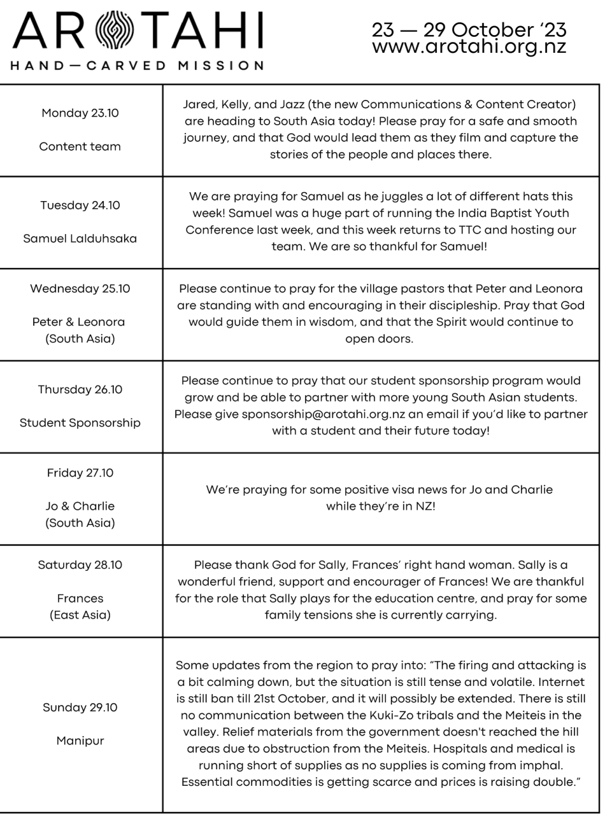

Salvation Army State of our community

We’re excited to announce and invite you to the launch of The Salvation Army #39
“State of our Community Report”.

The report has been compiled by The Salvation Army’s Social Policy and
Parliamentary Unit based on a community survey research project conducted in
June and July of this year. This survey was a micro-level project, which focused
on drilling down into Thames and hearing from the locals about their community.

We believe you will get value out of hearing the findings and would love it if you,
and others who you believe may be interested, will be able to attend.

The details of this event are:
• Venue - The Salvation Army Thames
• Address - 713 Pollen Street, Thames
• Date - 23 rd November 2023
• Time - 10:00 am

Refreshments will follow the launch of the Report and a time of Q&A. For catering
purposes, can you please RSVP to thames.corps@salvationarmy.org.nz

