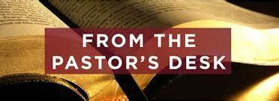
Pastoral letter #39
Rosters
5 November Greeter Des & Mercia
Sound Bernard/Charleen
Computer Terri
Morning Tea Colin & Doug
Worship leader Shaz
Kidzone Frances McL & Betty
Communion: Caroline
----------------------------------------------------
What’s on this week (Wednesday 1 November to Tuesday 7 November)

Chris, Lynette and Elizabeth at the Baptist Union National Hui in Manukau Thursday to Saturday

Wednesday 10am Women’s Group @ Church (lounge)
2pm Home group @ church
Thursday 9.30am Intercessors group in our auditorium
12.15pm New believers’ group
Sunday 5th 9.30am Preservice prayer in 305
10am Worship service
5pm Combined Service at Salvation Army
Tuesday 10am Tararu home group
Midday Tasty Tuesday
-------------------------------------------------
Church AGM

The Church AGM is on 26 November. David Gibson would like to have the ministry reports by 11th November if possible.
--------------------------------------------------
Warning about Phishing

Please stay vigilant against potential phishing threats, as more commonly available personal information, like your name and contact information combined with purchase information, can be engineered to phish for high-risk data. You can learn more about how to best protect yourself here: https://www.avg.com/en/signal/what-is-phishing

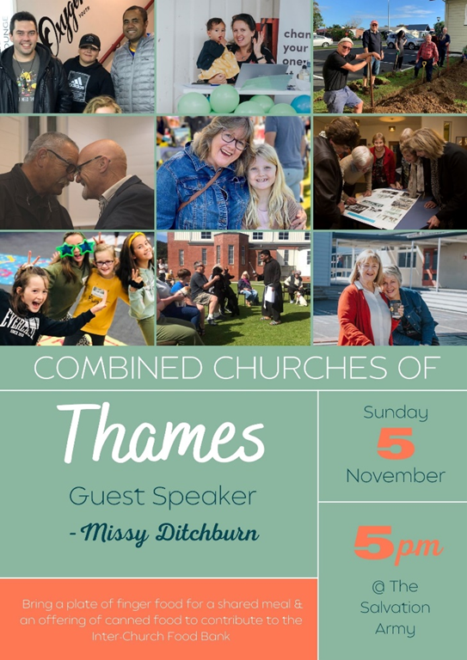

--------------------------------------------------------
Coming Home project

Project for establishing a home for homeless people, who are ready for a new life without addiction,
hopelessness, and poverty.
Vision:
• A community project in Thames.
• A house with house parents on-site.
• A support team and network in place.
• A place of love, connection, help and support.
• Continuous teaching and learning.
• Collaboration with counsellors and therapists.
• Recovery, healing and wholeness.
• Restoration of relationships to self, others and God.
• Reintegration into society.
You are welcome to join the planning team!
Meetings: Monday, 13. November 2023 from 7-9 pm
Monday, 11. December 2023 from 7-9 pm
At the Thames Baptist Church, 303 Mary Street
Any questions, please contact :
Chris (Baptist Church) 07 868 6274
Sonja 027 370 5001
-----------------------------------------------------------
Salvation Army State of our community

We’re excited to announce and invite you to the launch of The Salvation Army #39
“State of our Community Report”.

The report has been compiled by The Salvation Army’s Social Policy and
Parliamentary Unit based on a community survey research project conducted in
June and July of this year. This survey was a micro-level project, which focused
on drilling down into Thames and hearing from the locals about their community.
We believe you will get value out of hearing the findings and would love it if you,
and others who you believe may be interested, will be able to attend.

The details of this event are:
• Venue - The Salvation Army Thames
• Date - 23 November 2023 10:00 am

Refreshments will follow the launch of the Report and a time of Q&A. For catering
purposes, can you please RSVP to thames.corps@salvationarmy.org.nz
-------------------------------------------------------
Hospice Waikato remembrance service.

Sunday 26 November 2023, 2pm Thames Union Parish (St James church), Thames.
We encourage you to bring photos or other mementos to place with our candles as we remember our loved ones. Refreshments will be served following the service.
To register your attendance please phone Hospice on 07 859 1260 by Wednesday 15 November.
-----------------------------------------------------
Painting Bee at 307

Bernard is organising a painting bee for 307. If you are interested in helping, can you give him a call please.
-------------------------------------------------------
Pastoral Visiting Team

Lynette Mill, Helen Whittaker, Bev Gibson, Elizabeth Jones, Des and Mercia Barton and Brent and Berwyn Mason. If they visit you, they are visiting on behalf of the church.
-----------------------------------------------------------
Home groups and activity groups
Tararu 10am Tuesday weekly at Elizabeth Jones’ (Jenny B)
Lifestylers 2pm Tuesdays weekly at Peter Moyes’ (Lynette)
Coast 7pm Tuesdays fortnightly at McLaren’s (Colin)
Meal at 5.30pm
Hikutaia 7pm Tuesdays fortnightly at Shaz & Bernards (Puriri) (Shane)
Hillbillies 7pm Tuesdays fortnightly at various (Chris)
Womens knitting 10am Wednesdays weekly in the Church Lounge (Kathie & Pam)
Wednesday 2pm Wednesdays weekly in the Church Lounge (Chris)
Intercessors 9.30am Thursdays weekly in the church auditorium (Colin)
New People Foundation group 12.15pm Thursdays in the church auditorium (Chris & Shaz)
------------------------------------------------------------
Does anyone know where the copper nativity figures are?
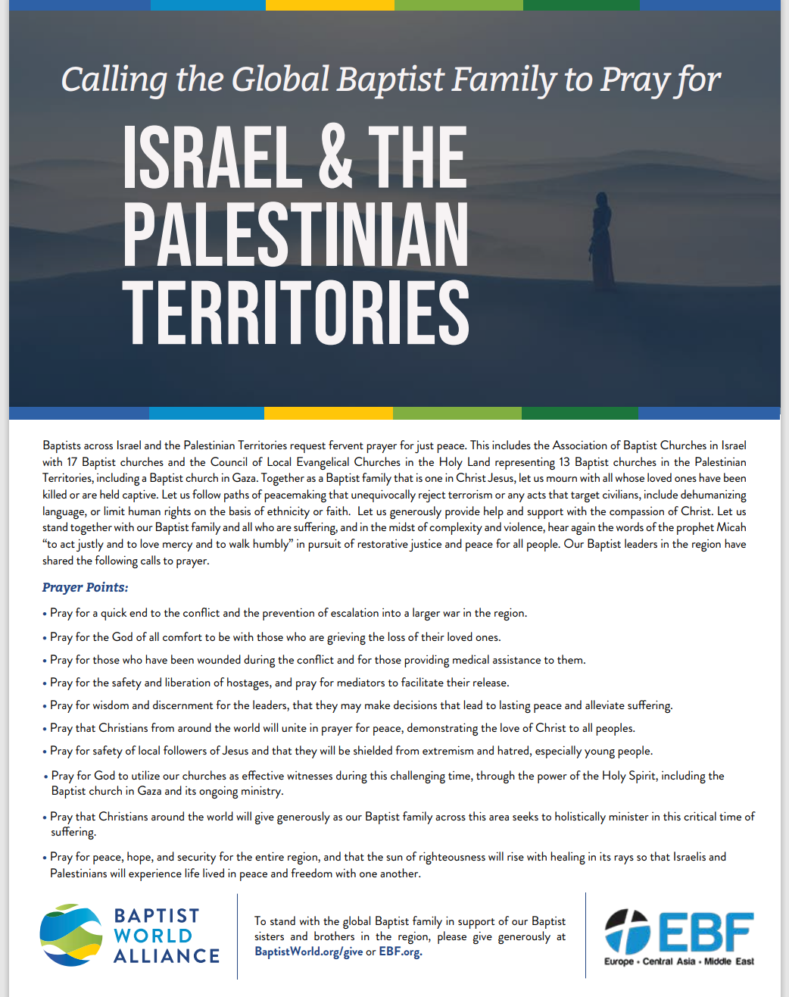

---------------------------------------------------------------
Olwyn Dickson in print

In the latest bimonthly Baptist magazine is a lovely article about Olwyn Dickson, former pastor’s wife here at Thames. I have emailed the copy of the magazine to those with email addresses and there are hard copies in the lounge or you can get it on the Baptist app.

