
Pastoral letter #44
Rosters
17 December Greeter Des & Mercia
Sound Bernard
Computer Sarah
Morning Tea Marion & Raylene
Worship leader Shaz
Kidzone Frances H & ?
Communion Gael McInnes
----------------------------------------------------
What’s on this week (Wednesday 13 December to Tuesday 19 December)

Wednesday 13th 9am Elders meeting
10am Women’s Group @ Church breakup (lounge)
10am Global Mission prayer group
5.30pm Worship team Christmas BBQ at Bernard & Shaz’
Thursday 14th 9.30am Intercessors group in our auditorium
Sunday 17th 9.30am Preservice prayer in 305
10am Worship service
-------------------------------------------------
Prayer from Henri Nouwen for Advent

Lord Jesus,
Master of both the light and the darkness, send your Holy Spirit upon our preparations for Christmas.
We who have so much to do seek quiet spaces to hear your voice each day.
We who are anxious over many things look forward to your coming amongst us.
We who are blessed in so many ways long for the complete joy of your kingdom.
We whose hearts are heavy seek the joy of your presence.
We are your people walking in darkness, yet seeking the light.
To you we say 'Come, Lord Jesus!'
Amen
--------------------------------------------------

Christmas Day service here

We will have a Christmas Day service on Monday 25th as well as the Sunday service on the 24th. At 10am

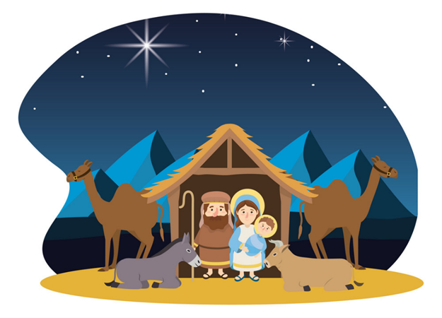
-----------------------------------------------------------
Christmas Poem 2017 By our own Robyn Ruddell

Freedom to worship, freedom to pray, to believe that our saviour was born Christmas day.
Freedom to gather, freedom to sing, to believe that this babe is Jesus our King.
Imagine heaven celebrating, joyous and loud and angels taking turns peeping through the cloud.
To catch a glimpse of a baby so small, sound asleep in an animal stall
Heaven brought down to dwell on this earth, to once again remind us of Gods glorious truth.
A baby so perfect, meek and sublime, radiantly allowing Gods glory to shine.
God loves us so dearly, he gave us his son, to reignite the kinship that Adam and Eve had undone.
Love and relationship is what this day should bring, but we like to celebrate with Christmas bling
Put up a tree, give out the gifts, lay out the tables all groaning with feasts.
Enjoy time with family, invite over some friends, go for a walk? Well, that depends.
So back to the reason that we are all here, not just for the past but for the future we will share
The reason that Jesus was born on this day, to dwell among man and show us the way.
The way back to God, our heavenly Father, to be his children and live with him forever.
Although the birth was, an amazing miracle to behold, it would take another 30 years for his purpose to unfold
As Christians we can celebrate the birth in all of its glory, but be listening at Easter for the ending of
the story.
-------------------------------------------------------------
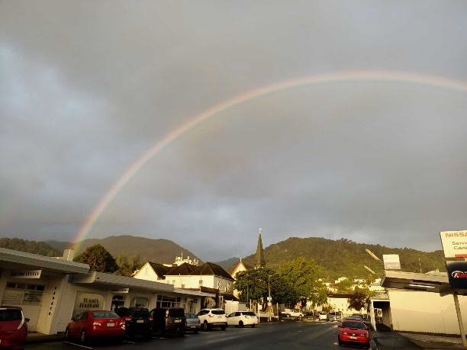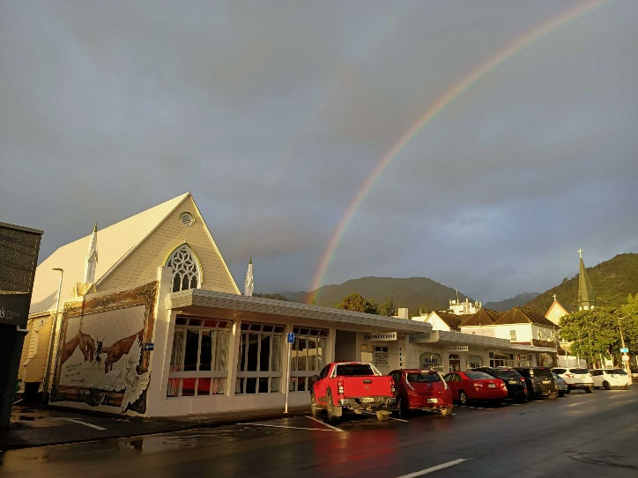
I always knew that TBC was a pot of gold!


Sound Desk and Microphones

If you are not on the Sound team, DO NOT play with the sound desk or pulpit microphone. They are expensive pieces of kit and easily broken. They are not toys. I do not want to get to the stage of having to lock the auditorium. Last Sunday, there was damage to both!!!!
------------------------------------------------------------

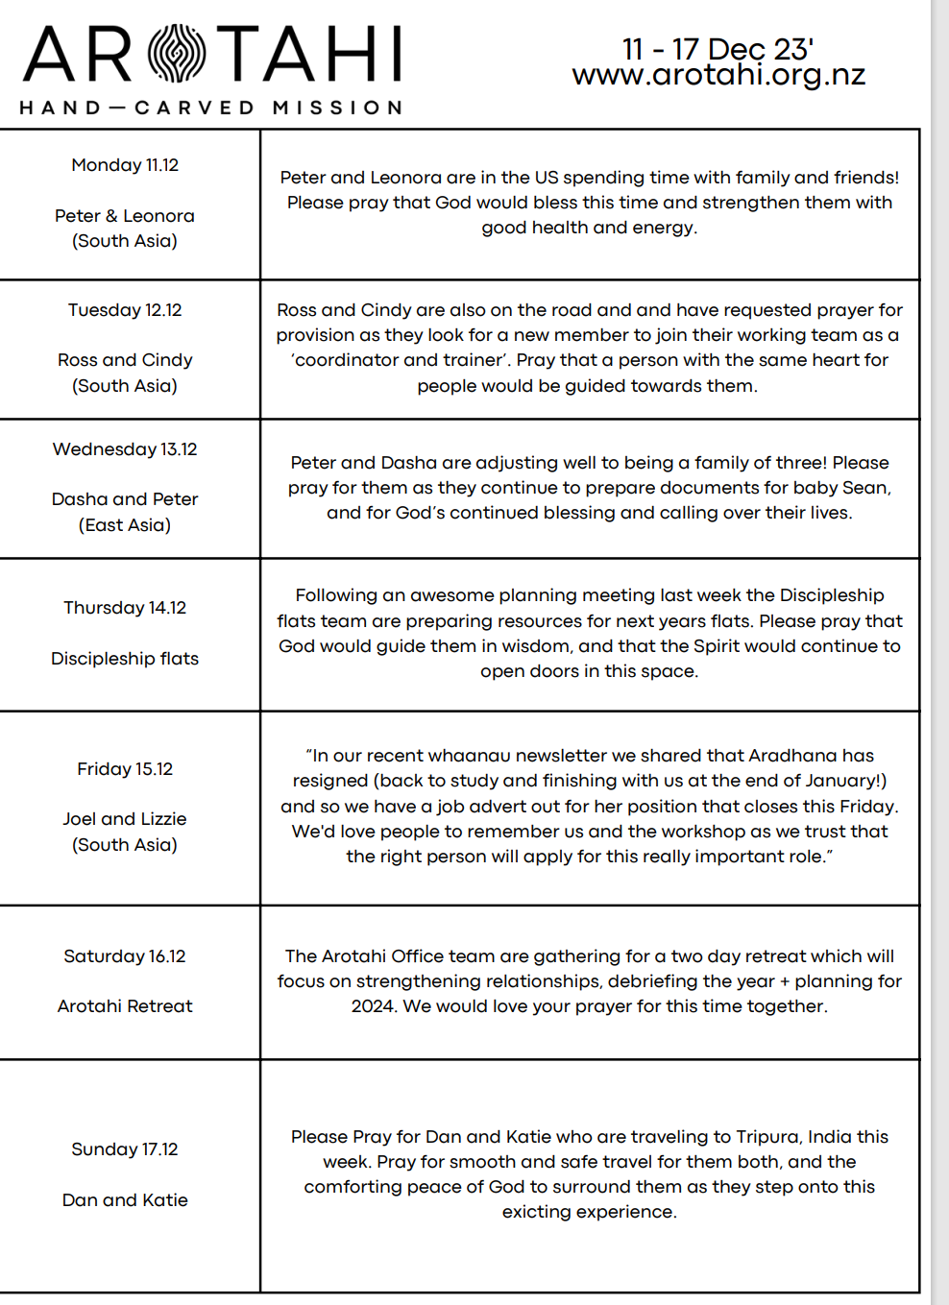-----------------------------------------------------------
Home groups and activity groups

All the homegroups and activity groups are winding up for the year. Back again in the New Year

