
Pastoral letter #4 2024
Rosters
28 January Greeter Colin & Doug
Sound Charleen
Computer Terri
Morning Tea Marion & Raylene
Worship leader Chris/Lynette
Kidzone School holidays no program
BBQ Noel & Rae Suckling
----------------------------------------------------
What’s on this week (Wednesday 25 January to Wednesday 31 January)
Sunday 28th 10am Worship service
6pm BBQ at Noel and Rae’s
Monday 29th Auckland Anniversary Day
Tuesday 30th 7pm Hillbillies home group at Lynettes
----------------------------------------------------
BBQ Season
28th Noel & Rae Suckling 104 Tararu Creek Rd
4th Willie & Shona Taylor 111 Rolleston St
11th Elizabeth Jones 31 Cypress Lane, BUPA Tararu – Potluck – no BBQ
18th Donald & Kathie Sangster 113 Regent Heights
25th Rose & Adrian Davis 25 Te Ana Lane, Kaueranga Valley
3rd March Judith Twentyman 23 Merrimana Drive, Totara Palms
--------------------------------------------------------------
Jules Riding
Jules Riding will be at our 18th February service.

From Levi
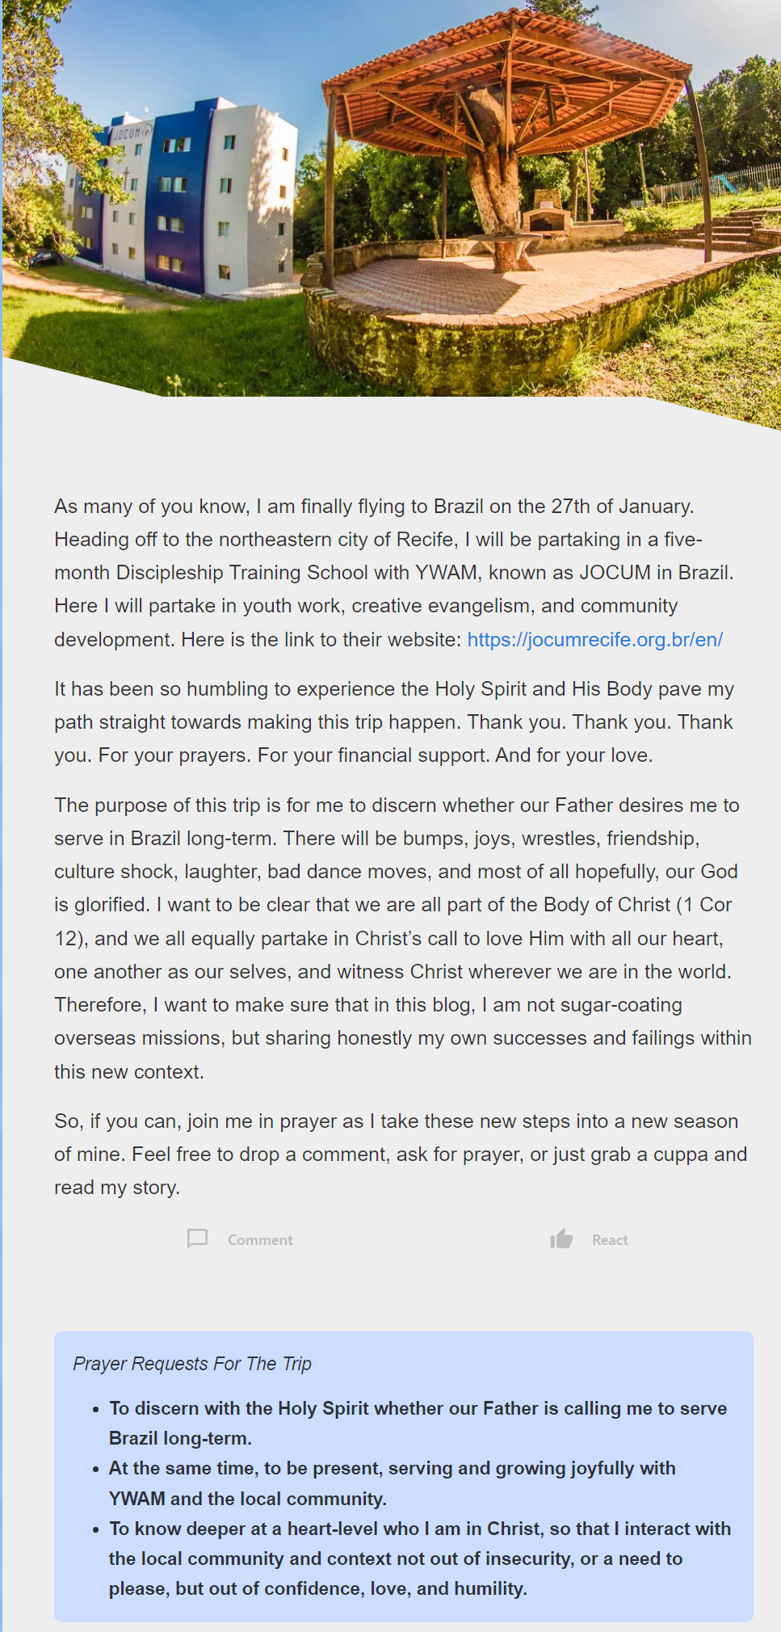
Hope Project

I have been the co-ordinator of the Hope Project Easter booklet deliveries for Thames. Is there anyone who would like to take over that role?
--------------------------------------------------------------
Scripture Union latest for those interested in children’s ministry.

https://issuu.com/scriptureunionnewzealand/docs/suadventuremagazine_apr2023
-------------------------------------------------------------
Newsletter compiler

Anyone want to do the weekly newsletter which gets emailed, posted and placed in the church lounge? Currently it is me who does it.
-------------------------------------------------------------
Used postage stamps for mission.

The box for the stamps is missing from the lounge. Any ideas?
Used postage stamps are sent to a stamp dealer who pays us for them and the money goes into Arotahi missions
-------------------------------------------------------------
Home groups and activity groups

Hillbillies 7pm Alternate Tuesdays Lynette’s on 30th
Intercessors 9.30am Thursday auditorium

Other homegroups and activity groups are waiting for February to restart.
Looking for additional home groups to start up.
--------------------------------------------------------------
Baptism of Elisha Wanhill last Sunday

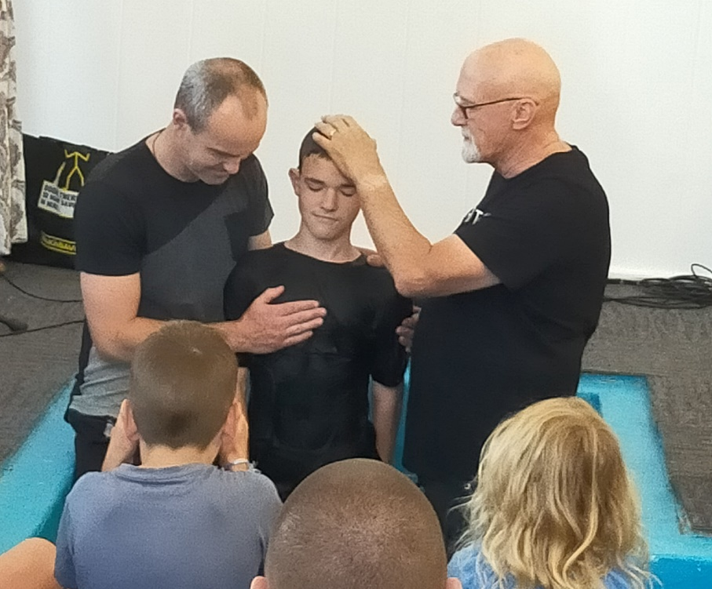
---------------------------------------------------------

The church, the people, the Treaty of Waitangi.

What is the connection? What can I do?
Monday nights, starting on the 5th of February. Come along to join in with a reading from the book, Huia Come Home, by J. Ruka, a plate of food to share for tea, a good ear, slow to speak and a willing heart. 6PM Church Lounge
-Bronwyn Dyer
-----------------------------------------------------------
Interim Elder seconded

The Elders have seconded Shane Dyer onto the Eldership to help them during the interregnum period without a pastor.
-----------------------------------------------------------
On Call Elders

When I leave, and before there is either an interim pastor or permanent pastor, the Elders will be on a weekly on-call roster for any pastoral matters. Check the Pastoral Newsletters for who is on.
-----------------------------------------------------------
Some people want to know where we are going at the end of February

This is our house at 199 Fairweather Rd, Myross Bush, RD2, Invercargill
There is plenty of room for visitors and camper vans.


-----------------------------------------------------------
LWT Team Leader Community

Caroline has resigned as the LWT Team Leader Community and she is off to Kenya and tiki touring around New Zealand in her camper van, then back here at the end of March.
We wish her well in this new phase of her life.
The Trust Board is looking at finding a replacement for her as soon as possible so we have continuity of service.
