 Pastoral letter #17
Rosters
14 May Greeter Phil & Diane Watson
Sound Peter
Computer Rose
Morning Tea Trevor & Max
Worship leader Josh
Kidzone Keri & Betty
21 May Greeter Colin & Doug
Sound Bernard
Computer Terri
Morning Tea Dawid & Antjie
Worship leader Josh
Kidzone Frances H & Betty
Communion Caroline

Two weeks because there will not be a newsletter next week
----------------------------------------------------
What’s on this week (Wednesday 17th to Tuesday 23rd May)

I am away in Invercargill from Monday 15th to Thursday 18th, so please contact the Elders for any pastoral needs.

Wednesday 17th 8am Elders prayer meeting
10am Women’s Group @ Church
2pm Home group @ church
Thursday 19th 9.30am Intercessors group in our church auditorium
Sunday 21st 9.30am Pre service prayer in 305
10am Worship service
Midday New people lunch
Tuesday 23rd 10am Tararu home group
Midday Tasty Tuesday
---------------------------------------------------------
Home groups and activity groups

Tararu 10am Tuesday weekly at Elizabeth Jones’ (Jenny)
Lifestylers 2pm Tuesdays weekly at Peter Moyes’ (Lynette)
Coast 7pm Tuesdays fortnightly at Betty Holmes’ (Colin)
Hikutaia 7pm Tuesdays fortnightly at Shaz & Bernards (Puriri) (Shane)
Hillbillies 7pm Tuesdays fortnightly at various (Chris)
Womens knitting 10am Wednesday weekly in the Church Lounge (Kathie & Pam)
Wednesday 2pm Wednesday weekly in the Church Lounge (Chris)
Intercessors 9.30am Thursdays weekly in our church auditorium (Colin)
--------------------------------------------------------
Have lunch with someone after church

We all eat lunch so why not invite a couple (or person) you do not know home to share your meal after church. If you don’t trust your cooking skills, take them to lunch in a café after church.

We do not act like a hound waiting to pounce on the fox as we share our faith with those whom the Lord has led across our paths. We build authentic friendships with them. - David Lundy
----------------------------------------------------------
New People Lunch

Every so often, the Elders put on a lunch for people new to the church to them to get to know us and vice versa and to understand our church, its vision and so forth. There are no hooks, just a free lunch and conversation. The next one will be on Sunday 21 May after church. If you have not attended one of these (and we have not had one since COVID hit on 2022), let me know and I will add you to the invitees.
----------------------------------------------------------
Happy Mothers Day (14th)




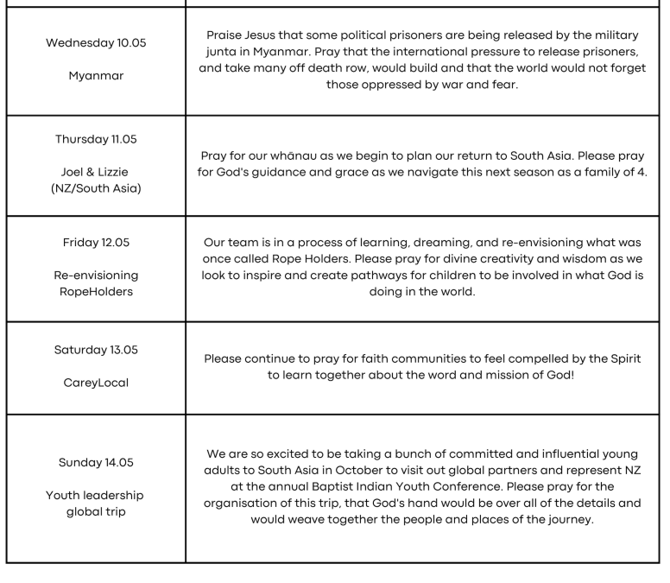
Praying for our global Baptist whānau: Sweden
The Uniting Church in Sweden has 637 churches with 58,569 members. Join us in thanking God for Sweden's longstanding commitment to peace and for their efforts to support peacemaking worldwide. Join us in prayer for church and ministry leaders as they stand for a Biblical worldview in the midst of a secular culture.

Ethnic violence has erupted in the northeast Indian state of Manipur. Baptist ministry partners are reporting that many buildings, including Baptist churches, have been burned down over the last few days. Please pray for peace now and going forward.
------------------------------------------------------------
Flat to rent

A couple at church last Sunday from Auckland have a 2 bedroom downstairs flat for rent in the Parawai area. If you know of good tenants, contact Gary Brockett on 021 027 02928 or garybrockett1@gmail.com for more details

The Waikato and Bay of Plenty Eastland Association are delighted to invite you to our Regional Hui. Jesus, People and places is our 2023 theme. We have invited input from Charles Hewlett - National Leader of the Baptist Union, Alan Jamison - Leader of Arotahi, Jonathan Robinson - Lecturer Carey College and Vicky Cullen – Welcome Bay Baptist. An evening with Craig and Michaela Vernall (reflections of 30 years in ministry)

Along with this we will be running two sessions of talking together and sharing ideas on the following topics: -Solid foundations for discipling our children; - Helping people come to faith and then take next steps in their journey; -Young Adults, School leavers: What can be done?; -Youth (School age) within our community; -Ideas and discussion around pastoral care practices; -Renewed worship amongst us; -Let’s talk Salvation, Repentance and Baptism

We are going to pray together. We are going to read scripture together. We are going to worship together. We are going to listen to God together. We are going to eat together

This Hui is for anyone who is part of a Baptist Church in our region.
This is open for anyone from the church, not just the leaders.
------------------------------------------------------------------

