 Pastoral letter #3 2023
Rosters
5 February Greeter The Pawleys
Sound Levi
Computer Terri
Morning Tea The Watsons
Worship leader Lynette
Kidzone Rose & Glen
----------------------------------------------------------
What’s on this week (Wednesday 1st to Tuesday)

Wednesday 1st 10am Arotahi prayer group at Ollies
2pm Home group @ church
Sunday 5th 10am Worship service
6pm BBQ at Judiths
Monday 6th Waitangi Day holiday
Tuesday 7th 10am Taruru home group at David and Jenny Coopers
Midday Tasty Tuesday
2pm Lifestylers home group at Peter Moyes.
7pm Coast home group at Bettys
7pm Hillbillies home group at Lynette’s
----------------------------------------------------------
Home groups and activity groups

Wednesday 2pm in the Church Lounge
Intercessors group Thursdays 9am old Church of Christ building
Hillbillies 7pm fortnightly check changing venue
Lifestylers 2pm Peter Moyle’s
Coast 7pm Betty Holmes’ (fortnightly)
Tararu 10am Elizabeth Jones’
Hikutaia second week of the school term – looking for more people to attend
----------------------------------------------------------
Scavenger Hunt and Dessert evening

Scavenger Hunt and Dessert evening
Date changed to Saturday 18th February
5.30pm Church lounge
Please bring a dessert and your friends. This is an all age event.
Contact Frances Hellendoorn for any further information
----------------------------------------------------------
Kidzone Meeting and short time of prayer

After church Sunday 19th February in 305.
We will meet briefly to pray and answer questions about the new Scripture Union material.
BBQ season hosts

5th Judith
12th Evening service
19th Shane & Bronwyn (Hikutaia)
26th Donald & Kathie
5 March Peter and Keri
12th Evening service
19th ????
26th ????
If you need a ride or worried about coming by yourself, ask someone to come with you or take you. Everyone welcome

----------------------------------------------------------
What have our people been doing over the break?

The Dyers went to Japan to visit their newest grandchild

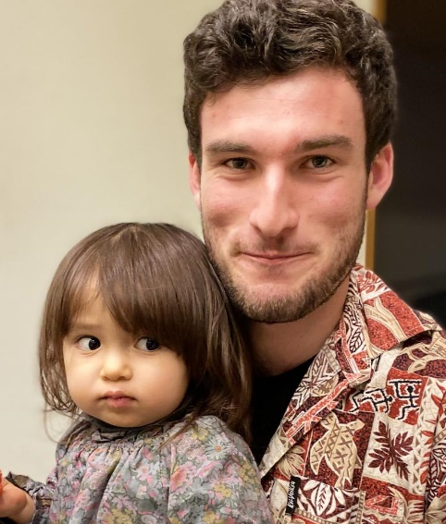

Have lunch with someone at church

We all eat lunch so why not invite a couple (or person) you do not know home to share your meal after church.
If you don’t trust your cooking skills, take them to lunch in a café after church.

1 Peter 4:9 Be hospitable to one another without complaint.
--------------------------------------------------------------
Dinner for 8



Dinner for 8 is a fellowship idea where a person/couple host a dinner party, and 3 other couples or numbers making up to 6 join the hosts for dinner. The host decides which person brings what so it is like a shared meal and they set the date and time.

The facilitator puts hosts and guests together, trying to put people together who may not know each other so well. It is designed to get to know others so that we may have more than a nodding acquaintance with others in the congregation.

I am looking for someone to co-ordinate this and for people to offer to be hosts or guests.
You may queue at my door or email me if any of these are you.
--------------------------------------------------------------
Pre-service Prayer

Before COVID (BC) we used to have a pre service prayer meeting in 305 every Sunday at 9am.
We need prayer covering for our services and it would be great if people could come a little earlier than 10am to pray.

Our prayers do more than just petition the Father. I’ve become convinced that in some situations they actually release cumulative amounts of God’s power until enough has been released to accomplish his will - Dutch Sheets
---------------------------------------------------------------
Rosters for Morning Tea and Greeter

After years of faithful service, Bev has given up the role of organising these rosters, and the task will now be done by the church office (Diane and Phil).
If you are interesting in being on either of these rosters, please contact them on admin@thamesbaptist.org.nz

Flooding in Auckland

An email has been set up for queries and gestures of support: floodsupport@northernbaptist.nz

Flood relief funds can be directed to our Northern Baptist Account: 02-0264-0226011-01
Reference: “Flood support” and also who is sending it – “name of church group”, “family”, “individual” or “other source”, sending the gift.

Northern Baptist Association (NBA) will ensure any funds are distributed to those flood damaged or offering relief.

So far, we are aware the Rānui have an Emergency Response centre (soon to be designated a civil defence centre) and other churches have also been open to their communities.

We are also aware that at least four churches have been severely affected by floods; unable to hold church meetings today. A number suffered some flood damage but with yesterday’s good weather and clean up, are able to offer services today. Thankfully, as far as we are aware, it seems a good number of our churches have not suffered any damage. However, with nearly a weeks’ worth of rain to come – this may change.

Thank you for your prayers and also offer of support.

Kia tau te aroha noa (Grace be with you),
Reti
(Northern Baptist Regional Leader)
-------------------------------------------------------------
PRAYER
God of Creation, and source of comfort, we pray for the people whose lives have been devastated by rain and flood. Bring them comfort. Protect the vulnerable. Strengthen the tired. Energise those working to support and rescue. May our response be generous and bring you praise. We ask in Jesus name. Amen
-------------------------------------------------------------
Locally the flooding and slips have meant some people have not been able to travel to Thames, and some of our people from 305 who live in tents have been flooded out, or unable to get to their tent sites due to flooded fords.
Please pray for our local people affected by the flooding and slips.
-------------------------------------------------------------

