
Pastoral letter #42
Chris in Invercargill from 28 November to 5 December – see the Elders for pastoral matters.
Rosters
26 November Greeter Betty & Judith
Sound Lisa
Computer Terri
Morning Tea Dawid & Antjie
Worship leader Chris & Lynette
Kidzone Keri & Glen
3 December Greeter Colin & Doug
Sound Lisa
Computer Joe
Morning Tea Diane & Phil P
Worship leader Lynette
Kidzone Rose & Glen
Preacher Shaz
Communion Frances H
----------------------------------------------------
What’s on this week (Wednesday 22 November to Tuesday 28 November)

Wednesday 10am Women’s Group @ Church (lounge)
2pm Home group @ church
Thursday 9.30am Intercessors group in our auditorium
10am Salvation Army State of Thames report
12.15pm New believers’ group
Sunday 26th 9.30am Preservice prayer in 305
10am Worship service
Straight after church Church AGM and potluck
2pm Hospice Remembrance St James Church
2.30pm Tararu Rest home service
Monday 27th 5pm Hillbillies Home group potluck tea and break up for the year at Des and Mercia’s
Tuesday 28th 10am Tararu home group
Midday Tasty Tuesday
2pm Lifestylers home group
-------------------------------------------------
Salvation Army State of our community

You are invited to the launch of The Salvation Army #39 “State of our Community Report”.
The report has been compiled by The Salvation Army’s Social Policy and
Parliamentary Unit based on a community survey research project conducted in June and July of this year. This survey was a micro-level project, which focused on drilling down into Thames and hearing from the locals about their community.
• The Salvation Army Thames 23 November 2023 10:00 am
Refreshments will follow the launch of the Report and a time of Q&A. For catering
purposes, can you please RSVP to thames.corps@salvationarmy.org.nz
-----------------------------------------------------
Hospice Waikato remembrance service.

This Sunday at 2pm Thames Union Parish (St James church), Thames. We encourage you to bring photos or other mementos to place with our candles as we remember our loved ones. Refreshments will be served following the service.
-------------------------------------------------------
Church AGM

The Church AGM is on this Sunday straight after church. Potluck lunch
--------------------------------------------------------
Tararu Rest Home Service

2.30pm if you would to go and support our team there this Sunday.
--------------------------------------------------------
Waikato Baptist Association AGM

On Sunday 3 December at 4pm at Cambridge Baptist Church
All welcome to attend.

Whiria Kids Fundraising bike ride
2 December
The Rail Trail from Thames to Paeroa
Others converging on Paeroa from Waihi and Te Aroha
Raising funds for Whiria Kids
Get sponsored and have a go.
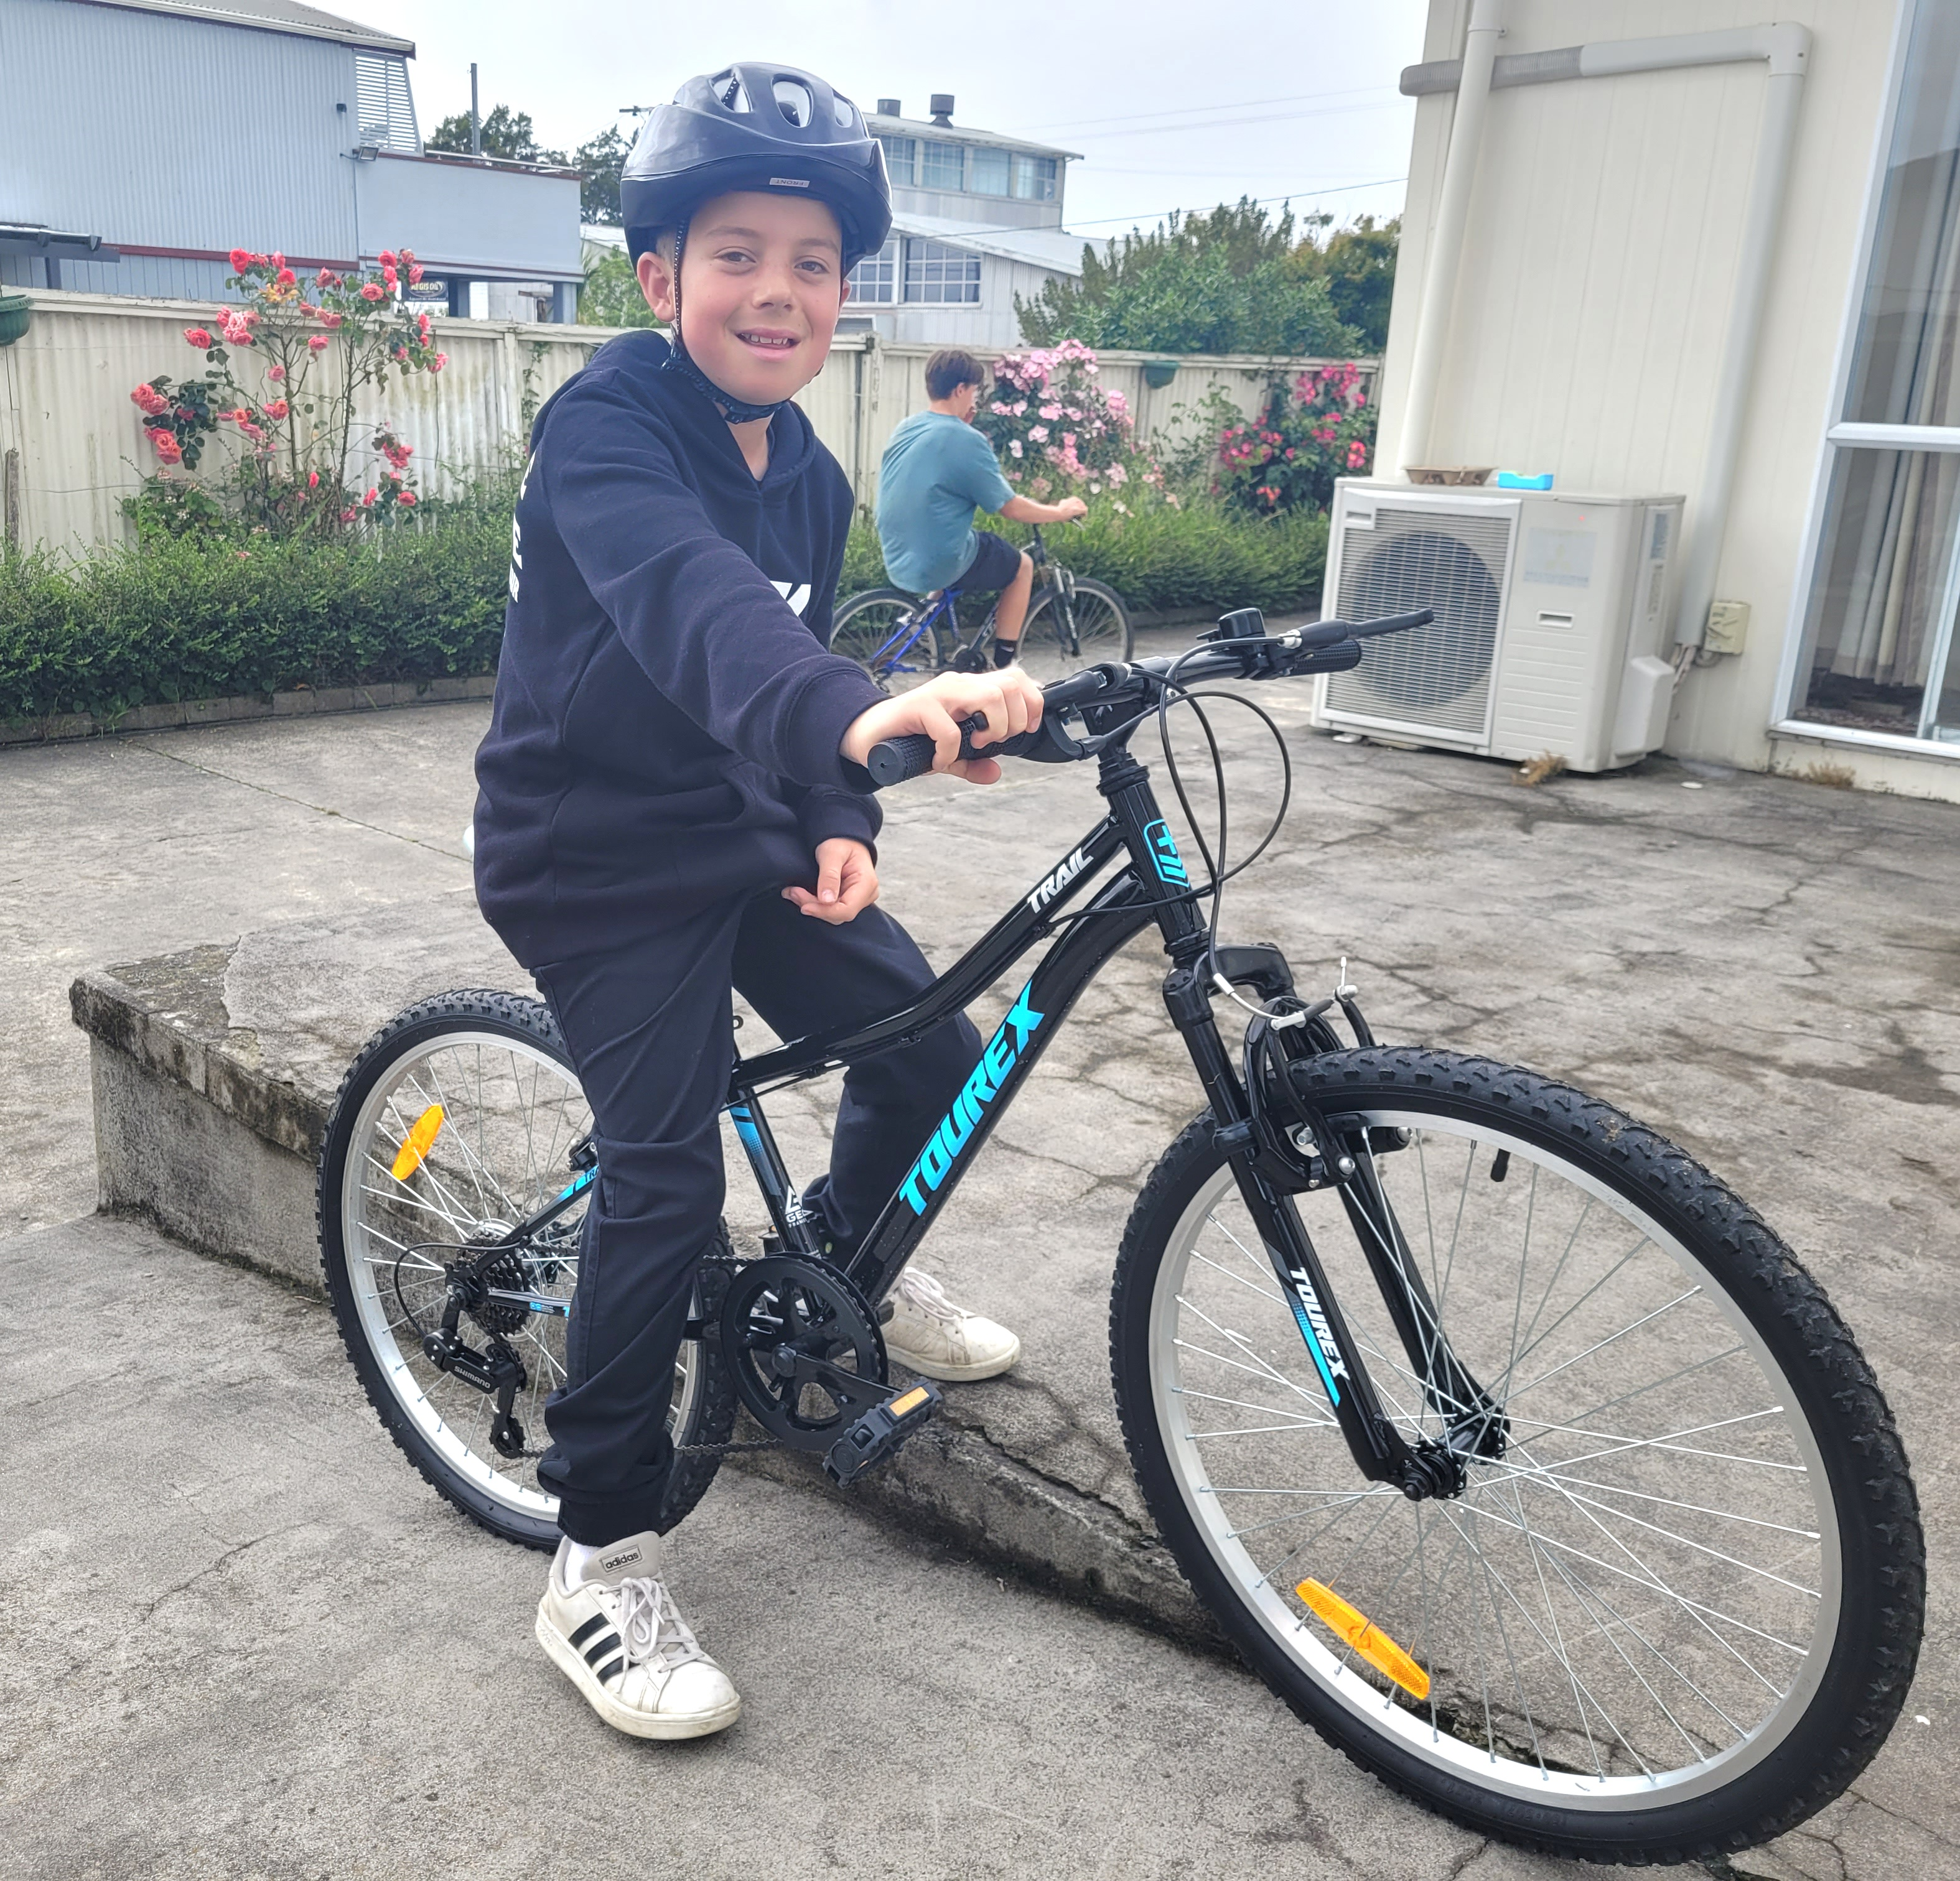
We will meet at the Thames wharf and set out on the Rail Trail at 8.00 am
Riders: Please look up the Hauraki Rail Trail website to understand important details before you ride the trail.
Sponsorship: What to do with money that each rider collects from their Sponsors :-

1.Cash be handed in on the day at Paeroa.
2. Money may be paid direct online to this Bank Account
Arotahi Koha Fund 02 0232 0150075 04 Particulars: HRT Bike Ride Reference: WKS

Safe and happy riding,
Elizabeth Mobile: 021 170 91667
-------------------------------------------------------
Foodbank needs

Thames Foodbank needs: Weetbix, noodles, powdered milk, deodorant, toothbrushes and toothpaste, and any treats for Christmas. Thank you so much for your generosity over what can be a difficult time for many.
------------------------------------------------------
Blue spiral bound notebook

There is a blue spiral bound notebook in my office, left in the church some weeks ago, looking for its owner. I can’t recognise the handwriting and it has no names in it.
--------------------------------------------------------
I found this old photo in my office. It seems to be in front of the curch before the lounge was put on the front of the church. Anyone know the story behind the photo?
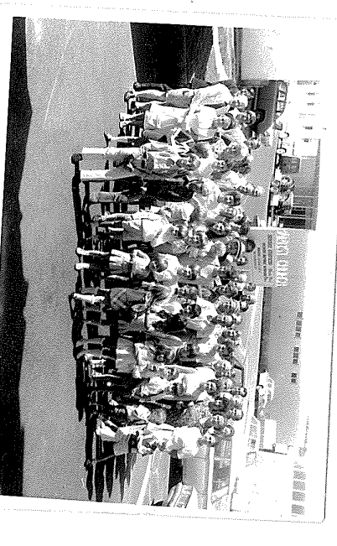
---------------------------------------------------------
Pastoral Visiting Team

Lynette Mill, Helen Whittaker, Bev Gibson, Elizabeth Jones, Des and Mercia Barton and Brent and Berwyn Mason. If they visit you, they are visiting on behalf of the church.
-----------------------------------------------------------
Home groups and activity groups
Tararu 10am Tuesday weekly at Elizabeth Jones’ (Jenny B)
Lifestylers 2pm Tuesdays weekly at Peter Moyes’ (Lynette)
Coast in recess at the moment
Hikutaia in recess at the moment
Hillbillies 7pm Tuesdays fortnightly at various (Chris)
Womens knitting 10am Wednesdays weekly in the Church Lounge (Kathie & Pam)
Wednesday 2pm Wednesdays weekly in the Church Lounge (Chris)
Intercessors 9.30am Thursdays weekly in the church auditorium (Colin)
New People Foundation group 12.15pm Thursdays in the church auditorium (Chris & Shaz)
------------------------------------------------------------
Christmas Parade float

We have to notify the organisers by 1 December if we are putting a float into the parade this year.
Film producers from Deer Heart Films Christopher and Miriam are keen to video our float preparation and the parade, if we do. So far I have had no suggestions from our church or the other churches. Do we want to do this?
-------------------------------------------------------------
