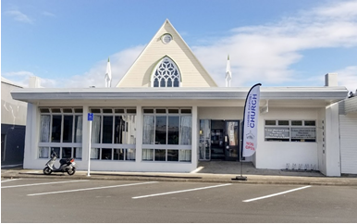
Newsletter 11
Sunday 17/3/2024
Roster  Greeter  Sound  Computer  Morning Tea  Worship Leader  Kidzone  On Call Elder  Communion |  | Des and Mercia Barton  Peter  Sarah  Trevor Weeks and Joe Streater  Eddie and Lynette  Keri and ?  Shane Dyer  Gael McInnes
Whats on this week Sunday 17th to Saturday the 23rd March
Sunday 17th March  Monday 18th  Tuesday 19th  Wednesday 20th  Thursday 21th  Friday 22nd | 10am  7pm  7pm  2pm  9.30am  10am | Worship Service-Preacher-Shaz Kerebs  Huia Come Home at Church Lounge  Hillbillies home group Contact Lynette Mills 0211023176  Gaels home group  Intercessors group at Church  Men’s Coffee Group
BBQ Season
The Sunday afternoon barbeques are over for the season so I would like to thank all of those who opened their homes during this time. The food and fellowship have always been great and it was a highlight of the week for many of those that attended. Our last venue at Betty’s was well attended and apart from the good food, everybody enjoyed the sunset from Betty’s lounge and deck.
Living Well Trust
Terri and Amanda and Eddie are the key people in LWT Community including 305, filling the gap for the foreseeable future. They are supported by a team of volunteers who provide support for those that attend the centre. They are at the moment putting in applications for the ongoing work of the Youth Work and the Drop-in Centre. Please pray for this work and the funding needed to support it. As Eddie stated the other week the food bank has found that its services are in increasing demand so please also pray for the continued supply of food and funding for this much needed ministry.
Church Maintenance
As you may have noticed our 9-year-old fridge freezer in the kitchen has broken down. Enquiries were made but it was found that the cost of repairs were more than the cost of a new replacement. Hopefully, we will have a sparkling new one in the kitchen soon. Thanks Bernard, for the good work that you are doing to keep our church running smoothly.
Elders Duties:
Newsletter compiler – Colin McLaren
Notices on Sunday service – Diane Pawley
Hope project co-ordinator – Shane Dyer
Website updater – Shane Dyer
Co-ordinator of Pastoral Visiting Team – Shaz
On Call Elders
Before he left Chris and the Elders assigned various tasks to the Elders according to their giftings and availability. It was decided that there was to be a duty Elder in charge of the Sunday service and calls during the week. However, if you have a confidential matter to discuss with an Elder, please don’t hesitate to contact your favourite Elder. Check the Newsletter to see who is on.
The church, the people, the Treaty of Waitangi.
Huia Come Home, by J Ruka. A copy can be purchased from the Lampbookshop. Come a long for Term 1 and let's read this life changing book together. It will open your eyes and get you thinking. Would love to see some men there, this is not a lady’s group, nor is it a romantic novel or a period drama, but it is about you and our beautiful country, and it won't give you the guilts. I'm happy to read it, we can all discuss it. I truly believe it is something every kiwi needs to hear. Regards Bronwyn
Global Missions
A reminder; Global missions meets every second Thursday of each month at 2pm. They meet in the Kidzone area behind the auditorium. The next meeting will be on Thursday the 11th of April.
Daily Bible Verse Text
If you are interested in receiving a verse direct to your cell phone please contact Colin McLaren with your cell phone number and you will be added to the list.
colin@cjmacs2020.co.nz or 027 2235393

Home Groups and Activity Groups
Huia Come Home  Hillbillies | 7pm on Monday  7pm Alternate Tuesdays | Church Lounge  Contact Lynette Mill
Global Missions | 2pm Monthly 2nd Thursday | Kidzone
Women’s group | 10am Wednesdays | Church Lounge
Gaels Home group | 2pm Wednesdays | Church Lounge
Intercessors Group | 9.30 am Thursdays | Church Auditorium
Men’s Coffee Group | 10am Fridays | Co Co Coffee Shop
Women’s Coffee Group | 10.30 1st Friday of each month | Aeroview Café

Looking for additional home groups to start up. Do you belong to a group that meets and feel that others would benefit from attending, contact Colin 0272235393 to have it included here.
Growing in God
Did you know that God created you for fellowship with Himself and so we will never feel fully complete unless we are in fellowship with Him. Are you wanting to grow in fellowship with God and to allow Him to develop and change you? Take time to quieten yourself to hear His voice and to learn the skill of being still before Him, to pray and read the Bible.
Romans 10:17 says “So faith comes from hearing, and hearing by the word of Christ”.
And Hebrews 11:6 says “And without faith it is impossible to please Him, for he who comes to God must believe that He is and that He is a rewarder of those who seek Him.
So be encouraged the more you spend time with The Lord the more you are able to discern the voice of God for your daily life.
This Sunday 17th March
Join in for some fun at morning tea and enter them into the competition to see who is our very own Master Baker. Be assured that it will be enjoyed by all and the leftovers if any, will grace the tables at 305 and the food bank

Arotahi
Please find below the weekly prayer list for Arotahi, If you are interested in a paper copy of the newsletter please let me know or contact Elizabeth Jones and she and we will arrange it for you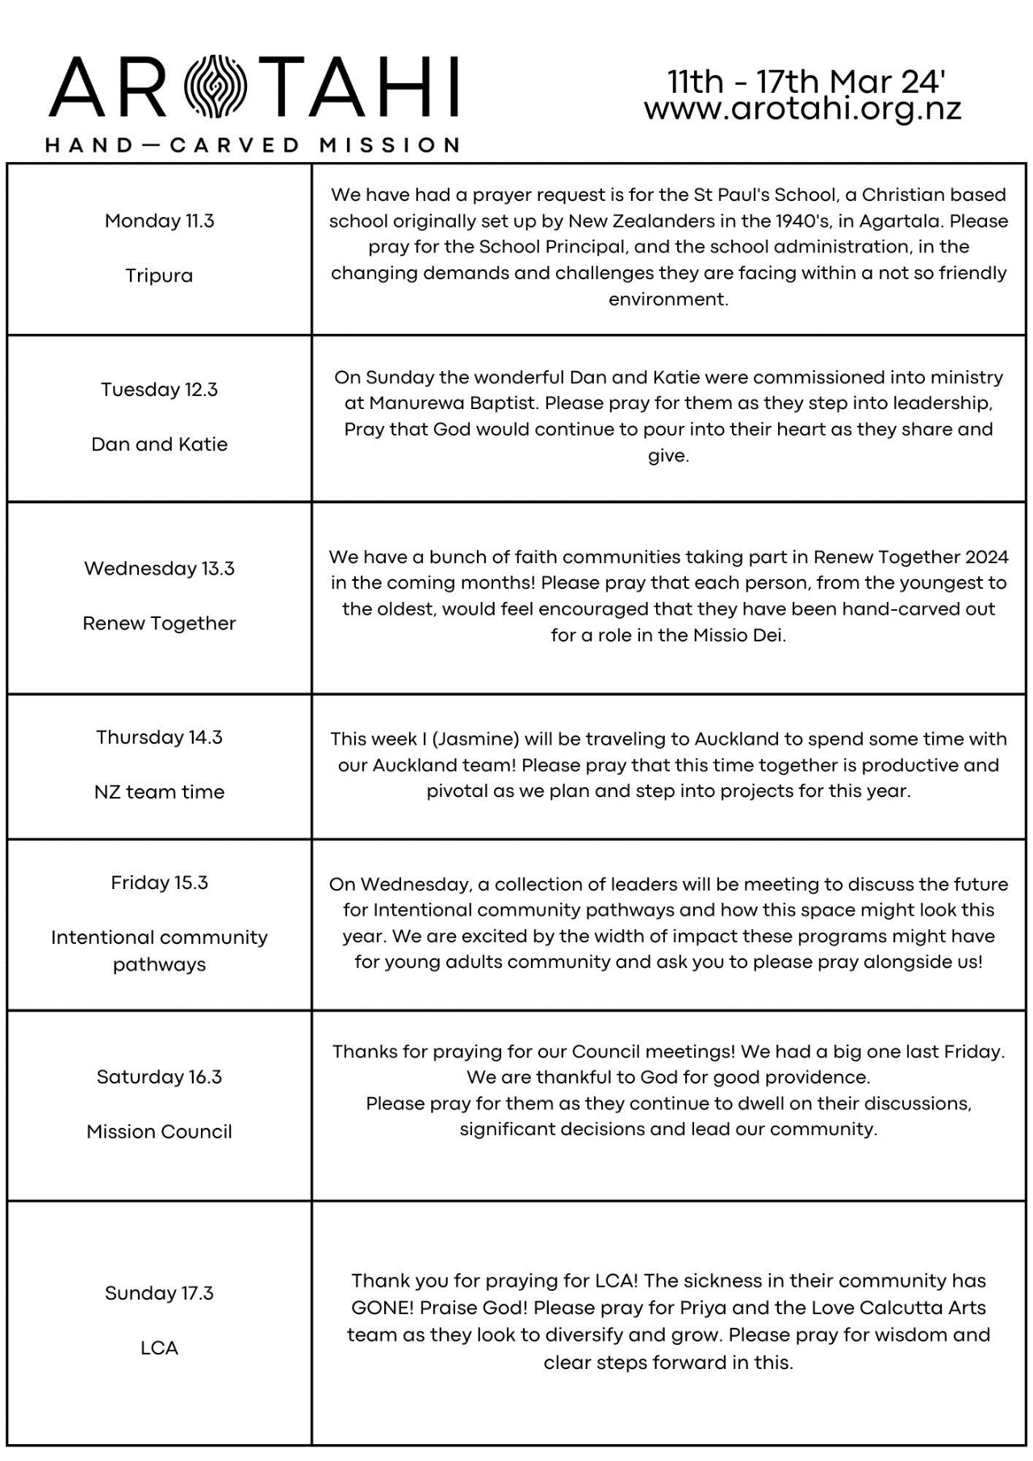

A thought for the week
I have been thinking about fellowship and the importance of Christians meeting together. Often this can be a neglected activity but for those that practice this habit, it will enrich their lives. Please see the following verses that describe key benefits that are derived from Christian fellowship
1 Thessalonians 5:11 Therefore encourage one another and build one another up, just as you are doing.
Hebrews 10:25 Not neglecting to meet together, as is the habit of some, but encouraging one another, and all the more as you see the Day drawing near.
1 John 1:3 That which we have seen and heard we proclaim also to you, so that you too may have fellowship with us; and indeed our fellowship is with the Father and with his Son Jesus Christ.
Ecclesiastes 4:9-12 Two are better than one, because they have a good reward for their toil. For if they fall, one will lift up his fellow. But woe to him who is alone when he falls and has not another to lift him up! Again, if two lie together, they keep warm, but how can one keep warm alone? And though a man might prevail against one who is alone, two will withstand him—a threefold cord is not quickly broken.
1 John 1:7 But if we walk in the light, as he is in the light, we have fellowship with one another, and the blood of Jesus his Son cleanses us from all sin.
Matthew 18:20 For where two or three are gathered in my name, there am I among them.
Acts 2:42 And they devoted themselves to the apostles' teaching and the fellowship, to the breaking of bread and the prayers.
Hebrews 10:24 And let us consider how to stir up one another to love and good works,
Galatians 6:2 Bear one another's burdens, and so fulfill the law of Christ.
1 Peter 3:8 Finally, all of you, have unity of mind, sympathy, brotherly love, a tender heart, and a humble mind.
1 Corinthians 1:9 God is faithful, by Whom you were called into the fellowship of His Son, Jesus Christ our Lord.
Romans 1:12 That is, that we may be mutually encouraged by each other's faith, both yours and mine.
Acts 2:44-47 And all who believed were together and had all things in common. And they were selling their possessions and belongings and distributing the proceeds to all, as any had need. And day by day, attending the temple together and breaking bread in their homes, they received their food with glad and generous hearts, praising God and having favour with all the people. And the Lord added to their number day by day those who were being saved.
John 17:21-23 That they may all be one, just as you, Father, are in me, and I in you, that they also may be in us, so that the world may believe that you have sent me. The glory that you have given me I have given to them, that they may be one even as we are one, I in them and you in me, that they may become perfectly one, so that the world may know that you sent me and loved them even as you loved me.
Hebrews 10:24-25 And let us consider how to stir up one another to love and good works, not neglecting to meet together, as is the habit of some, but encouraging one another, and all the more as you see the Day drawing near.
2 Corinthians 6:14 Do not be unequally yoked with unbelievers. For what partnership has righteousness with lawlessness? Or what fellowship has light with darkness?
1 Corinthians 12:12 For just as the body is one and has many members, and all the members of the body, though many, are one body, so it is with Christ.

Duty Elder | Shane Dyer | 021 242 6217
Church Administrator | David Gibson | 021 1339773
Church Bank Account | Westpac | 03 0458 0192366 00

If you would want your giving to be confidentially recorded for tax purposes please contact the Administrator David Gibson.

