 Pastoral letter #22
Rosters
2 July Greeter Marie & Herman
Sound Bernard
Computer Joe
Morning Tea Dawid & Antjie
Worship leader Shaz
Kidzone Rose & Mercia
Communion Elizabeth
----------------------------------------------------
What’s on this week (Wednesday 28 June to Tuesday 27 June)

Wednesday 28th 10am Women’s Group @ Church
2pm Home group @ church
7pm Church Council meeting
Thursday 29th 9.30am Intercessors group in our church auditorium
Midday New believers group
Sunday 2nd 9.30am Pre service prayer in 305
10am Worship service
Tuesday 4th 10am Tararu home group
Midday Tasty Tuesday
2pm Lifestylers home group
--------------------------------------------------------
Living Well Trust news

We have had some very positive feedback by individuals from the work we are doing in 305. In addition we now have a new receptionist/administrator working Wednesdays and Thursdays, Amanda Goldsmith. Welcome Amanda! We now have 5 new volunteers helping in the Thames Foodbank. Welcome to Tammy, Lynley, Chris, Jules and Marion. The foodbank requires jars and sauce bottles for putting dish and clothes washing products in. Also any paper bags which you are not using. Please bring to the office. Main Foodbank requests: Weetbix, tins of spaghetti, tins of beans, milk powder, and tampons. Many thanks for helping us with this awesome work we do to support people with food parcels.
---------------------------------------------------------
Church Life Survey

Please participate in the Church Life Survey
Our church is part of this nationwide survey of church attenders. This is a confidential opportunity for you to have your say on the life of our church and be heard by our leaders. Can you take 10-15 minutes to fill it out today or over the week?
On line
https://clsnz.org/chis96Be2rIdawic/01GX4EFGA96HZDKDN7JJZ6M3G9/en

Or by paper copy

A Poem by Rose

If only we were all born with an equal chance.
And if the only things addictive were to laugh and sing and dance.
If only everyone had a home, a bike, maybe a car,
And all our food was healthy and didn’t travel from afar.
If only all the predators would ‘pack their bags’ and go away…
And rain would come only at night, so we’d have sunny blue-skied days.
If only there was a cycle trail all the way up the Kauaeranga
(And my leaky roof was fixed before the rain and wind gets stronger!)
Our species is quite smart – we send rockets into Space…
But what do we each do to make this Earth a better place?

Rose
----------------------------------------------------------
From Samanda re KVCC Holiday Camp

Kia Ora church whanau, our next kids holiday camp is on the 10th - 14th of July with the theme "Blueprints". It is a building camp and I would love it if you could donate/ lend us any of these items below:
1. Nails 2. Hammers
3. Saws 4. Drills
5. Screws 6. Pliers
7. Wheels 8. Measuring Tapes
9. Caution Tape 10. Bottles for Water Rockets
11. Cookie cutters for a gingerbread house
I will try my absolute hardest to return the borrowed things.
----------------------------------------------------------
Tasty Tuesday

From Mercia
This is a great mission to partner with other churches in Thames, taking turns each week to supply
a mid-day meal for up to 35 people. Our turn comes round once a month or twice if there is a 5th
Tuesday.

Last Tuesday we had a lady trying the door before opening time so went to speak to her as to when we were open, but she had seen the notice outside the church advertising Tasty Tuesday and wanted to say what a great ministry this was as so many people needed a meal, she actually congratulated us!

We, at the Baptist Church need help on our turn. I know some of you have done your share for many years and that is a blessing. The help needed is cooking or supplying a main course or a dessert, vegetable dish or salad etc, all this can be done at the church, any costs can be recompensed by giving your docket into the office, also people to serve or do dishes. If we could increase our team numbers it will take the pressure off a few. Any help would be appreciated.

Galatians 6v9 'Let us not become weary in doing good, for at the proper time we will reap a harvest if we do not give up. Therefore, as we have opportunity let us do good to ALL people, especially those who belong to the family of believers.'
---------------------------------------------------------

Mission Support

Levi is fundraising to 'dip his toes' over in Brazil to see whether God is wanting him to serve there long-term. He would be very grateful for any prayer, finance or practical support in fundraising. One practical support would be if anyone has card materials, or photo paper that he can print his photograph on to sell at the Saturday market. Or they could kindly donate to:
KiwiBank L J DYER 38-9019-0098352-02
--------------------------------------------------------
Home groups and activity groups

Tararu 10am Tuesday weekly at Elizabeth Jones’ (Jenny B)
Lifestylers 2pm Tuesdays weekly at Peter Moyes’ (Lynette)
Coast 7pm Tuesdays fortnightly at Betty Holmes’ (Colin)
Hikutaia 7pm Tuesdays fortnightly at Shaz & Bernards (Puriri) (Shane)
Hillbillies 7pm Tuesdays fortnightly at various (Chris)
Womens knitting 10am Wednesday weekly in the Church Lounge (Kathie & Pam)
Wednesday 2pm Wednesday weekly in the Church Lounge (Chris)
Intercessors 9.30am Thursdays weekly in our church auditorium (Colin)
New Beginnings 12.15pm Thursdays weekly in church lounge (Shaz & Chris)
-------------------------------------------------------
Incorrect phone number in the Directory

Janneke Vethaak’s number of 021 2675270 and not 027
-------------------------------------------------------
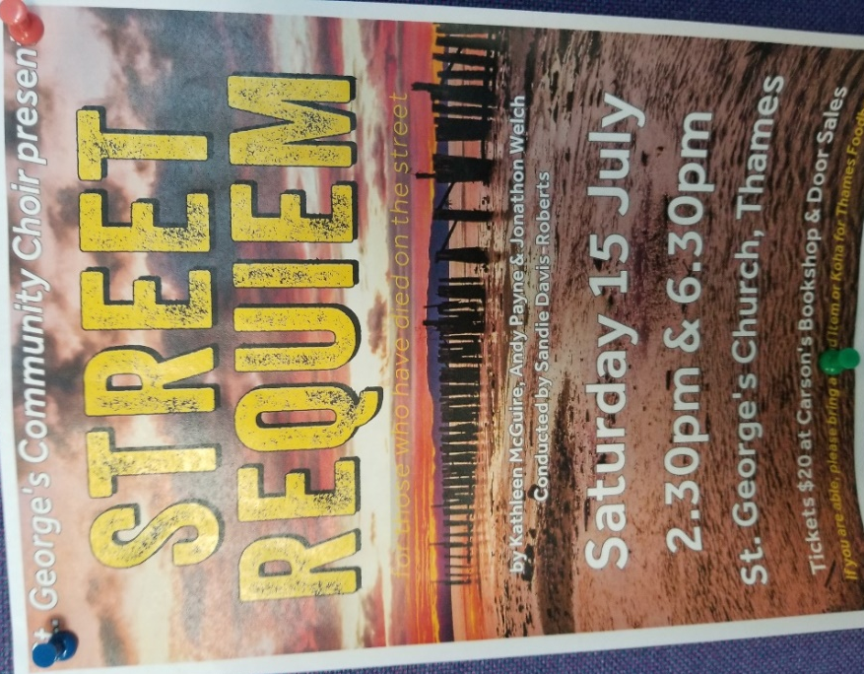
---------------------------------------------------------
The Supported Lifestyle Trust Art Exhibition

Artie advises that several pieces of art were sold during the exhibition including one of his pieces.
---------------------------------------------------------


