
Pastoral letter #32
Rosters
10 September Greeter Colin & Doug
Sound Bernard & Charleen
Computer Rose
Morning Tea Marion & Raylene
Worship leader Josh
Kidzone Frances Mclaren & Mercia
Communion Caroline
----------------------------------------------------
What’s on this week (Wednesday 6 September to Tuesday 12 September)

Wednesday 6th 10am Women’s Group @ Church (lounge)
2pm Home group @ church
Thursday 7th 9.30am Intercessors group in our church auditorium
12.15pm New believers’ group
Sunday 10th 9.30am Preservice prayer in 305
10am Worship service
5pm Evening service with Food
Tuesday 12th 10am Tararu home group
Midday Tasty Tuesday
3pm Lifestylers home group
7pm Peter Lyndon-James Tough Love seminar
--------------------------------------------------------
Baptist Hui in November at Manukau Baptist Church 2-4 November

We have 3 voting delegate places (me + 2)
But others can attend as well for the full 3 days or for one of the days
Register at hui.baptist.nz/
--------------------------------------------------------
It’s finally happening

Settlement date for us obtaining 307 is on the 14th September. Praise God for his provision and Friendship Club for their generosity.
--------------------------------------------------------
Valley Profile article

If you have not seen the Valley Profile article on the work of the Living Well Trust, a copy is on the lounge noticeboard. Thank you Kelley Tantau, the reporter.

Home groups and activity groups
Tararu 10am Tuesday weekly at Elizabeth Jones’ (Jenny B)
Lifestylers 2pm Tuesdays weekly at Peter Moyes’ (Lynette)
Coast 7pm Tuesdays fortnightly at McLaren’s (Colin)
Meal at 5.30pm
Hikutaia 7pm Tuesdays fortnightly at Shaz & Bernards (Puriri) (Shane)
Hillbillies 7pm Tuesdays fortnightly at various (Chris)
Womens knitting 10am Wednesdays weekly in the Church Lounge (Kathie & Pam)
Wednesday 2pm Wednesdays weekly in the Church Lounge (Chris)
Intercessors 9.30am Thursdays weekly in the church auditorium (Colin)
Pastoral Visiting Team

Lynette Mill, Helen Whittaker, Bev Gibson, Elizabeth Jones, Des and Mercia Barton and Brent and Berwyn Mason. If they visit you, they are visiting on behalf of the church.
----------------------------------------------------
Interesting thought from Levi’s Carey College studies essay

“Dudley's and Ammerman's refined ‘bird’s-eye’ viewpoint (Ammerman, Carrol et al. Studying Congregations. Nashville: Abingdon Press, 1998) presented a significant insight that the majority of the Thames Baptist Church’s congregation that attended the Sunday service and home-groups live outside of the Thames central area where the church building is located. In contrast, those of our congregation that primarily attend the drop-in centre, usually those in financial hardship, have a large proportion living within the Thames central area. This finding related to the high proportion of lower economic housing neighbourhoods in central and surrounding areas. Areas that are in distance or separation from most of the Sunday service congregation that live in middle-high economic areas.

Although a significant part of our church’s missional stance is aimed towards supporting those in lower-economic need (evidenced by a recent church opinion survey), the long distance from our residential proximity makes forming a communal bond and discipleship in Christ less effective. Observing our Sunday service congregation in my previous CTP topic of inclusion, I found that most of those of lower economic status did not appear comfortable sitting within the auditorium during the Sunday Service or attending the home-groups during the week. Instead those that would attend the Sunday service would sit in the church’s lounge where they would attend the weekly free lunch. However, those of the congregation that attended the Sunday services and homegroups that lived in closer residential proximity to congregants attending the drop-in centre, and/or interacted with them outside of the designated open hours of the church building, e.g. having lunch together outside of the services of the church building, or travelling together, were more effectively discipled, and appeared more welcomed within the wider church activities.

Though it is a difficult task to request that congregants move into housing of closer proximity to recipients of our missional stance, it is a need and command by our Lord Jesus to be in closer communal living with those of lower economic status (Luke 14:13; Mark 10:21; Matt 25:35).”

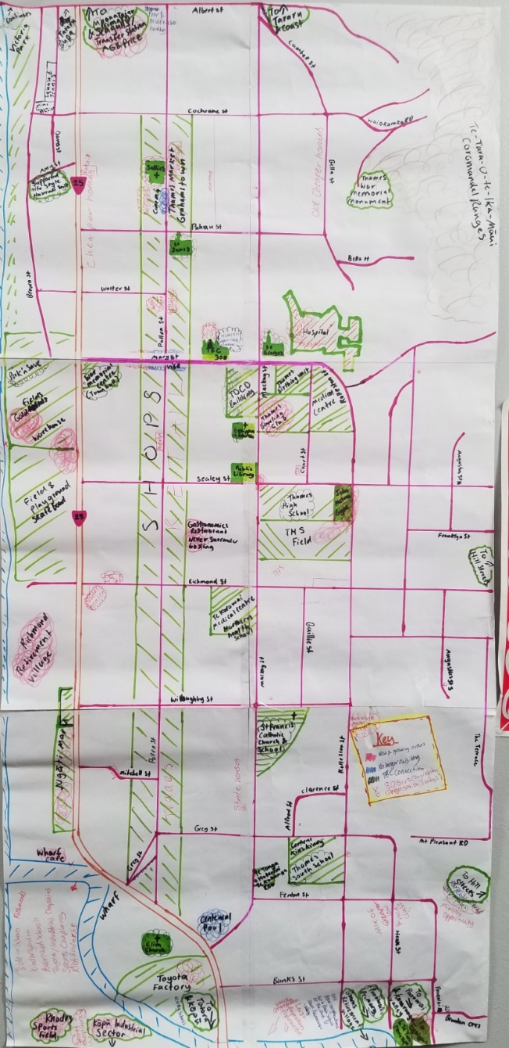

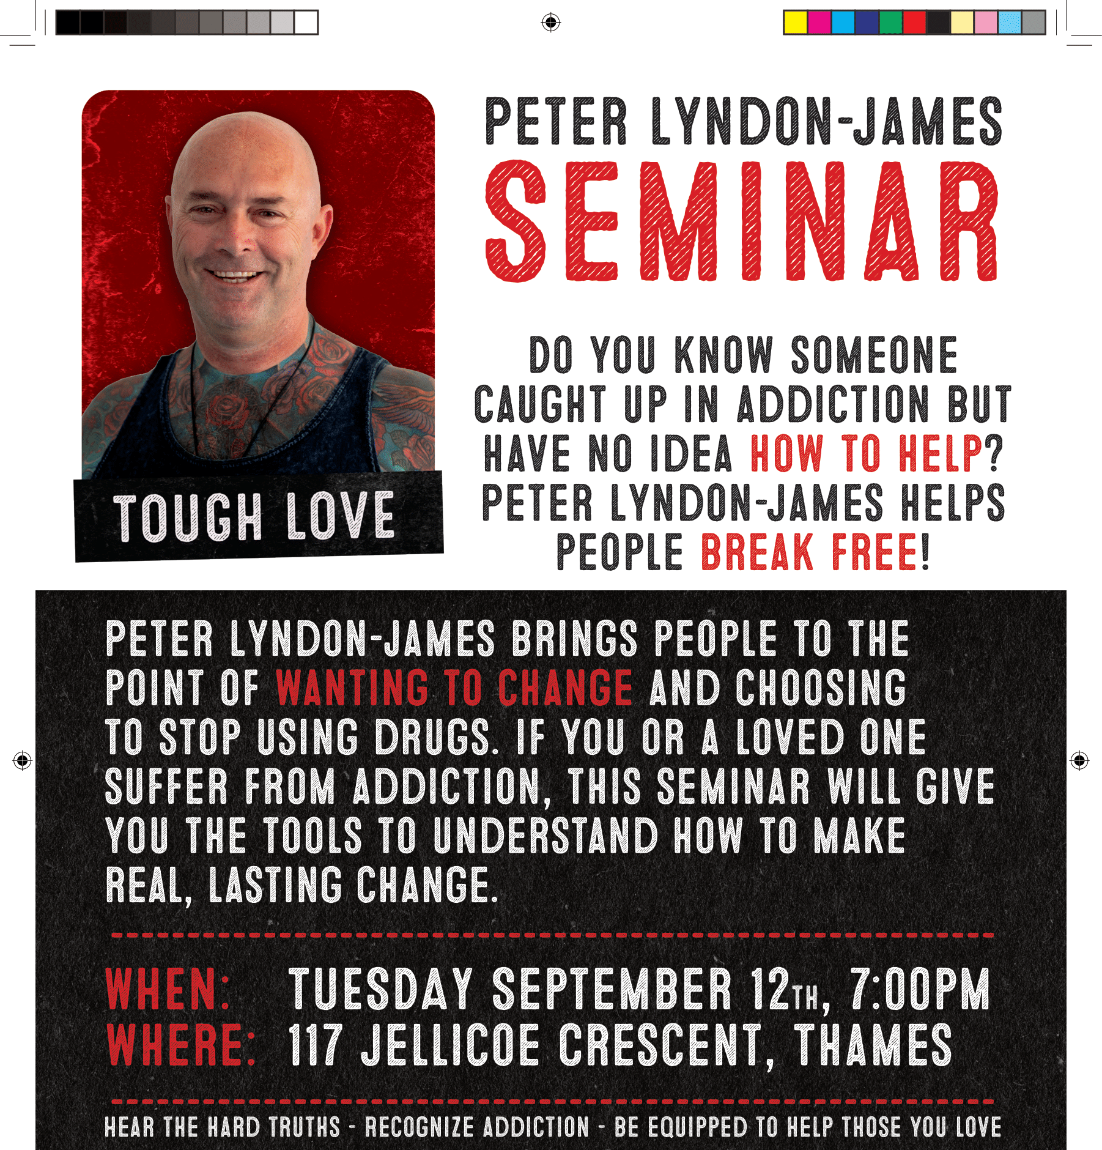

------------------------------------------------------
From Amy Callaghan – in India

Prayer requests
Pray for our maternity ward to re-open without delay once the obstetrician arrives.
Pray that our eye department will establish regular patients and news will grow in surrounding areas.
Pray that we can connect with local town people through community health talks that I would like to begin.
Pray that staff here will be refreshed and reinvigorated by His Spirit to love and serve these people joyfully.
Pray that income will increase so staff salaries can resume.
Pray that the persistent swelling in my knee will go.

May the Lord bless you and keep you, and make His face shine upon you and give you peace. Go in grace! –Amy

Her full newsletter is on the Missions noticeboard in the Lounge
--------------------------------------------------
Te Tapui Loop walk
Saturday 16 September
Meet 8.15am outside Thames Baptist Church
Join us for a walk in peaceful mature forest on this old volcano in Richmond Downs, Matamata. You can either walk to the lookout tower at the summit for 360 degree views or enjoy a shorter walk in the bush and return to the cars. The countryside is beautiful rolling green farmland and worth a drive through, with views stretching back to the Firth of Thames. Loop takes 3-4 hours return with lunch included. We will drive through sleepy Walton on the way.
Bring: Morning/Afternoon tea and lunch, Drink, jacket, walking shoes/boots and a contribution to petrol costs. (No shops on this trip).-From Frances Hellendoorn
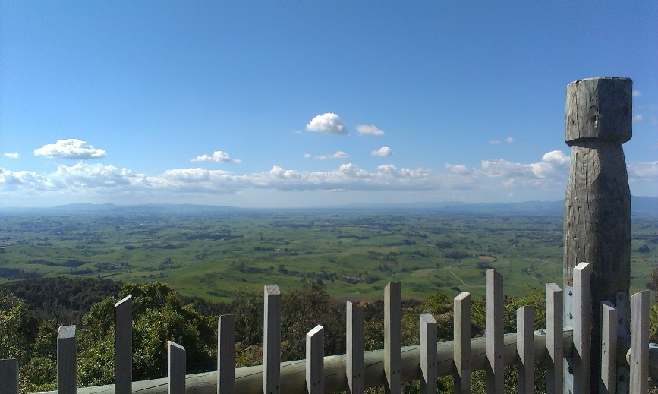

----------------------------------------------------
The Global Mission Prayer Group

Formerly known as Baptist Missionary Fellowship (BMF) is restarting and is looking for new people to join them in the monthly prayer time. They are considering changing the day and time to suit others. Please contact Elizabeth Jones if you are interested.
----------------------------------------------------


