 Pastoral letter #16
Rosters
7 May Greeter Marion & Sarah
Sound Bernard
Computer Terri
Morning Tea Betty & Judith
Worship leader Shaz
Kidzone Frances McL & Glen
Communion Elizabeth
----------------------------------------------------
What’s on this week (Wednesday 3rd to Tuesday 9 May)

Wednesday 3rd 10am Women’s Group @ Church
2pm Home group @ church
Thursday 27th 9.30am Intercessors group in our church auditorium
Sunday 30th 9.30am Pre service prayer in 305
10am Worship service
Tuesday 2nd 10am Tararu home group
Midday Tasty Tuesday
---------------------------------------------------------
What a wonderful weekend last weekend!

The Heritage night organised by Frances H and Elizabeth was great. We prayed for Christians in countries where there is persecution and then heard the stories of the 20 people who attended, of their forebears. Sunday morning service on the Parables was great.
And Sunday evening Combined Service was a real Holy Spirit event. So powerful. Over a 100 people attended from the churches in town and from 305.
Morning of Prayer and Reflection - May 12

These mornings provide a place to step aside from our normal busy schedules to better see what God is saying and doing in our lives. They provide opportunity for refreshment so that we may be better enabled to reconnect with our worlds.The meetings usually start with a led reflection/prayer around a ‘theme’ and then there is time for individual interaction with this through journaling or using the creative activities provided. A handout is available to aid reflection.
Time: 9:30am - 12pm Venue: Saint James, 82 Nixon St, Hamilton East
Cost: $10 appreciated
BYO journal, Bible. Morning tea provided.
Registration: Jan Sampson (027) 480 5188 or spiritualdirector3@gmail.com
If you would like you are welcome to bring your lunch and join me after our morning together.. Caroline attends this, if you want to join her.
----------------------------------------------------------
Anyone have a spare Smart TV?
Kidzone would like a Smart TV for their room so they can get onto the Internet for songs and activities. Has anyone got a spare one lying around?
----------------------------------------------------------
Considering doing study at Carey College?

Open Day Tuesday 23 May 9-3 and an online open evening zoom Tuesday 6 June 7.30-8.45pm
---------------------------------------------------------
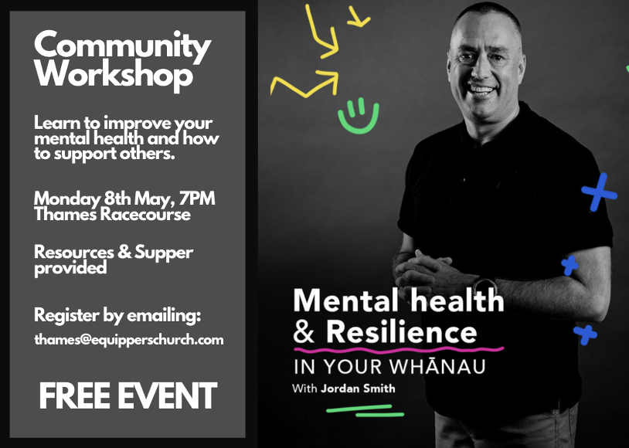
Thames Equippers Church is hosting a free mental health workshop, aimed at helping families and those working with people, to know how to support people with their mental well-being.

(Note: The content is suited for the carer, or the professional involved in supporting individuals, a certain level of mental well-being and capacity is needed to engage with the content).
---------------------------------------------------------------
Home groups and activity groups

Tararu 10am Tuesday weekly at Elizabeth Jones’ (Jenny)
Lifestylers 2pm Tuesdays weekly at Peter Moyes’ (Lynette)
Coast 7pm Tuesdays fortnightly at Betty Holmes’ (Colin)
Hikutaia 7pm Tuesdays fortnightly at Shaz & Bernards (Puriri) (Shane)
Hillbillies 7pm Tuesdays fortnightly at various (Chris)
Womens knitting 10am Wednesday weekly in the Church Lounge (Kathie & Pam)
Wednesday 2pm Wednesday weekly in the Church Lounge (Chris)
Intercessors 9.30am Thursdays weekly in our church auditorium (Colin)
--------------------------------------------------------
Have lunch with someone after church

We all eat lunch so why not invite a couple (or person) you do not know home to share your meal after church. If you don’t trust your cooking skills, take them to lunch in a café after church.

St. John of the Cross, put it this way: “A soul which remains alone…is like a burning coal which is left by itself: it will grow colder rather than hotter.”
----------------------------------------------------------
New People Lunch

Every so often, the Elders put on a lunch for people new to the church to them to get to know us and vice versa and to understand our church, its vision and so forth. There are no hooks, just a free lunch and conversation. The next one will be on Sunday 21 May after church. If you have not attended one of these (and we have not had one since COVID hit on 2022), let me know and I will add you to the invitees.
----------------------------------------------------------
The Family Heritage Dinner

During Your Family Heritage Dinner we listened to stories of courage, tenacity faith and a diversity of human experience. We got to know each other in a way we would not have done if we had not stopped to listen. From Colin's McLaren clan having brawls outside the church if the pecking order of being seated in church was disturbed, to Herman's father who told a story of a man with a glass eye leaving it out in the field so that the farm workers thought they were being watched, to Lynette's Great Great Grandmother Susannah, who married four times, including being the wife of a Wesleyan Missionary to the Manipoto people in the 1840s – Frances H

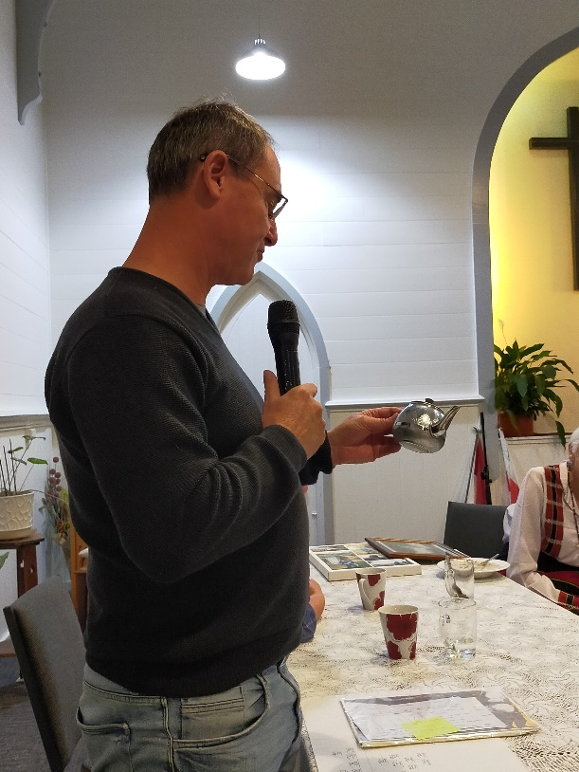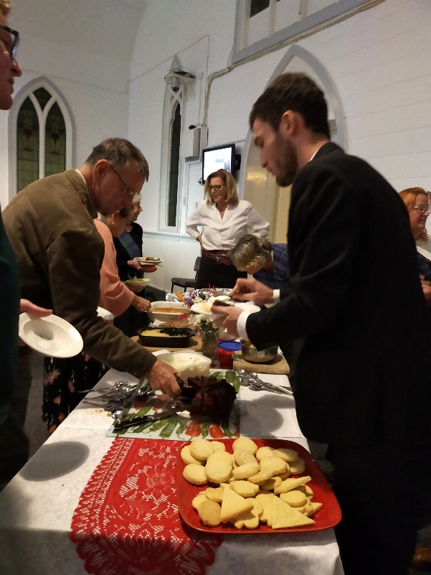



Bangladesh heat wave
Please pray for the people of Bangladesh who have been experiencing a heat wave - one day was as high as 40.6 C. Pray for those most vulnerable who don't have a place to shelter or seek help. Pray for the heat to relent.

Peter & Dasha (East Asia)
I have been running a weekly music-recording-skills workshop for two friends from our Sunday club who are doing their own recordings. Pray that this would be a great time of joy, community, and connection.

TTC graduates
Thank God for the graduating Tripura Theological College class of 2023. Please pray for their next steps, that Jesus would be close in his friendship and guidance to each of the graduates. Pray for doors to open in the right direction.

Woven Life Foundation
During April, Dtom held a TeenStar course for 10 girls aged 8 to 13 years old in a small village in the Kalasin province. TeenStar is a sexual and reproductive health course that introduces pre-teen girls to the changes their body will go through during adolescence and how best to care for themselves and keep themselves safe during this time in their lives. The children on the course were excited to learn about the changes they are, and about to experience and to understand more about some of the risks from those who might seek to take advantage of them. They were keen to learn more. Pray that this course would continue to grow in its reach.
-----------------------------------------------------------------


