 Pastoral letter #12
Rosters
7 April Greeter Des & Mercia
Good Friday Sound Bernard
Computer Sarah
Morning Tea Dawid & Antjie
Worship leader Lynette & Chris
Kidzone NO
Communion
9 April Greeter Philip & Diane Watson
Easter Sunday Sound Lisa
Computer Terri/Nicole
Morning Tea Phil & Diane Pawley
Worship leader Josh
Kidzone No
Communion No
----------------------------------------------------------
What’s on this week (Wednesday 5th to Tuesday 11th)

Wednesday 5th 10am Women’s group in the Lounge
2pm Home group @ church
Thursday 6th 9.30am Intercessors group in our church auditorium
Friday 7th Good Friday
9.30am Pre service prayer in 305
10am Worship service
Sunday 9th Easter Sunday
9.30am Pre service prayer in 305
10am Worship service
Monday 10th Public Holiday
Tuesday 11th 10am Tararu home group at Elizabeth’s
Midday Tasty Tuesday
2pm Lifestylers home group @ Peter Moyes’
----------------------------------------------------------
Home groups and activity groups

Tararu 10am Tuesday weekly at Elizabeth Jones’
Lifestylers 2pm Tuesdays weekly at Peter Moyes’
Coast 7pm Tuesdays fortnightly at Betty Holmes’
Hikutaia 7pm Tuesdays fortnightly at Shaz & Bernards (Puriri)
Hillbillies 7pm Tuesdays fortnightly at various
Womens knitting 10am Wednesday weekly in the Church Lounge
Wednesday 2pm Wednesday weekly in the Church Lounge
Intercessors 9.30am Thursdays weekly in our church auditorium
---------------------------------------------------------
Easter Services
10am Palm Sunday
10am Good Friday
Communion and Hot Cross Buns
10am Easter Sunday - He is risen
------------------------------------------------------------
Foodbank Needs
Sugar, Tinned Vegetables, Tinned Spaghetti, Tinned Fruit, Washing Powder, Packet Soup, Crackers, Milk Powder, Noodles
-------------------------------------------------------------
From Samanda
(In addition to her youth work, Samanda now coordinates the Holiday camps at the Christian camp)

Kauaeranga Valley Christian Camp is running Narnia Camp this school holidays April 11-14 and April 15-21.

Last week’s newsletter had a list of assistance (human resource and stuff) that Samanda would like for these camps.

1 NURSE/FIRST AIDER during 15-21 April.
2. Kitchen Help
3. MALE cabin leaders over the age of 16 during 15-21 April
4. General Help

-------------------------------------------------------------
Your Family Heritage Dinner
Thames Baptist Church
5.30pm Saturday 29 April

Dress in your family heritage costume.
Please bring a dish from your heritage.

A taonga/treasured possession to tell us about
eg. family tapestry/legend/Christening gown.

Email your heritage photographs to Levi for a slideshow during the dinner.
Levi Dyer levidyer20@gmail.com

Enquiriers to Elizabeth Jones 021 1709167
or Frances Hellendoorn 021 2805471

A bit of history

Frances H found a memoir from a man who was a 1 year old when the Baptist Church started in Thames, Billy Blomfield, dated May 31 1936. He describes many of the founders of the church (the ones for whom there is stained glass windows).
James Renshaw – a kindly hearted bald headed Sheffield man, with a heart for the worshippers good both spiritually and martially.
Mr Driver, thin stern and black bearded.
Major Murray who turned up one Sunday in full Scottish regimentals.
Mr Mason who toted bibles on his back to the miners up the hills. An old patriarch with staff in hand, and a long flowing white beard, a gentle loving soul
The Coopers from below Parawai cemetery, a patriarch who wore a comb in his long hair.
Mr Jones, the first minister, a kindly hearted earnest man, a bachelor.
And so on.
He described the flavour of the church as “Hard Shell Baptists”.

Ask Frances if you want to read the whole document.
------------------------------------------------------
What does Easter mean for us?

Sybe Haakma prepared a questionnaire asking what people think about the Easter story.
These are the answers from those attending Tasty Tuesday last week.
• What does his death on the cross mean for us in 2023, how does it affect us now? I feel sad that lots of people don’t know what it means for us.
• God gave his son for us. (He died on the cross for us).
• How many eggs do we get? Heaps
• The death of Christ
• The Romans were scared of his power. New beginnings
• The trial, arrest, crucifixion, burial. They were all uncalled for. They were scared of his power of the people. Easter eggs – new beginnings. Reminder of arrest burial, crucifixion. God is great.
• Good
• I love Easter. I think we’d do well with an Easter show.
• Celebration. Chocolates
• Hang out with family/friends. Jesus was birthday.
• Why couldn’t God bring us back in a less painful way for Jesus? Such a show of love.
• If another church would like to do a lunch here like the ones that are here. Would you? It’s lovely here, very friendly and kind and the food is always lovely to eat and healthy too.
• Is there anybody out there?
(And 4 blank ones put in the responses box, so they could get the Easter egg!)
--------------------------------------------------
Have lunch with someone after church

We all eat lunch so why not invite a couple (or person) you do not know home to share your meal after church. If you don’t trust your cooking skills, take them to lunch in a café after church.

To a great extent, what matters in our approach to people is not just what we do, but how we do it, and when - Dallas Willard

From Ngāruawāhia Baptist Church (the new church plant which has benefited from our pews)

Their first Baptism service in the mighty Waikato river on Sunday. Stewart Best (Pastor) writes: "This young man came to see me recently with his dad and shared how he had been praying in his bed and God clearly told him it was time to be baptised. His dad joined us in the river, and it was a special time, check out the joy on his face. No doubt the Holy Spirit was at work here..."

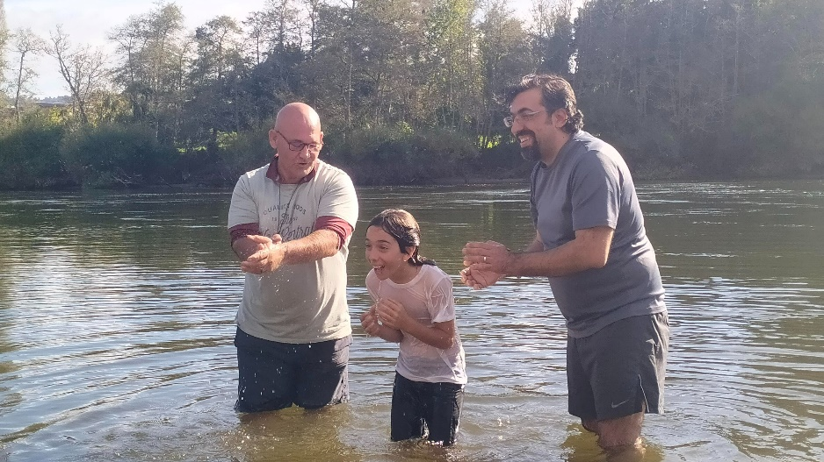
--------------------------------------------------------
David and Jan Kitchen

David and Jan are moving mid-April to Te Anau to live. They will be missed. They have been stalwarts of this church and are our eldest couple. They have been very active in the life of the church, both here and in Hillcrest Baptist. David has been an Elder and Property Deacon. Their wisdom and godly lives has been an example to us all and they are much appreciated.

We are having a potluck lunch after church on Sunday 16th April to farewell them. If anyone would like to contribute to buying a farewell gift, please see me.
--------------------------------------------------------
Updates from our Mission agency Arotahi

Peter & Dasha (East Asia)
We have been spending some more time with people who have made the decision to follow Jesus. Please pray for our Sunday group and these new people, as we are discipled together.

Youth at Easter Camps
Thank you God for every single one of the thousands of youth who are at an Easter Camp this weekend. Thank you that you love and want to commune with each one of them deeply. Lord, we pray for your Spirit.

