
Pastoral letter #29
Rosters
20 August Greeter Bronwyn & Shane
Sound Donald
Computer Joe
Morning Tea Betty & ???
Worship leader Josh
Kidzone Rose & Foster
Communion Gael
----------------------------------------------------
What’s on this week (Wednesday 16 August to Tuesday 22 August)

Wednesday 16th 10am Women’s Group @ Church (lounge)
2pm Home group @ church
7pm Worship leaders planning meeting
Thursday 17th 9.30am Intercessors group in our church auditorium
12.15pm New believers’ group
Sunday 20th 9.30am Preservice prayer in 305
10am Worship service
Midday Full team worship practice and lunch
POTLUCK LUNCH FOR OLLIE’S BIRTHDAY IS CANCELLED
Tuesday 22nd 10am Tararu home group
Midday Tasty Tuesday
2pm Lifestylers home group
7pm Hill billies home group
7pm Coast home group (with meal at 5.30pm)
--------------------------------------------------------
Pastoral Visiting Team

Lynette Mill, Helen Whittaker, Bev Gibson, Elizabeth Jones, Des and Mercia Barton and Brent and Berwyn Mason. If they visit you, they are visiting on behalf of the church.
------------------------------------------------------
Baptism

We are having a baptism service on Sunday 27 August. “Come on in, the waters fine”. If you have been considering baptism and are thinking of taking the next step, see me before then.
--------------------------------------------

Quiz on 27th after lunch

Shaz has prepared a fun afternoon of a Quiz time. Shared lunch then quizzing. All welcome, Invite your friends
----------------------------------------------------
Spare walker

Does anyone have a spare walker (zimmer frame) that they are not using that we could keep at the church for those with mobility issues. We have a wheel chair but a walker would be useful too.
-----------------------------------------------
Daily Bible Verse

Since I upgraded my phone, I don’t seem to be able to do the multiple recipients texts. Until I sort it out, sorry nothing from me each morning.
-----------------------------------------------
Sound techs and Computer operators for Sunday worship services

With Lisa now in Romania, Levi heading to Brazil and Sarah heading back home to Germany this month, we need more people to do the “back of the room” stuff which makes the worship services flow. Training will be given.

---------------------------------------------------------
More Night services?

It was suggested at the last Elders meeting that we have our 5pm night services fortnightly rather than once a month, but in order to do that, I need people who are able to give a short testimony or homily or sermon. There is so much life experience and church experience in this congregation that I would like to tap into. If you think that is you, can you let me know please.
--------------------------------------------------------------
Home groups and activity groups
Tararu 10am Tuesday weekly at Elizabeth Jones’ (Jenny B)
Lifestylers 2pm Tuesdays weekly at Peter Moyes’ (Lynette)
Coast 7pm Tuesdays fortnightly at McLaren’s (Colin)
Meal at 5.30pm
Hikutaia 7pm Tuesdays fortnightly at Shaz & Bernards (Puriri) (Shane)
Hillbillies 7pm Tuesdays fortnightly at various (Chris)
Womens knitting 10am Wednesday weekly in the Church Lounge (Kathie & Pam)
Wednesday 2pm Wednesday weekly in the Church Lounge (Chris)
Intercessors 9.30am Thursdays weekly in our church auditorium (Colin)
New Beginnings 12.15pm Thursdays weekly in church lounge (Shaz & Chris)
-------------------------------------------------------

The Hillbillies homegroup farewelled Sarah Tefehne at their last meeting with a pot luck meal and a quiz organised by Noel Suckling.

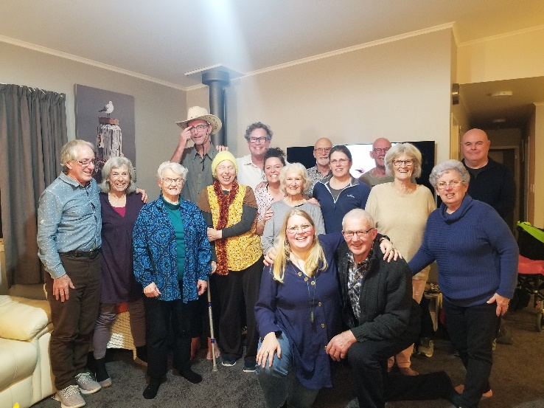
Notice the beam of light descending on Herman! What does it mean?


The winner of the quiz became the cowboy and the loser became the horse.
Looking for suitable caption for this picture. “Just horsing around”, a “neighsayer”. Any better ones. Chocolate fish prize.
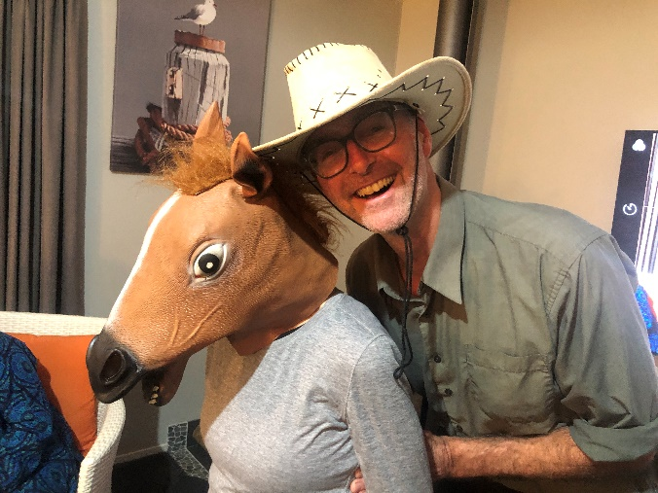



At Elim Church

LWT news

Welcome to Lieneke, our new p/t Youth Worker.

Thames Foodbank thanks you for your support. We are still requesting jars for repacking into. Food items needed:
Weetbix, instant coffee, tinned tomatoes, tinned pasta sauce, tinned sweetcorn, muesli bars.
--------------------------------------------------
