 Pastoral letter #1 2023
Rosters
22 January
Greeter Des & Mercia
Sound Bernard
Computer ???????
Morning Tea Colin & Frances
Worship leader Shaz
Kidzone Clipboards
----------------------------------------------------------
What’s on this week (Wednesday 18th to 24th December – Sunday 25th)

Wednesday 18th 2pm Home group @ church
7pm Worship Team leaders meeting
Friday 20th 9am Elders prayer retreat
Sunday 22nd 10am Worship service
6pm BBQ at Rose and Adrians
Tuesday 24th 5pm LWT Board meeting
7pm Hillbillies home group at Noel & Rae’s
----------------------------------------------------------
Church Phone Directory

We are about to publish the 6 monthly update of the church telephone directory. If you have changed any details in the last 6 months (name, address, phones) please let Diane in the office know. If you are not in the directory and would like to be, please let Diane know on admin@thamesbaptist.org.nz

Usually there is always someone who waits until too late to tell us. Don’t be that person.
----------------------------------------------------------
Home groups and activity groups

Please check with your facilitator as to start dates for the New Year.
----------------------------------------------------------
BBQ season

Anyone want to host our Sunday evening BBQ. People bring meat and salads and dessert, you just provide the venue. Rose and Adrian are hosting this Sunday.
---------------------------------------------------------
Scavenger Hunt and Dessert evening

Saturday 11 February 2023 starting at 5.30pm Church lounge
We will form teams and choose a crazy name for your team. The hunt will be in cars within the Thames township for 1 hour, arriving back at the Church lounge with the items, for prizes.
Please bring a dessert to share. This is an all age event. Bring your family and friends
What have our people been doing over the break?

Shane Dyer on the top of the world – Mt Ruapehu

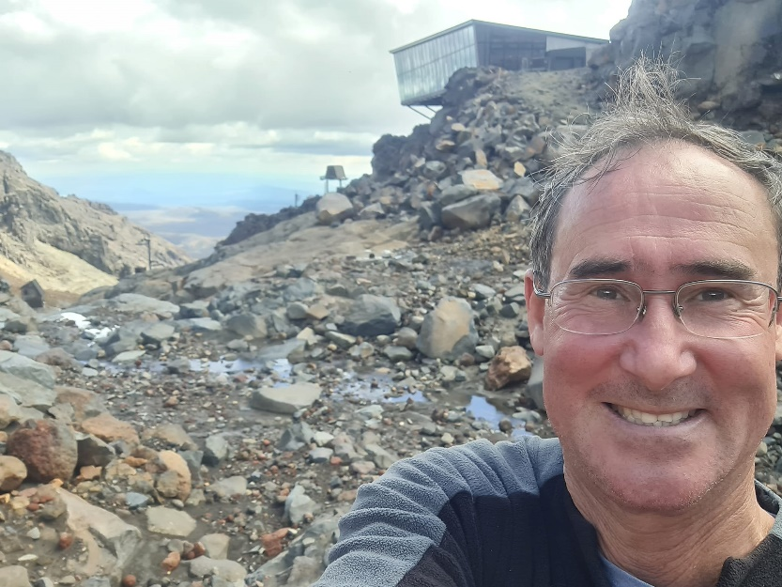

Frances McLaren paddle boarding

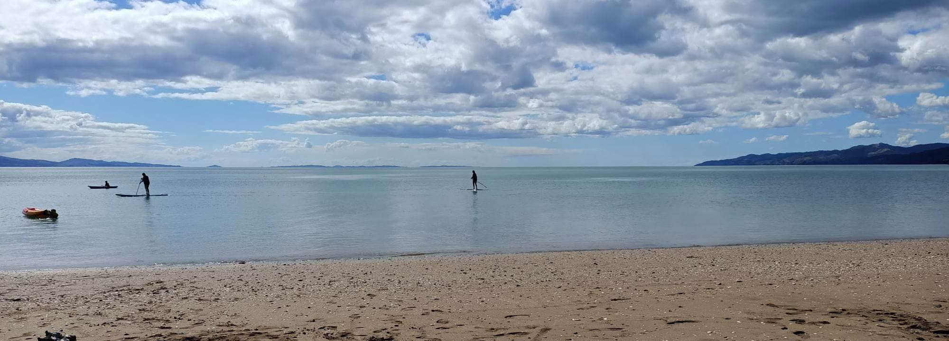

David Cooper chasing rogue sheep on his property

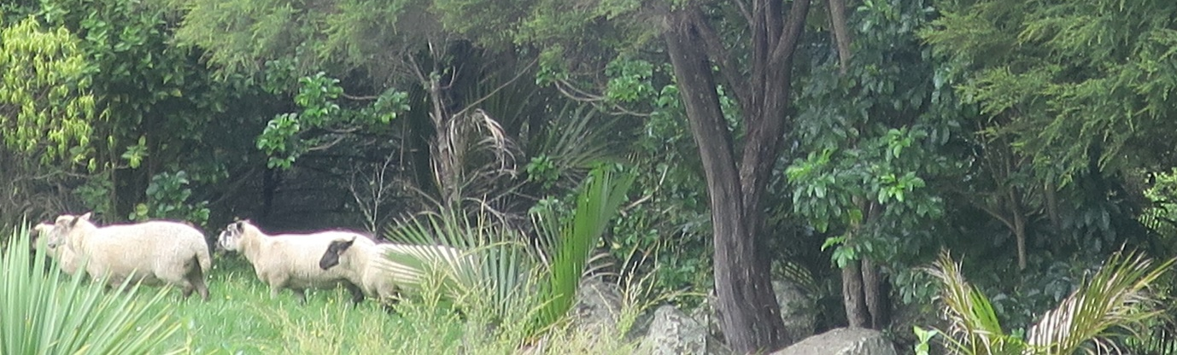

Me, eating different Christmas present food (from my granddaughter!)

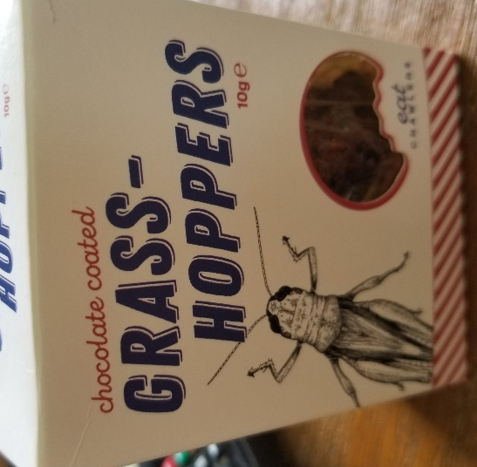
What have the rest of you been doing?
---------------------------------------------------------------
Have you started your daily devotions this year yet?

We cannot imagine not eating every day or drinking each day, yet we do not prioritise our time with God each day.
A quick sample of some on line devotionals to sample if you haven’t got one started yet.

Daily Devotions - In Touch
www.intouch.org/read/daily-devotions
Daily Devotionals - Today's Inspiring Bible Devotion
www.crosswalk.com/devotionals
Devotions Archive - Billy Graham Evangelistic Association
billygraham.org
Chuck Swindoll's 'Insight for Today' Daily Devotional Library - I…
insight.org
Daily Hope with Rick Warren - Devotional - Pastor Rick's Daily …
pastorrick.com
Joyce Meyer Ministries - Daily Devo
joycemeyer.org
Daily devotionals from God's Word - Today Daily Devotional
today.reframemedia.com
Daily Devotional Calendar | Today in the Word
www.todayintheword.org

Or the Lamp Christian bookshop has plenty.

There are a couple of very nice ones in our Church Library too:
The Bible in 366 days for Men by Angus Buchan
Daily Marriage Builders for Couples by Fred & Florence Littauer

It is incredible to think that Almighty God speaks to us through his Word, yet we casually skim the Bible before racing off to our first appointment!
Hearing God’s Voice by Henry and Richard Blackaby
-----------------------------------------------------------

Elders Retreat this Friday

Every year around this time the Elders get together on a retreat dedicated to hearing from God about what He wants us as a church to focus on and to strive to do in the coming year. On Friday, the Elders (Shaz, Diane, Colin and I) are meeting at Puriri to discern the will of God.
Please pray that we will hear clearly what He has to say to the church.
---------------------------------------------------------
An Ecological Examen for 2022

The Examen is a call – a personal invitation to take time to reflect from the deep place of your heart. This personal invitation is about deepening our relationship with God in every aspect of our life. Our relationship with God takes time, and in that relationship, we’re called to conversion – to a change of mind and heart. The beauty of the Examen is that it takes repetition and time to go into the depth of our heart, to develop a more personal and intimate relationship with God, in whose image and likeness we have been created.

As we begin to review the year, Invite the Spirit to guide you as you enter into the ‘Silence and Surrender to this time of Stillness.’

Begin by expressing gratitude as you recall those moments, throughout the year when you have consciously been aware of and enjoyed being part of God’s creation, wherever the year may have taken you.

Ask for the grace and insight to see creation as God does. Where have you been most aware of God’s presence in your environment as you begin reviewing your year?

Take time to review, and come to a greater understanding, by acknowledging the challenges and joys you may have experienced, as you recall how you cared for the gift of creation in various contexts throughout the year. Especially notice if you have been drawn towards God or away from God and notice how this may have affected your actions and your responses at the time.

In response to this new insight, notice what needs further loving attention to develop a greater appreciation of relationship with creation in my environment. How can I address these in some small way – in my family and community?

In moving forward into a new year, I ask for the grace to reconcile my relationship with God, creation, and humanity – to hear more deeply the ‘cry of the earth and the poor.’ How can I improve my attitude towards my relationship with creation and make consistent choices to bring about change in my life – no matter how small – for a better world?
----------------------------------------------------------------

