 Pastoral letter #24
Rosters
16 July Greeter Shane & Bronwyn
Sound Bernard
Computer Sarah
Morning Tea Suze & Andy
Worship leader Lynette/Chris
Kidzone School Holidays
----------------------------------------------------
What’s on this week (Wednesday 12 July to Tuesday 11 July)

Wednesday 12th 9.45am Coromandel Pastors Cluster here
10am Women’s Group @ Church
2pm Home group @ church
Thursday 13th 9.30am Intercessors group in our church auditorium
Midday New believers group
Friday 14th Matariki holiday
Sunday 16th 9.30am Pre service prayer in 305
10am Worship service
Tuesday 11th 10am Tararu home group
Midday Tasty Tuesday
2pm Lifestylers home group
--------------------------------------------------------
Pastoral Visiting team

There are more than 86 couples/families/singles associated with our church through our Sunday worship or our mid-week events or 305 regulars. I am looking for a team of people who could help me in making sure that we visit these people regularly.
If you have a compassionate heart and a confidential mind-set and would like to be part of this team, can you let me know please?
--------------------------------------------------------
LWT and Foodbank

Data for May 2023 - Food Parcels – 48 (feeding 139 people) – 80 adults and 59 children
Data for June 2023 - Food Parcels – 39 (feeding 101 people) – 68 adults and 33 children
Thank you for all your support for the Thames Foodbank.

Our work is going well, with people enjoying coming for breakfast and a social connection, which we know is very important. Foodbank is busy too but we still have some needs: sweet biscuits, instant coffee, chippies, tinned or packet soup, Marmite, sanitary pads and tampons.

Special Guest

World Vision’s Julia Grace will be speaking and playing at our worship service on Sunday 30 July

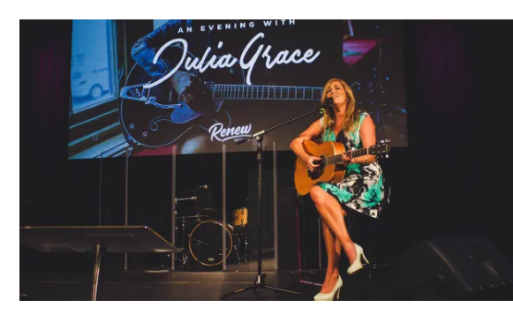
Julia Grace is a Tui-award winning gospel singer/songwriter. A renowned mental wellness advocate who speaks on crisis, anxiety and stress, there has never been a more important time to hear the message of hope that Julia Grace brings. Hope that change is always possible, in our lives and in our world.

Invite your friends to come with you.

Baptist National Hui 2023

It is happening in Manukau City this November. Join us for three days from 2 – 4 November 2023. (Optional pre-hui events will take place on Wednesday 1 November). When arranging travel to Auckland, please consider that Hui will begin with check in from 9:00 - 10:15am on Thursday 2 and conclude at 4:30pm on Saturday 4 November (please note CHANGE in FINISH time). Early Bird Registrations for National Hui open on the 7 August
---------------------------------------------------------

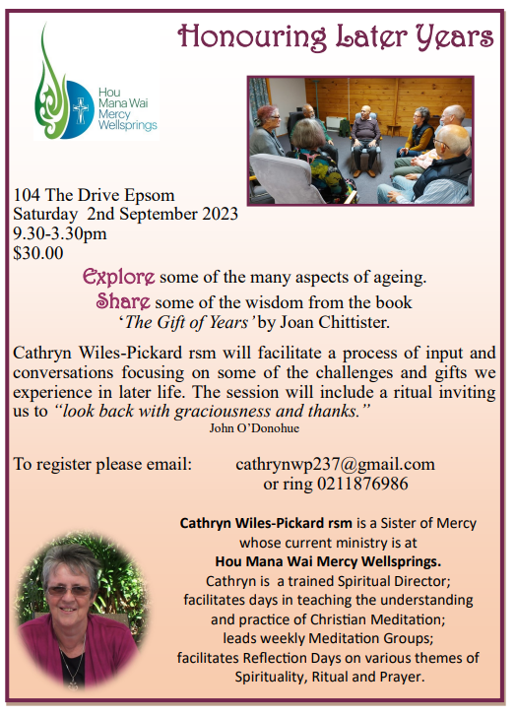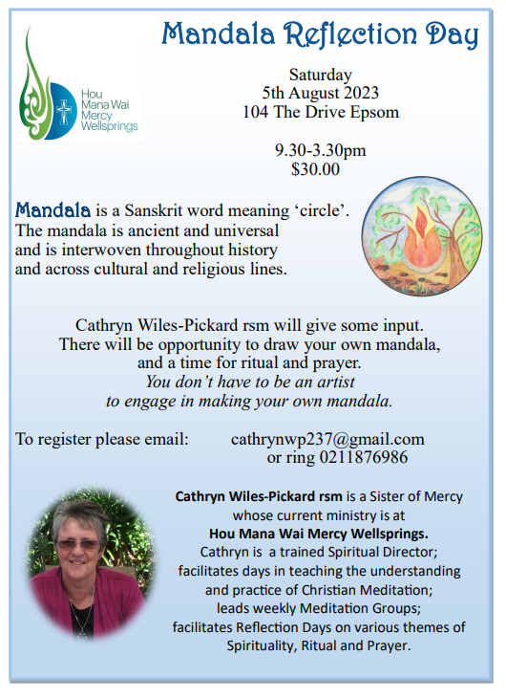

Church Outing

YOU ARE INVITED to a church outing:
Saturday 22 July

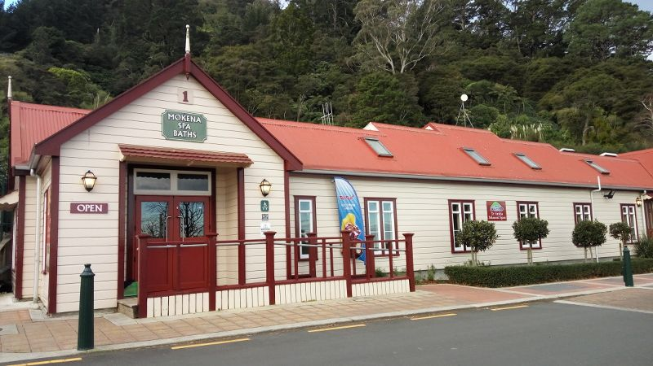

Meet 12.30pm Thames Baptist Church to travel to Te Aroha No. 2 Thermal Bathhouse / Outdoor Spa pool and heated swimming pools (Changing rooms are heated and have showers).
and Domain Cottage Cafe and Wetlands walk or Bush walk if too wet.

Bring: Swimming togs, walking shoes
Costs up to $11 for pool complex
Donation for petrol if car pooling
Cafe costs or bring your own afternoon tea

Enquires to Frances Hellendoorn 021 280 5471
Email: yellowflowerathome@gmail.com
---------------------------------------------------
Mission Support

Levi is fundraising to 'dip his toes' over in Brazil to see whether God is wanting him to serve there long-term. He would be very grateful for any prayer, finance or practical support in fundraising. One practical support would be if anyone has card materials, or photo paper that he can print his photograph on to sell at the Saturday market. Or they could kindly donate to:
KiwiBank L J DYER 38-9019-0098352-02
--------------------------------------------------------
Home groups and activity groups
Tararu 10am Tuesday weekly at Elizabeth Jones’ (Jenny B)
Lifestylers 2pm Tuesdays weekly at Peter Moyes’ (Lynette)
Coast 7pm Tuesdays fortnightly at Betty Holmes’ (Colin)
Hikutaia 7pm Tuesdays fortnightly at Shaz & Bernards (Puriri) (Shane)
Hillbillies 7pm Tuesdays fortnightly at various (Chris)
Womens knitting 10am Wednesday weekly in the Church Lounge (Kathie & Pam)
Wednesday 2pm Wednesday weekly in the Church Lounge (Chris)
Intercessors 9.30am Thursdays weekly in our church auditorium (Colin)
New Beginnings 12.15pm Thursdays weekly in church lounge (Shaz & Chris)-------------------------------------------------------

