 Pastoral letter #6 2023
Rosters
26 February Greeter Shane & Bronwyn
Sound Bernard
Computer ??????
Morning Tea Betty & Doris
Worship leader Chris & Lynette
Kidzone Keri & Mercia
----------------------------------------------------------
What’s on this week (Wednesday 22nd to Tuesday 28th)

Wednesday 22nd 10am Women’s group in the Lounge
2pm Home group @ church
7pm Church Council meeting
Thursday 23rd 10am Intercessors group in our church auditorium
Sunday 26th 10am Worship service
Midday Full worship team lunch and practice
6pm BBQ at Donald & Kathies
Tuesday 28th 10am Taruru home group at Elizabeth’s
Midday Tasty Tuesday
2pm Lifestylers home group at Peter Moyes.
5pm LWT Board meeting
----------------------------------------------------------
Our Guest speaker on Sunday 26th

Samuel Lalduhsaka
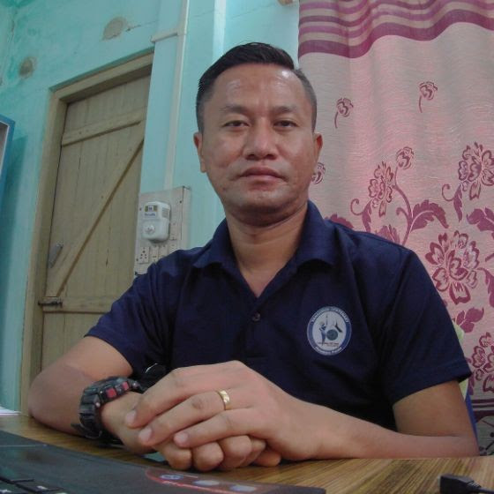

The Principal Lecturer at Tripura Theological College for the last 15 years
Flood relief

Some churches have asked about financially contributing to flood relief. The Waikato Association has set up this following account.

Waikato Baptist Association 03-0314-0224517-00
Please write “flood relief” as a reference

As far as we know there is no significant needs in our region but lots on the motu. If you want to contribute, then we will make sure it goes to churches - people that are in need.

Ranui Baptist from West Auckland was very efficient in providing aid to people in need in their area, and have been asked if they can help in the Hawkes Bay. They will need extra volunteer helpers of anyone is keen to help. Let me know so I can pass it on to the Regional Leader.
--------------------------------------------------------------------
Lent

Starts on 22 February and goes to Easter. But many will not know its significance as it is not practiced in many Protestant churches.

Lent is the Christian season of spiritual preparation before Easter. In Western churches, it begins on Ash Wednesday. During Lent, many Christians observe a period of fasting, repentance, moderation, self-denial, and spiritual discipline. The purpose of the Lenten season is to set aside time for reflection on Jesus Christ—to consider his suffering and his sacrifice, his life, death, burial, and resurrection.

In the past we have 40 acts of generosity as part of Lent https://40acts.org.uk/
We are not doing it this year as a church but I suggest that you consider registering as an individual and do it as a way of giving out during this time.
-----------------------------------------------------------------
Prayer and Fasting event

The Intercessors Group have planned a prayer and fasting time from 28 Feb to 3 March, from 5pm to 7pm each night during that time in the church auditorium. Opening each night with worship led by Beattie.
All welcome.
----------------------------------------------------------------
Scavenger Hunt last Saturday

Thank you Levi and Frances H for organising a great night. 6 teams competed in hunting for the weird items needed. Lots of laughter and competitiveness, especially when it came to poor Levi rating the finds.

The overall winners were the Wanhills, going under the flag of the Underhills, with their roadkill possum and deceased Oyster Catcher winning the most disgusting category.

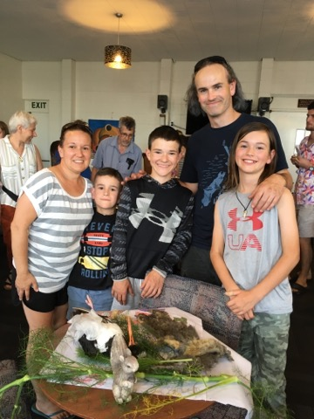
More Computer operators needed for Sundays

Terri and Nicole have carried the burden of operating the computer on Sundays for the last 12 months and we need to train new people to help out. Contact me if you are willing.
-----------------------------------------------------------
Worship team all teams practice and lunch

Sunday 26th after church. Bring a plate to share. For musicians, singers and sound team.
If you are interested in any of these roles and not currently involved, you are welcome to attend.
----------------------------------------------------------
Rosters for Morning Tea and Greeter

After years of faithful service, Bev has given up the role of organising these rosters, and the task will now be done by the church office (Diane and Phil). If you are interesting in being on either of these rosters, please contact them on admin@thamesbaptist.org.nz

If are currently on rosters, can you confirm your availability too please. So far I have had only 2 people reply to this. We need to publish a new roster for NEXT WEEK

We are trying to coordinate the various rosters (Kidzone, worship and MT/Greeter) so we do not have the same person doing multiple tasks on the same day).
---------------------------------------------------------
Home groups and activity groups

Tararu 10am Tuesday Elizabeth Jones’
Lifestylers 2pm Tuesdays Peter Moye’s
Coast 7pm Tuesdays fortnightly at Betty Holmes’
Hikutaia second week of the school term – looking for more people to attend
Hillbillies 7pm Tuesday fortnightly check with changing venues
Womens 10am Wednesday in the Church Lounge
Wednesday 2pm Wednesday in the Church Lounge
Intercessors 9am Thursdays our church auditorium
The rest of the BBQ season hosts

5 March Peter and Keri
12th Evening service
19th ????
26th ????
If you need a ride or worried about coming by yourself, ask someone to come with you or take you. Everyone welcome
----------------------------------------------------------
Pre-service Prayer

Before COVID (BC) we used to have a pre service prayer meeting in 305 every Sunday at 9am.
We need prayer covering for our services and it would be great if people could come a little earlier than 10am to pray.

It is a very dangerous thing not to pray because it means you depend on yourself. Praying in itself is an act of trust in God. - David Lundy
-----------------------------------------------------------
Have lunch with someone after church

We all eat lunch so why not invite a couple (or person) you do not know home to share your meal after church. If you don’t trust your cooking skills, take them to lunch in a café after church.

God created us for love and not selfishness, for hospitality and not isolation, for generosity and not stinginess, for service and sacrifice, goodness and grace - Marva Dawn
---------------------------------------------------------------
Join a kōrero with Jay Ruka, the author of ‘Huia Come Home’, Dean of Taranaki Cathedral Church of St Mary and Director of Te Manu Hononga – Sir Paul Reeves Centre.

E oho! Te Tiriti o Waitangi and the church

Wednesday 22 March 2023, 12:10pm to 1:30pm

The huia — a metaphor for a conflicted history. Once the sacred guardian of New Zealand’s native forests, the huia was a symbol of the land’s unique beauty and spirituality. The rare bird’s tragic extinction in the early 1900s represents a shot to the heart of Aotearoa and is a potent metaphor for a country’s conflicted history. Using the story of the untimely extinction of the huia, Jay Ruka offers a fresh perspective on the narrative of Aotearoa; a tale of two cultures, warring worldviews, and the things we lost in translation.
Revisiting the early missionaries, the transformative message of the gospel, and the cultural missteps of the Treaty of Waitangi, Jay's book Huia Come Home invites us to reconnect with the unique story offered by the indigenous Māori lens. In relearning the history that lies in the soil of Aotearoa, we might just find a shared hope for the future and a recovery of national treasures once thought to be extinct.

This event will also be delivered using Zoom. You do not need to install the software in order to attend, you can opt to run Zoom from your browser.

Register if you’d like to join this talk online and we'll send you the link to use on the day.
https://dia-nz.zoom.us/webinar/register/WN_jp6Mr2x_QkOnkRUeDPlkDA#/registration
----------------------------------------------------------------
From John Tucker, Principal of Carey College

The Carey year is about to kick off on Monday the 27th of February and we’d love to see a whole lot more men and women learning and growing and being transformed through a season of theological study or ministry training. I believe that the Lord is calling a number of people in our churches into his harvest field, and that he wants them to be equipped for this work. It’s not too late.

Carey is the theological college and ministry training centre of the Baptist churches of New Zealand. We exist for you and your church. In partnership with Baptist churches across New Zealand, we offer a range of learning pathways, from church-based ministry internships, to pastoral leadership training, to Intermission (a one-year, full-time discipleship training experience for school leavers and young adults). And then there’s the option of part-time biblical study for those who simply want to grow in their understanding of the gospel and their place in the mission of God.

Most of these are available by distance. Your people don’t need to leave their church to learn through Carey. And for those who need financial assistance, we also offer a range of scholarships: https://www.carey.ac.nz/study/scholarships/. Our staff are Spirit-led teachers, world class scholars, with significant practical ministry experience. So everything is in place.

I’m praying that someone in your church would hear the Lord’s call, and start a journey of training that equips them for the work to which God has called them.
-----------------------------------------------------

