
Pastoral letter #37
Rosters
22 October Greeter Colin & Doug
Sound Bernard/Charleen
Computer Joe
Morning Tea Andy & Doris
Worship leader Shaz
Kidzone Frances H
----------------------------------------------------
What’s on this week (Wednesday 18 October to Tuesday 24 October)

Wednesday 10am Women’s Group @ Church (lounge)
2pm Home group @ church
Thursday 9.30am Intercessors group in our church auditorium
12.15pm New believers’ group
Sunday 22nd 9.30am Preservice prayer in 305
10am Worship service
Midday Full Worship team lunch and practice
Monday 23rd Public Holiday
Tuesday 24th 10am Tararu home group
Midday Tasty Tuesday
6pm LWT Board meeting
---------------------------------------------------------
Ian Brown Scholarship

Administered by the Waikato Baptist Association. It is up to 10,000 for study and can be shared amongst a few if required.
There maybe someone in sphere of influence who would benefit from this then feel free to pass it on. We are looking at how we can continue to develop young and emerging leadership amongst our churches.
See Chris for more details
----------------------------------------------------------
Statement from the Spiritual Directors International Board on Israel and Gaza

As a diverse and international organization, we know that SDI members and friends may be experiencing a wide range of emotions in response to the recent attack on southern Israel on October 7th and the assaults on Gaza that have followed.

As the Board of SDI, our hearts cry out at the unconscionable violence that is occurring in Israel. We decry the taking of innocent lives wherever and whenever it occurs. As human beings who recognize the value of life, what some of us call the spark of the Divine that we recognize in others, the murder of civilians, the rape, torture, and kidnapping of children, the elderly, or any person, are never justifiable under any circumstances. They are crimes against humanity.

We are in pain with Israel and the Palestinian people. There will be no victors here. We call on all parties to this conflict to abide by international laws and the Geneva Convention relative to the Protection of Civilian Persons in Time of War. While we know that this is a time for accompaniment and not fixing, we also pray for the gift of time’s span. A time where all parties may find a way through their unimaginable loss and heartbreak to a place where compassion and healing may manifest for those so long traumatized by ongoing violence.

Our hearts are with those who are in mourning, and we pray, each according to their own tradition, for the wellbeing of the children and elderly and all who are now hostages. We do not have answers, but as spiritual directors, companions, and guides, we can decry inhumanity and savagery, bear witness to the devastating pain engendered by the recent attacks, and accompany those who are suffering, in pain, and in mourning.

We hold you all in our hearts. If you are in pain, tell us what you need. We are here, we are in pain, we are with you, and we are listening.
--------------------------------------------------------------
Food bank Data for September 2023

Food Parcels – 49 (feeding 71 people) – 39 adults and 32 children
One foodbank recipient recently said “Thank you so much – it is really appreciated – you do a wonderful job.”
Thank you for all your support for the Thames Foodbank.
Items needed: Weetbix, milk powder, tinned tomatoes, tinned pasta sauce, tinned corn, soap.
All donations (monetary or goods) should now come into the Living Well Trust office or if anyone wants to make an online donation we can provide the details.
In addition, we also need more volunteers to help in running our drop-in centre (Open Door) for the community where we are able to provide a listening ear and a sense of community for our clients.
Potential volunteers need to contact me and I will talk them through what is involved.
If anyone wants to talk further about our work at Living Well Trust please see our website and Facebook page (below) or needs more information, please feel free to contact me.
Ngā Mihi
Caroline Talbot (Team Leader Community)
------------------------------------------------------------
This is how Thames Baptist Church & Community Ministries at 303/305 Mary Street, Thames 3500 performed on the Google Business platform in September 2023 compared to the previous month.

13 calls +30%
0 messages
58 people asked for directions +52%
20 website visits from profile -39%
183 profile views +5%
-------------------------------------------------------------
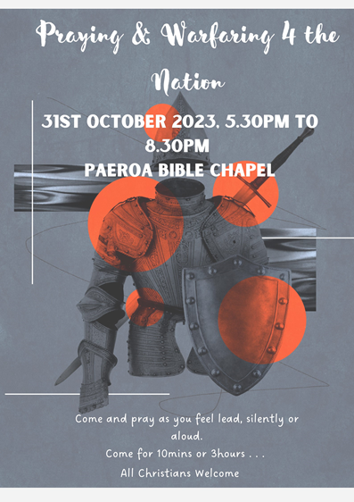

From Chris Cahill, President of the Police Association
In the latest newsletter:
“We know that crime does not exist in a vacuum. It has many drivers. For example, poverty, while not an excuse for crime, can’t be ignored, especially when it means ‘home’ is a crowded motel room in an unfamiliar community with no connection to a stable education for many children. The poverty cycle continues as people are locked out of choices. The NZ Herald reported children as young as 12 looking for work because they are not in school, raising the question, ‘what’s that 12-year-old going to look like when they are 16?’ “

Reading the NZ Herald article myself, it speaks of almost 10,000 kids from 5-16 years old who have been out of school for 20 consecutive days up to March this year. Our nation has a problem!
---------------------------------------------------------
Pastoral Visiting Team

Lynette Mill, Helen Whittaker, Bev Gibson, Elizabeth Jones, Des and Mercia Barton and Brent and Berwyn Mason. If they visit you, they are visiting on behalf of the church.
-----------------------------------------------------------
Home groups and activity groups
Tararu 10am Tuesday weekly at Elizabeth Jones’ (Jenny B)
Lifestylers 2pm Tuesdays weekly at Peter Moyes’ (Lynette)
Coast 7pm Tuesdays fortnightly at McLaren’s (Colin)
Meal at 5.30pm
Hikutaia 7pm Tuesdays fortnightly at Shaz & Bernards (Puriri) (Shane)
Hillbillies 7pm Tuesdays fortnightly at various (Chris)
Womens knitting 10am Wednesdays weekly in the Church Lounge (Kathie & Pam)
Wednesday 2pm Wednesdays weekly in the Church Lounge (Chris)
Intercessors 9.30am Thursdays weekly in the church auditorium (Colin)
New People Foundation group 12.15pm Thursdays in the church auditorium (Chris & Shaz)

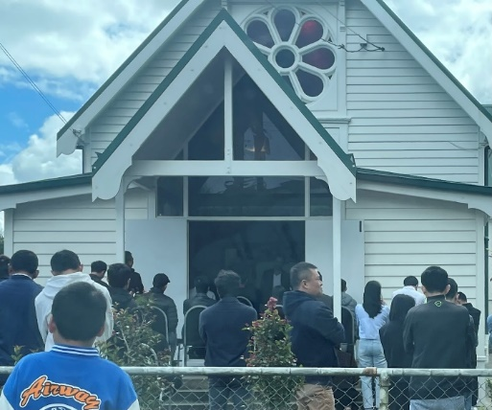
Our National Leader Charles Hewlett took this photo. “I had to take a photo of the church around the corner from me. Each Sunday there are so many people wanting to worship and celebrate communion they must sit and stand outside. May this be a problem for New Zealand Baptists!”

Hear, hear.
----------------------------------------------------------------
Thames Aglow

Next meeting at the old Church of Christ building in Parawai on Friday 28 October 10am – 12. Shared lunch. Speaker is Trevor Reith from Westside Church in Hamilton
-----------------------------------------------------------------
Coming Home

The initial meeting looking at Thames’ community response to addiction and homelessness was held on Monday 16th, chaired and introduced by Sonja Metz. A crowd of over 40 people attended. The churches were well represented as well as the Community Board, TCDC staff, MSD and the Manaaki Centre. Examples of how it has worked in other areas (or not worked) were presented and a very productive discussion took place, which will be followed up at the next meeting on 13 November at our church.

There is a lot of groundwork to be gone through, and people to be included including the possible clients of such a venture. Funding needs to be explored. One suggestion was that the new group could come under the LWT but the group is not in a position to address and present to the LWT Board on how our Trust could umbrella this, at this stage.
--------------------------------------------------------

