 Pastoral letter #9 2023
Rosters
19 March Greeter Des & Mercia
Sound Bernard
Computer Terri
Morning Tea Doris
Worship leader Shaz
Kidzone Frances H & Betty
----------------------------------------------------------
What’s on this week (Wednesday 15th to Tuesday 21st)

Wednesday 15th 10am Women’s group in the Lounge
2pm Home group @ church
Thursday 16th 9.30am Intercessors group in our church auditorium
Saturday 18th 10-11.30am Lamp Bookshop event
Sunday 12th 9.30am Pre service prayer in 305
10am Worship service
Tuesday 21st 10am Taruru home group at Elizabeth’s
Midday Tasty Tuesday
2pm Lifestylers home group @ Peter Moyes’
7pm Coast home group
7pm Hillbillies home group @ Hermans
----------------------------------------------------------
Home groups and activity groups

Tararu 10am Tuesday weekly at Elizabeth Jones’
Lifestylers 2pm Tuesdays weekly at Peter Moyes’
Coast 7pm Tuesdays fortnightly at Betty Holmes’ 7th
Hikutaia 7pm Tuesdays fortnightly at Shaz & Bernards (Puriri) 7th
Hillbillies 7pm Tuesdays fortnightly at Frances & Fosters 7th
Womens knitting 10am Wednesday weekly in the Church Lounge
Wednesday 2pm Wednesday weekly in the Church Lounge
Intercessors 9.30am Thursdays weekly in our church auditorium

“Without the small groups the church in urban society simply does not experience one of the most basic essentials of the gospel – true, rich, deep Christian soul-fellowship or koinonia.” - Howard Snyder, The Problem of Wineskins, church structure in a technological age
--------------------------------------------------------
From Our Regional Leader Peter Foster

Thank you so much to those people and churches who have gone out of their way to support the churches and people that are impacted by the cyclone. Amazing! We have received in total (to date) $19715.00. $500.00 went to Whitianga Baptist as their food bank took a hit over that time.
$9905.00 went to Gisborne Baptist. Gisborne are working closely with Salvation Army and with the Mayoral Relief Fund. Thanks so much Jim McIntosh for the work that you and your team are doing for the people of Gisborne and the East Coast. We still have $9310 to distribute - this will more than likely go to Gisborne Baptist. We will keep an amount to the side ($3500.00) in case some unexpected needs come up in the next while. After a time, we will then distribute this amount.

Awesome to see what is happening at Ngāruawāhia. The replanting of the church has gone well. Stewart Best is doing a good job along with the support of Hamilton Central and the Waikato Baptist Association. Their pews have come from Thames Baptist. Data projector from Te Awamutu Baptist. Sound system from Hamilton Central. Great to see churches helping each other out.

Been reflecting on Matthew 16:24-26 Then Jesus told his disciples, “If any want to become my followers, let them deny themselves and take up their cross and follow me. For those who want to save their life will lose it, and those who lose their life for my sake will find it. For what will it profit them if they gain the whole world but forfeit their life? Or what will they give in return for their life?
This passage came to mind as I read a book recommended to me by Craig Vernall ‘The Coddling of the American Mind’ In a world where we emphasis safety, rights, how I feel, subjective truth etc . How do we present this passage to those who would listen? Following Jesus is not safe. It is about sacrifice, denial of oneself and doing what Christ calls us to. I am so appreciative that Christ took up his Cross. Even through, as we read about him in the Garden of Gethsemane, he looked and asked if there was another way. He responded to the call because he knew that he knew. He lost his life for our sake. Just blows me away.
------------------------------------------------------------
Have lunch with someone after church

We all eat lunch so why not invite a couple (or person) you do not know home to share your meal after church. If you don’t trust your cooking skills, take them to lunch in a café after church.

“Within the bond of fellowship, we are inspired to have faith in the eternal unity of life”- Scott Walker ---------------------------------------------------------
Meet the Author Stephen Whitwell

STEPHEN WHITWELL has ministered with the Elim Church for 33 years and as Director of Studies at a large church Bible School. He writes a monthly e-letter, Brief WORD, which circulates worldwide. He has written and published personal study booklets, and his book ‘Heart Attack – Seven Lessons From A Near-Death Experience’ was released in June 2015. This came out of his near-fatal heart attack during 2014. He has a passion for helping people discover who they are, and for writing and speaking. He is married to Wendy and they have two adult children.

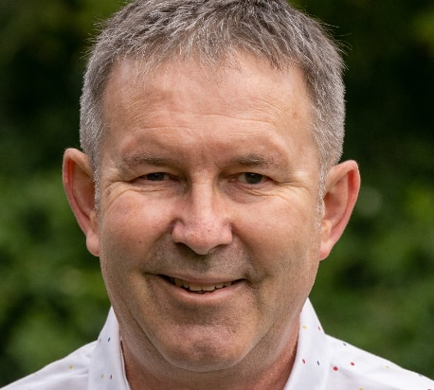

At the Lamp Bookshop on Saturday 18 March from 10-11.30am
RSVP by 13 March to Lisa 027228228. Light morning tea provided
-----------------------------------------------------------
Ramadan

The Islamic Holy month of Ramadan for the year 2023 starts on the evening of Wednesday, March 22nd lasting 30 days and ending at sundown on Thursday, April 20. Islamic holidays always begin at sundown and end at sundown the following day/days ending the holiday or festival.
Ramadan is the ninth month of the Islamic calendar. It is a month of fasting, prayer, giving and self-evaluation observed by Muslims. The month lasts 29-30 days depending on the sightings of the crescent moon.

Pray for Muslims during this time that they will meet the risen Jesus in their prayers. Jesus is not unknown to Muslims, the Quran refers to Jesus by the Arabic name “Isa,” but they deny his divinity.
--------------------------------------------------------
Baptist Magazine

The latest printout version of the Baptist is now on the lounge table for those who do not have access to the Baptist app or website.
-----------------------------------------------------------
Quote of the week:

“Externally focused churches are internally strong, but they are oriented externally… They build bridges to the communities instead of walls around themselves. They do not shout at the dirty stream; they get in the water and begin cleaning it up” -Rusaw & Swanson The Externally Focused Church
-----------------------------------------------------------
Foodbank needs

The following items are short in Foodbank: Jam, Breakfast cereal, Baked beans, Tinned spaghetti,
Sugar, Rice
-----------------------------------------------------------
Hope booklets

The Hope booklets will be here shortly and I need people who can walk the streets (not street walkers LOL) putting them in the letterboxes please.

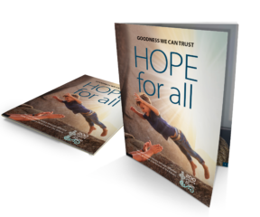
Cookie Day

Cookie Day held at Thames High School was amazing! Samanda our youth worker, Caroline our manager, Foster and Francis gave away cookies baked by the church/community to show the students that they have value. Students were really grateful for it and the school had a joyful atmosphere all throughout because of the act of kindness. Thank you to all those that baked the cookies.

