
Pastoral letter #40
Rosters
12 November Greeter Shane & Bronwyn
Sound Peter
Computer Joe
Morning Tea Betty & Judith
Worship leader Josh
Kidzone Frances McL & Foster
----------------------------------------------------
What’s on this week (Wednesday 8 November to Tuesday 14 November)

Wednesday 9am Elders Meeting
10am Women’s Group @ Church (lounge)
2pm Home group @ church
Thursday 9.30am Intercessors group in our auditorium
12.15pm New believers’ group
Saturday 11th 11am Armistice Day (if you don’t know what that is, ask your grandparents)
Sunday 12th 9.30am Preservice prayer in 305
10am Worship service
5pm Café Church service
Monday 13th 7pm Coming Home planning meeting
Tuesday 14th 10am Tararu home group
Midday Tasty Tuesday
2pm Lifestylers home group
7pm Coast homegroup
7pm Hillbillies home group
-------------------------------------------------
Café Church on Sunday 12th

Looking for 5-10 minute testimonies, and soup makers please.


Biscuits needed for the 13th

The LWT Youth team are shouting morning tea for the teachers at Thames High School on Monday 13th. Can the biscuit and cake makers in our midst provide the bikkies please. Let Mike Wilkes know if you can help 021 475 024
-----------------------------------------------------------
Coming Home project

Project for establishing a home for homeless people, who are ready for a new life without addiction,
hopelessness, and poverty.
Vision:
• A community project in Thames.
• A house with house parents on-site.
• A support team and network in place.
• A place of love, connection, help and support.
• Continuous teaching and learning.
• Collaboration with counsellors and therapists.
• Recovery, healing and wholeness.
• Restoration of relationships to self, others and God.
• Reintegration into society.
You are welcome to join the planning team!
Meetings: Monday, 13. November 2023 from 7-9 pm
Monday, 11. December 2023 from 7-9 pm
At the Thames Baptist Church, 303 Mary Street
Any questions, please contact : Chris (Baptist Church) 07 868 6274 or Sonja 027 370 5001
-----------------------------------------------------------
Salvation Army State of our community

We’re excited to announce and invite you to the launch of The Salvation Army #39
“State of our Community Report”.

The report has been compiled by The Salvation Army’s Social Policy and
Parliamentary Unit based on a community survey research project conducted in
June and July of this year. This survey was a micro-level project, which focused
on drilling down into Thames and hearing from the locals about their community.
We believe you will get value out of hearing the findings and would love it if you,
and others who you believe may be interested, will be able to attend.

The details of this event are:
• Venue - The Salvation Army Thames
• Date - 23 November 2023 10:00 am

Refreshments will follow the launch of the Report and a time of Q&A. For catering
purposes, can you please RSVP to thames.corps@salvationarmy.org.nz
-------------------------------------------------------
Hospice Waikato remembrance service.

Sunday 26 November 2023, 2pm Thames Union Parish (St James church), Thames.
We encourage you to bring photos or other mementos to place with our candles as we remember our loved ones. Refreshments will be served following the service.
To register your attendance please phone Hospice on 07 859 1260 by Wednesday 15 November.
Church AGM

The Church AGM is on 26 November. David Gibson would like to have the ministry reports by 11th November if possible.
--------------------------------------------------
Waikato Baptist Association AGM

On Sunday 3 December at 4pm at Cambridge Baptist Church
All welcome to attend.
--------------------------------------------------------

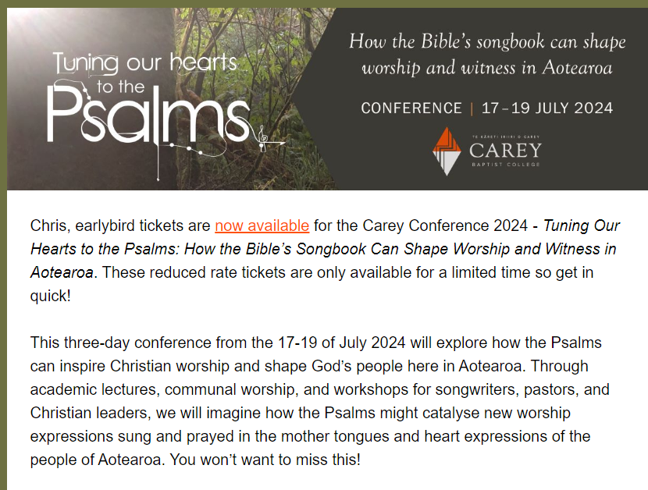
----------------------------------------------------------
Thames Foodbank

needs the following: Weetbix, tinned fruit, peanut butter, margarine and milk powder. Thank you for supporting your local foodbank! Caroline
-----------------------------------------------------------
KIDZONE prayer request

Please join the Kidzone team in praying for 12 children.
Thank you The Kidzone Team
------------------------------------------------------------
Pastoral Visiting Team

Lynette Mill, Helen Whittaker, Bev Gibson, Elizabeth Jones, Des and Mercia Barton and Brent and Berwyn Mason. If they visit you, they are visiting on behalf of the church.
-----------------------------------------------------------
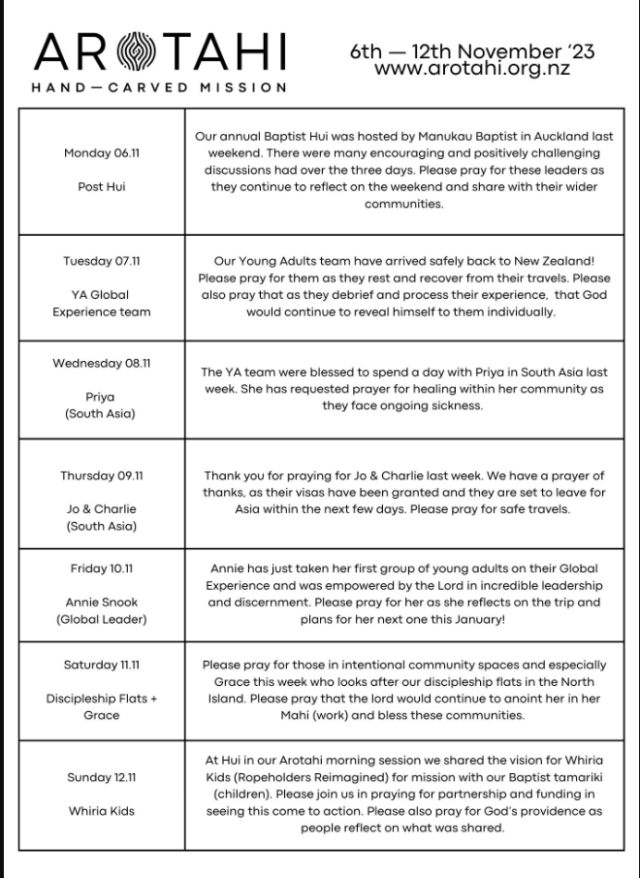

Home groups and activity groups
Tararu 10am Tuesday weekly at Elizabeth Jones’ (Jenny B)
Lifestylers 2pm Tuesdays weekly at Peter Moyes’ (Lynette)
Coast 7pm Tuesdays fortnightly at McLaren’s (Colin)
Meal at 5.30pm
Hikutaia in recess at the moment
Hillbillies 7pm Tuesdays fortnightly at various (Chris)
Womens knitting 10am Wednesdays weekly in the Church Lounge (Kathie & Pam)
Wednesday 2pm Wednesdays weekly in the Church Lounge (Chris)
Intercessors 9.30am Thursdays weekly in the church auditorium (Colin)
New People Foundation group 12.15pm Thursdays in the church auditorium (Chris & Shaz)
------------------------------------------------------------
Quiet Day: Waiting on God

We invite you to slow down and ask God into the busyness of the Advent, Christmas and summer holiday seasons. Join us as we wait and wonder in anticipation.
Resources and materials for reflection and prayer provided.
Date: Saturday Nov 18, 9am -4pm
Venue: Hou Man Wai Mercy Wellsprings
104 The Drive, Epsom, Auckland, 1023
Cost: $80 includes lunch ( $20 deposit with registration then $60 due 3rd Nov)
Enquiries/registration: lindaspiggott@gmail.com
Facilitators: Karen Haines &amp; Linda Piggott
--------------------------------------------------



