
Pastoral letter #30
Rosters
27 August Greeter Philip & Dianne
Sound Peter
Computer Terri
Morning Tea Phil & Diane Pawley
Worship leader Chris
Kidzone Rose & Foster
----------------------------------------------------
What’s on this week (Wednesday 16 August to Tuesday 22 August)

Wednesday 23rd 10am Women’s Group @ Church (lounge)
2pm Home group @ church
Thursday 24th 9.30am Intercessors group in our church auditorium
12.15pm New believers’ group
Sunday 27th 9.30am Preservice prayer in 305
10am Baptism Worship service
Midday Shared lunch followed by quiz afternoon
Tuesday 29th 10am Tararu home group
Midday Tasty Tuesday
--------------------------------------------------------
Baptism

We are having a baptism service this Sunday. “Come on in, the waters fine”. If you have been considering baptism and are thinking of taking the next step, see me before then.
--------------------------------------------
Quiz on 27th after lunch

Shaz has prepared a fun afternoon of a Quiz time. Shared lunch then quizzing. All welcome, Invite your friends
------------------------------------------------------
Pastoral Visiting Team

Lynette Mill, Helen Whittaker, Bev Gibson, Elizabeth Jones, Des and Mercia Barton and Brent and Berwyn Mason. If they visit you, they are visiting on behalf of the church.
----------------------------------------------------
Daily Bible Verse

Since I upgraded my phone, I don’t seem to be able to do the multiple recipients texts. Apparently new phones do not have that multiple recipient function. I tried using the app on the computer to send texts but that is hudgely expensive Sorry. So you will now get your morning text by email. I hope that suits.
--------------------------------------------------
Home groups and activity groups
Tararu 10am Tuesday weekly at Elizabeth Jones’ (Jenny B)
Lifestylers 2pm Tuesdays weekly at Peter Moyes’ (Lynette)
Coast 7pm Tuesdays fortnightly at McLaren’s (Colin)
Meal at 5.30pm
Hikutaia 7pm Tuesdays fortnightly at Shaz & Bernards (Puriri) (Shane)
Hillbillies 7pm Tuesdays fortnightly at various (Chris)
Womens knitting 10am Wednesday weekly in the Church Lounge (Kathie & Pam)
Wednesday 2pm Wednesday weekly in the Church Lounge (Chris)
Intercessors 9.30am Thursdays weekly in our church auditorium (Colin)
New Beginnings 12.15pm Thursdays weekly in church lounge (Shaz & Chris)
-------------------------------------------------------
Prayer Request

In May 2023, violence erupted in Manipur – an Indian state located in the northeastern part of the country along the Myanmar border. As of August 4, the violence has resulted in more than 170 deaths, 1,800+ houses burned, 350+ churches destroyed, and over 500 individuals injured and hospitalized. More than 50,000 people have been forced to flee their homes for refugee camps because of, among other political factors, their ethnicity and faith in Jesus Christ.

Please stand in prayer for the Christians in Manipur state where many Kuki Baptist and even Meitei Christians have become refugees in their own land. Samuel our TTC Principal from Agartala who was with us recently is a Mizo (one of the Kuki group of peoples in the North East as were the Darlongs with whom we lived and worked in the 50' 60' and 70's.) The NE India CC of which Samuel is a exec member is active in helping those in Manipur – Elizabeth
----------------------------------------------------
From The Living Well Trust

Data for June 2023: Food Parcels – 39 (feeding 101 people) – 68 adults and 33 children
Data for July 2023: Food Parcels – 66 (feeding 194 people) – 105 adults and 89 children
Thank you for all your support for the Thames Foodbank.
Items presently needed: tins of sweetcorn, tinned tomatoes, tinned pasta sauce
In addition, we also need more volunteers to help in running our drop-in centre (Open Door) for the community where we are able to provide a listening ear and a sense of community for our clients.
----------------------------------------------------
Walker for the use of mobility challenged people at church

Artie has provided a walker for the use of people at church. Thank you, Artie. We also have a wheelchair for those who need it at church.
-----------------------------------------------------
Thoughts from the BU Regional Leader Peter Foster

Henry Nouwen puts it this way.
“Hospitality means primarily the creation of a free space where the stranger can enter and become a friend instead of an enemy. Hospitality is not to change people, but to offer them space where change can take place. . . Hospitality is not a subtle invitation to adopt the lifestyle of the host, but the gift of a chance for the guest to find his own.”
He says it is a movement from ‘hostility to friendship’.
Bible passages seem to always have hospitality cushioned amongst passages about love and grace.

Ephesians 2:15-22 does not mention the word ‘hospitality’ but there is a movement from alien / stranger to saint / citizen. This of course is the action of love and grace on the part of Jesus. His death and resurrection, the ultimate act of hospitality!

I would dare to say that the action of gospel renewal for your community starts with the movement and power of hospitality.
-------------------------------------------------------------------------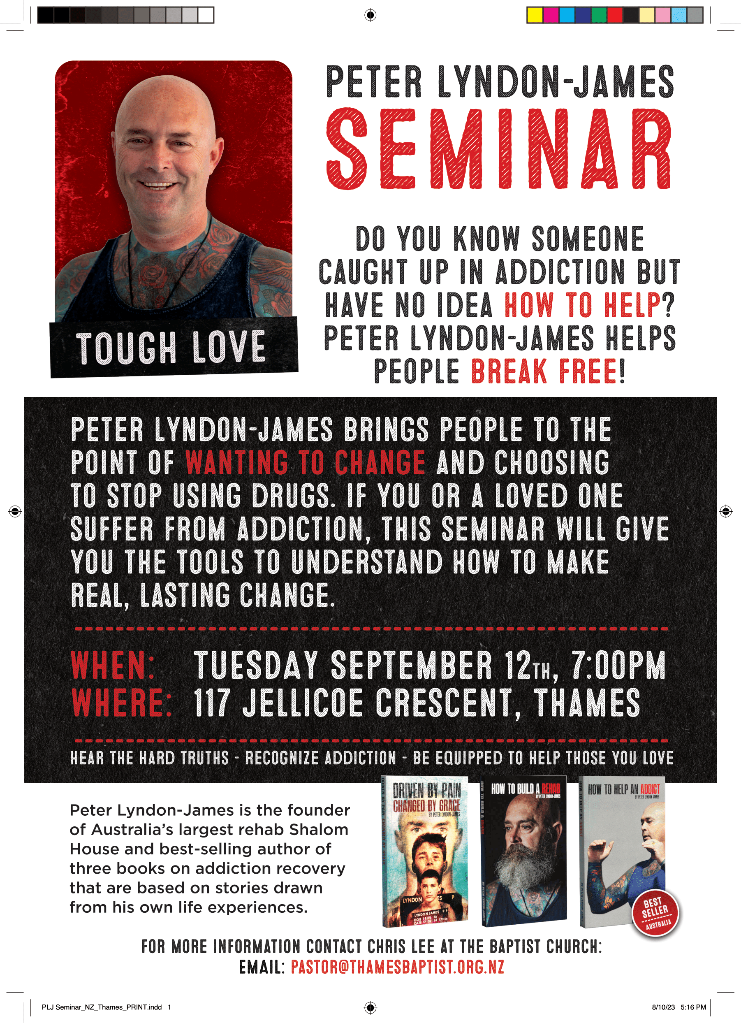

Does someone want to pop around the shops and hotels to give these posters out for shop windows?

