 Pastoral letter #10
Rosters
26 March Greeter Marie & Herman
Sound Bernard ? Lisa?
Computer Terri
Morning Tea Colin & Doug
Worship leader Lynette & Chris
Kidzone Frances McL & Glen
----------------------------------------------------------
What’s on this week (Wednesday 22nd to Tuesday 28th)

Wednesday 22nd 10am Women’s group in the Lounge
2pm Home group @ church
Thursday 23rd 9.30am Intercessors group in our church auditorium
Sunday 26th 9.30am Pre service prayer in 305
10am Worship service
2.30pm Tararu Rest home service
Tuesday 28th 10am Tararu home group at Elizabeth’s
Midday Tasty Tuesday
2pm Lifestylers home group @ Peter Moyes’
6pm LWT Board meeting
----------------------------------------------------------
Please pray for the service at Tararu Retirement home this Sunday.

Pray for Gael as she brings the message. Judith as she plays the piano and Philip as he leads the service. Pray also that the residents will find the love of Jesus being felt.
---------------------------------------------------------
Thames Aglow 24 March

Meeting 24 March 10am to midday at the old Church of Christ building in Parawai Rd. Guest speaker Angela Torrens, music by Rachael Baker. Shared lunch to follow. All welcome.
---------------------------------------------------------
Home groups and activity groups

Tararu 10am Tuesday weekly at Elizabeth Jones’
Lifestylers 2pm Tuesdays weekly at Peter Moyes’
Coast 7pm Tuesdays fortnightly at Betty Holmes’
Hikutaia 7pm Tuesdays fortnightly at Shaz & Bernards (Puriri)
Hillbillies 7pm Tuesdays fortnightly at various
Womens knitting 10am Wednesday weekly in the Church Lounge
Wednesday 2pm Wednesday weekly in the Church Lounge
Intercessors 9.30am Thursdays weekly in our church auditorium

Hope booklets

The Hope booklets are here and I need people who can walk the streets (not street walkers LOL) putting them in the letterboxes please. Delivery starts today (Sunday) and must be delivered before Easter weekend. Be in and choose the area you want!

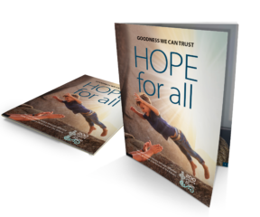
-------------------------------------------------------------
Ramadan

The Islamic Holy month of Ramadan for the year 2023 started on the evening of Wednesday, March 22nd lasting 30 days and ending at sundown on Thursday, April 20. Islamic holidays always begin at sundown and end at sundown the following day/days ending the holiday or festival.
Ramadan is the ninth month of the Islamic calendar. It is a month of fasting, prayer, giving and self-evaluation observed by Muslims. The month lasts 29-30 days depending on the sightings of the crescent moon.

Pray for Muslims during this time that they will meet the risen Jesus in their prayers. Jesus is not unknown to Muslims, the Quran refers to Jesus by the Arabic name “Isa,” but they deny his divinity.
-------------------------------------------------------------
Have lunch with someone after church

We all eat lunch so why not invite a couple (or person) you do not know home to share your meal after church. If you don’t trust your cooking skills, take them to lunch in a café after church.

A church that lives in love with the people God has placed around them will thrive more often than not. - Paul Nixon
-----------------------------------------------------------
Foodbank stats

Data for January 2023 - Food Parcels – 45 (feeding 128 people) – 77 adults and 51 children
Data for February 2023 - Food Parcels – 59 (feeding 187 people) – 109 adults and 78 children
Thank you for all your support for the Foodbank.

Caroline Talbot – Manager LWT
------------------------------------------------------------

Frances Hellendoorn finishing the Auckland Harbour Crossing (in the green cap)



Des, a man of many talents, on his homemade paddle board. Forever young.

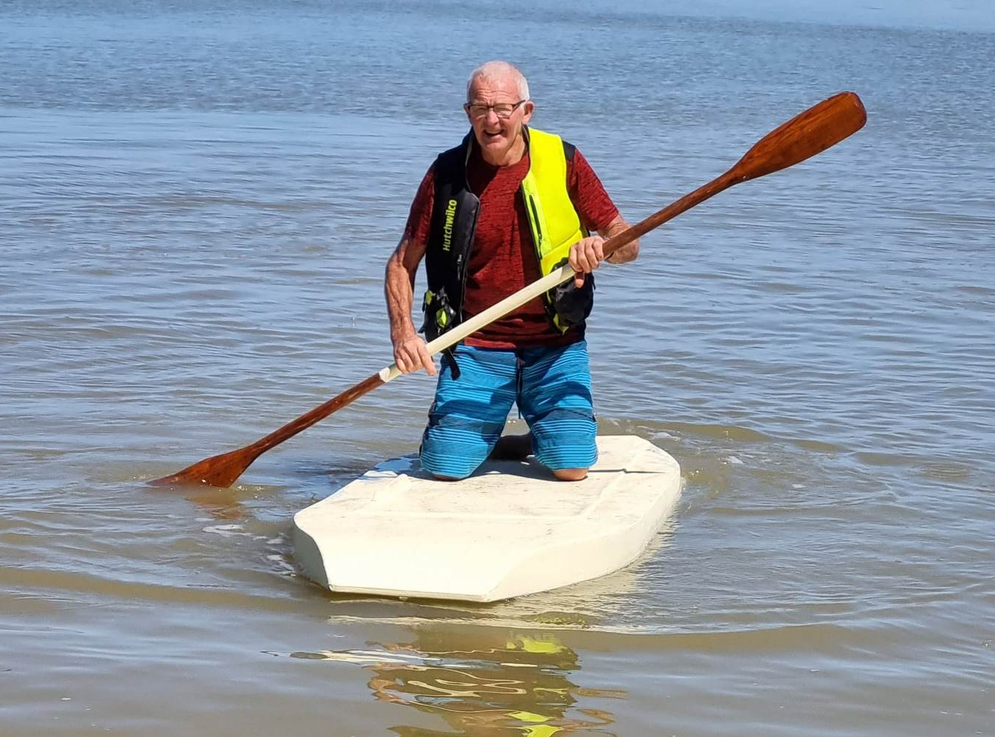
----------------------------------------------------------------
Missions Prayer for the week

Prayer for our global whānau: Denmark
Join us in prayer for the Baptist Union of Denmark, with 54 churches and 4,996 members. We give thanks for the Myanmar Baptist refugee churches in Denmark who are standing together in prayer for and support of the many people impacted by the political coup in Myanmar. In 2021, the BWA and European Baptist Federation (EBF) assisted with advocacy efforts in Denmark to stand against legislation that would have forced all sermons not given in Danish to be translated and submitted to the government. We continue to pray for these religious freedom efforts to stand and for God to bless the faithful ministry of Baptist churches in their communities.

Quote of the week:

The Christian religion is not a set of doctrines about Christ, neither is it a rule of life based upon the teachings and example of Christ. It is not even an earnest and sincere endeavour to live according to the mind and spirit of Christ. “Christ lives in me” is the essence of the Christian religion as set forth in the New Testament. It is not a system, but a presence; the spirit of Christ indwelling the spirit of us.
Samuel Chadwick
----------------------------------------------------------------
Mary Street getting a wash – flooding - 1917?

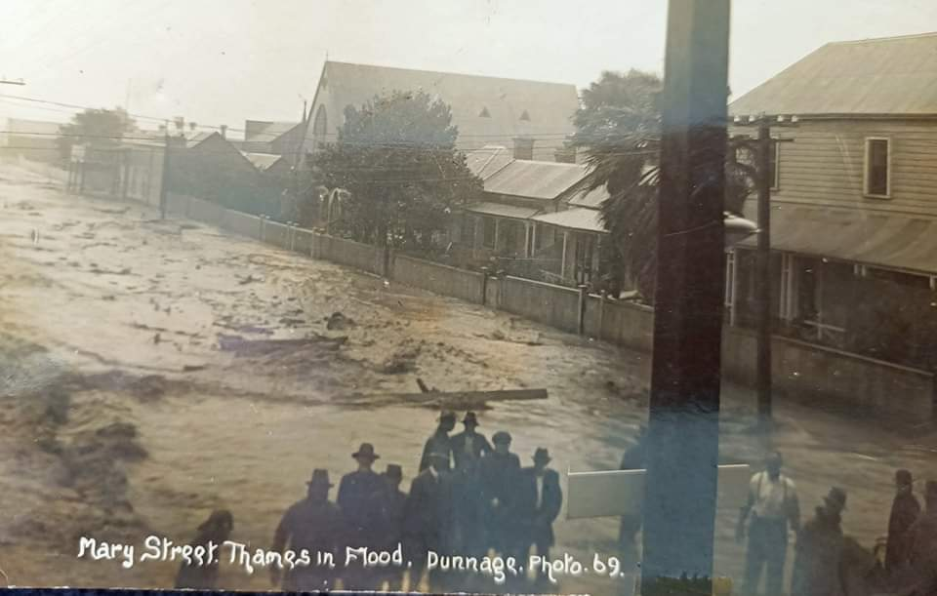
---------------------------------------------------------

This better not be in our church! Sit anywhere!

