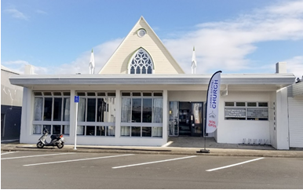
Newsletter 23
Sunday 9/6/2024
Roster  Greeter  Sound  Computer  Morning Tea  Worship Leaders  Kidzone  On Call Elder |  | Philip and Diane Watson  Bernard  Joe  Suze McElroy and Andy Dunn  Shaz  Rose and Mercia  Shane Dyer
What’s on this week Sunday 9th June to Saturday the 15th June
Sunday 9th June  Monday 10th  Monday 10th  Tuesday Next Week  Tuesday 11th  Wednesday 12th  Thursday 13th  Thursday 13th  Friday 14th | 10am  8am  7pm  3pm  2pm  9.30am  2pm  10.30am | Worship Service - Ross Horton  LWT Prayer Meeting 305 Mary St  Huia Come Home at Don and Kathy Sangsters  Hillbillie’s home group Contact Lynette 021 1023176  Life Stylers Home Group at Peter Moyles Place Contact Lynette 021 1023176  Gael’s home group  Intercessor’s group at Church  Global Missions Contact Lynette  Men’s Coffee Group Coco Coffee Bar

Living Well Trust
Please continue to pray for Terri, Eddie, Amanda and the volunteers and their work in 305
Please continue to pray for Mike, Samanda, Rachel and Linny as they lead the Youth programs in Matatoki, Moanataiari, and the Parawai schools.
Mike and Eddie are leading a prayer meeting every Monday at 8.00am to pray for the ministry of LWT and the church. All are welcome.
Thames Community Foodbank
Shopping bags required. If you have any spare shopping bags - please would you donate them to the foodbank by:
bringing them to Church; or
dropping them into 305 Mon-Thur 9am to 12pm; or
give Terri a call on 027 766 0332 and she will pick them up
The shopping bags are useful to pack food parcels into when people can't use boxes.
And a big heartfelt thank you for all your prayers, food support, and ice cream containers this year.
We really appreciate you and how you bless us!

Home Groups and Activity Groups
Living Well Trust  Huia Come Home  Hillbillies | 8.00am Monday  7pm on Monday  7pm Alternate Tuesdays | 305 Mary Street  Church Lounge  Contact Lynette Mill
Global Missions  Lifestylers Home Group | 2pm Monthly 2nd Thursday  3pm Tuesdays except school holidays | Contact Lynette Mill  Contact Lynette Mill
Women’s group | 10am Wednesdays | Church Lounge
Gael’s Home group | 2pm Wednesdays | Church Lounge
Intercessors Group | 9.30 am Thursdays | Church Auditorium
Men’s Coffee Group | 10am Fridays | Coco Coffee Bar
Women’s Coffee Group | 10.30 1st Friday of each month | Aeroview Café

Huia Come Home Day Out
Huia Come Home Book - Planned Day Trip Saturday 22nd June. This is for anyone who would like to come along.
"Huia Come Home Day Trip to Puriri, Waharoa, Matamata, and Okoroire Hot Springs:
Please bring:
Food/Drink for the day (Can purchase in Matamata)
Togs/Towel Allow approx $20 Hot Springs entry
Contribution to petrol costs
This is following the story of peace, that came from the spread of the gospel throughout iwi in New Zealand following the CMS work in Hauraki and Matamata
Meet at Thames Baptist Church at 9.30am, Saturday 22nd June
Enquiries to Frances Hellendoorn on 021 280 5471"
Church Family News
Shane is the duty Elder this week but he has been working over seas during the last fortnight. He gets back today so may have Jet lag for a few days. Hopefully we will be able to get some photos for next weeks newsletter.
Bronwyn, Shanes wife,
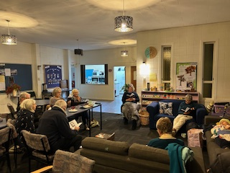
has been leading the Huia Come Home book review during the last term
It has been well attended and from the many reports has been well worthwhile. It has been reported that the participants have found it very stimulating both intellectually and spiritually.

Arotahi
If would like to support Global Missions and you are interested receiving a paper copy of the Arotahi newsletter, please contact Elizabeth Jones and she and she will arrange it for you.
Thames Baptist Fellowship Directory update
Our directory which has our contact details was last issued Feb 2023 and we have lots of comings and goings since then.
If you have directory changes, please email Terri at admin@thamesbaptist.org.nz , or call her on 027 766 0332 to let her know your changes or new details.

Healing Meeting
Last February Chris organised a Healing Meeting run by Don Simpson. Several people responded on the night and we have been approached by several people asking for another meeting. We have organised with Don for a repeat on Saturday the 29th of June at 7pm. Don is an evangelist who uses the healing meetings to challenge people for Christ. Several people have given their hearts to The Lord through this ministry.
we encourage you to pray and support this ministry and to bring people along who you feel are seeking The Lord
Prayer Chain
Do you need prayer or do you know some-one who needs prayer, then please contact Jenny Bowman at 027 868 6260 or 86 86260 and she will contact her team. Remember prayer works, The Holy Spirit answers our prayers.
Women's Day Conference on Saturday 15th June @ Thames Elim.
Replenish' Women's Conference
9am - 3pm
$30 per person
The day is broken into 3 sessions of worship and a message and all based around the theme of "Behold I am doing a new thing"
Morning tea and lunch are provided and included in the ticket price.
Also bring pocket money to spend at the market stalls run during the lunch break.
We are looking forward to gathering together as the women of Thames:)
If you are wanting to go, please contact Jessica Finlay at Thames Elim.
Thought for the Week
Rest in God
When Pontius Pilate told Christ he had the power to crucify him or set him free and Jesus looked him straight in the eyes and said you have no power but that which the Father gave you.
Sometimes I think about this moment in awe.
I mean wow. Really let that sink in.
Pilate really thought he was in control of the situation but little did he know he was simply a pawn in a divine plan.
Think about the freedom Christ was living in that He refused to fight the will of God, even when allowing that will to bring Him to the cross.
Often, we find it easy to doubt God when something happens in our lives that we don't understand makes us uncomfortable or uneasy.
But what if we had the faith to look at our perceived problems dead in the eyes and tell them that you have no power but that which my father gave you?
Imagine how much rest we could live in if we stopped living as if we were orphans in this world and we knew, I mean really knew, that God was working all things for our benefit…even our crosses.
True freedom is rest in God.
This is why it is said that those who conquered the Promised Land received rest.
Think about a situation you're living through today and ask God if it's something you need to look in the eyes and say: God is in control and I'm His son/daughter and He's working all things out for my good. I'm NOT an orphan. He is with me.
Start believing in a radical way. Let your faith rise.
Is there a situation you are struggling with today that you need to lay down, down at God’s feet?
Down loaded from https://t.me/PepeMatter/19601
I found this article on the internet and thought it profound. It is based on
1 Peter 5:6–7
6 Therefore humble yourselves under the mighty hand of God, that He may exalt you at the proper time,
7 casting all your anxiety on Him, because He cares for you.
As you do this maintaining your relationship with Jesus on a regular basis you are walking in The Spirit
Galatians 5:13–16
13 For you were called to freedom, brethren; only do not turn your freedom into an opportunity for the flesh, but through love serve one another.
14 For the whole Law is fulfilled in one word, in the statement, “You shall love your neighbor as yourself.”
15 But if you bite and devour one another, take care that you are not consumed by one another.
16 But I say, walk by the Spirit, and you will not carry out the desire of the flesh.

Daily Bible Verse Text
If you are interested in receiving a verse direct to your cell phone, please contact Colin McLaren with your cell phone number and you will be added to the list.
colin@cjmacs2020.co.nz or 027 2235393

Music Outreach Event
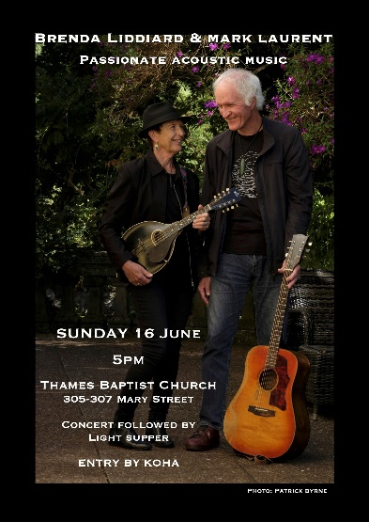
We have the privilege to host the longtime music duo, Mark Laurent and Brenda Liddiard at Thames Baptist Church, where they will perform for us on June 16 at 5pm.
Both are professional musicians and songwriters in their own right. Mark and Brenda are members of Cityside Baptist Church, Auckland and have been playing together since the 1970’s.
Astute and seasoned performers with at least 30 albums to their names, their music style includes contemporary acoustic folk gospel themes.
We will be opening this event to those beyond our Church family, so please consider marking your calendar and think about who you could invite.
On Call Elders
The on-call Elder this week is Shane Dyer. However, if you have a confidential matter to discuss with an Elder, please don’t hesitate to contact your favourite Elder.

Duty Elder | Shane Dyer | 021 242 6217
Church Administrator | Terri Churton | 027 766 0332
Church Bank Account | Westpac | 03 0458 0192366 00

If you would want your giving to be confidentially recorded for tax purposes please contact the Administrator Terri Churton.

