 Pastoral letter #13

Short week = short newsletter
Rosters
16 April Greeter Colin & Doug
Sound Lisa
Computer Joe
Morning Tea Antjie & Dawid
Worship leader Shaz/Chris
Kidzone NO
Communion Gael
----------------------------------------------------------
What’s on this week (Wednesday 12th to Tuesday 18th)

Wednesday 12th 8am Elders prayer meeting
10am Women’s group in the Lounge
2pm Home group @ church
Thursday 13th 9.30am Intercessors group in our church auditorium
Sunday 16th 9.30am Pre service prayer in 305
10am Worship service
Midday Farewell lunch for David and Jan Kitchen
Tuesday 18th 10am Tararu home group at Elizabeth’s
Midday Tasty Tuesday
2pm Lifestylers home group @ Peter Moyes’
7pm Coast homegroup
7PM Hillbillies home group
----------------------------------------------------------
Home groups and activity groups

Tararu 10am Tuesday weekly at Elizabeth Jones’ (Jenny)
Lifestylers 2pm Tuesdays weekly at Peter Moyes’ (Lynette)
Coast 7pm Tuesdays fortnightly at Betty Holmes’ (Colin)
Hikutaia 7pm Tuesdays fortnightly at Shaz & Bernards (Puriri) (Shane)
Hillbillies 7pm Tuesdays fortnightly at various (Chris)
Womens knitting 10am Wednesday weekly in the Church Lounge (Kathie & Pam)
Wednesday 2pm Wednesday weekly in the Church Lounge (Chris)
Intercessors 9.30am Thursdays weekly in our church auditorium (Colin)

Do people believe in the Resurrection?

Sybe Haakma prepared another questionnaire asking people at Tasty Tuesday, this time about the Resurrection story – a myth, magic or a miracle? The response was…
A Myth 3
Magic 3
Miracle 7
And one added their own category: “It was a blessing to all man”
-------------------------------------------------------
David and Jan Kitchen

David and Jan are moving mid-April to Te Anau to live. They will be missed. They have been stalwarts of this church and are our eldest couple. They have been very active in the life of the church, both here and in Hillcrest Baptist. David has been an Elder and Property Deacon. Their wisdom and godly lives has been an example to us all and they are much appreciated. We are having a potluck lunch after church on Sunday 16th April to farewell them. If anyone would like to contribute to buying a farewell gift, please see me.

Your Family Heritage Dinner
Thames Baptist Church 5.30pm Saturday 29 April
Dress in your family heritage costume. Please bring a dish from your heritage.
A taonga/treasured possession to tell us about eg. family tapestry/legend/Christening gown.
Email your heritage photographs to Levi for a slideshow during the dinner.
Levi Dyer levidyer20@gmail.com
Enquiriers to Elizabeth Jones 021 1709167 or Frances Hellendoorn 021 2805471

The Tararu home group at Elizabeths, facilitated by Jenny. A wonderful godly bunch of women.

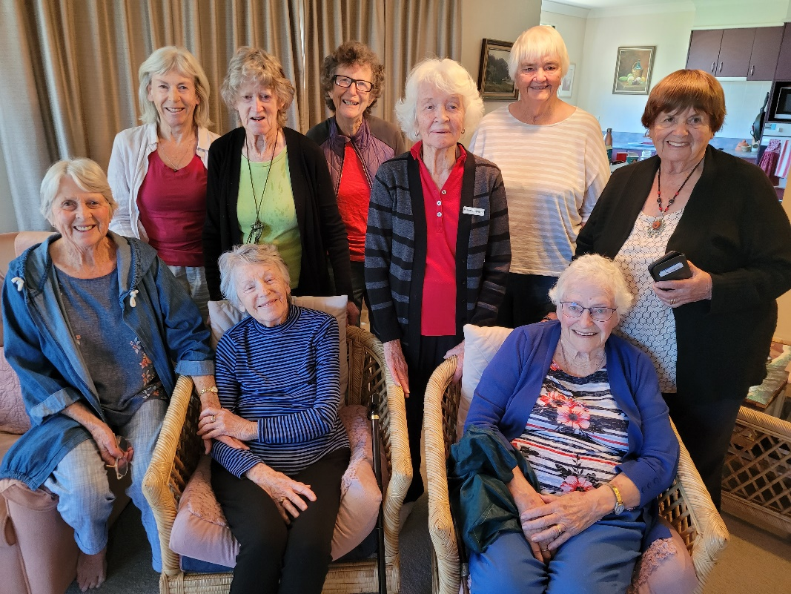

----------------------------------------------------------
Have lunch with someone after church

We all eat lunch so why not invite a couple (or person) you do not know home to share your meal after church. If you don’t trust your cooking skills, take them to lunch in a café after church.

“Visitor” is insider/outsider language. For this reason, we do not have visitors at church; we have guests and they are only a guest as long as they feel like one. - Paul Nixon
Latest mission letter from Amy on the missions board in the lounge

Prayer request: In the last month I have felt very discouraged and would love your support in prayer. I’m losing patience and feeling fatigued from the cultural differences that make me operate at such a slower pace than I’m used to. Despite our successes, I seem to be focusing on all our shortcomings. And now our Community Health department has closed (since projects and funding came to an end). My hope of ever joining them and working in Community Health here has sort of vanished. If you remember, my whole reason for coming was to work in this field so I feel quite confused and discouraged as to why God placed me here. He is sovereign and He knew this would happen, yet I haven’t quite submitted to this and it’s hard not to be doing what I expected and long for.

