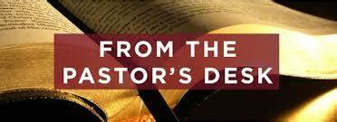
Pastoral letter #34
Rosters
24 September Greeter Des & Mercia
Sound Bernard & Charleen
Computer Rose
Morning Tea Betty & Judith
Worship leader Shaz
Kidzone Frances H and Frances McL
----------------------------------------------------
What’s on this week (Wednesday 20th September to Tuesday 26th September)

Wednesday 20th 10am Women’s Group @ Church (lounge)
2pm Home group @ church
Thursday 21st 9.30am Intercessors group in our church auditorium
12.15pm New believers’ group
Saturday 23rd 9am Working bee at 307
Sunday 24h 9.30am Preservice prayer in 305
10am Worship service
2.45pm Home group leaders meeting
Tuesday 26th 10am Tararu home group
Midday Tasty Tuesday
3pm Lifestylers home group
6pm LWT Board meeting
--------------------------------------------------------
Baptist Hui in November at Manukau Baptist Church 2-4 November

You can attend for the full 3 days or for one of the days
Register at hui.baptist.nz/
--------------------------------------------------------
Working Bee at 307

9am Saturday 23rd September.
Window cleaning and removal of stickers, kitchen sort out, toilet scrub, books to keep or give to Zonta. Lime lock the leaching on the block walls. Plant the little garden out back. Paint over signage inside.
MANY HANDS MAKE LIGHT WORK (electrician joke)
--------------------------------------------------------
From Living Well Trust

Data for August 2023 - Food Parcels – 72 (feeding 193 people) – 123 adults and 70 children
Thank you for all your support for the Thames Foodbank.
Items presently needed: tins of fruit, baked beans or spaghetti, tinned pasta sauce, Ben’s rice
All donations (monetary or goods) should now come into the Living Well Trust office or if anyone wants to make an online donation we can provide the details.
In addition, we also need more volunteers to help in running our drop-in centre (Open Door) for the community where we are able to provide a listening ear and a sense of community for our clients.
Potential volunteers need to contact me and I will talk them through what is involved.
-Caroline
--------------------------------------------------------[
Home groups and activity groups
Tararu 10am Tuesday weekly at Elizabeth Jones’ (Jenny B)
Lifestylers 2pm Tuesdays weekly at Peter Moyes’ (Lynette)
Coast 7pm Tuesdays fortnightly at McLaren’s (Colin)
Meal at 5.30pm
Hikutaia 7pm Tuesdays fortnightly at Shaz & Bernards (Puriri) (Shane)
Hillbillies 7pm Tuesdays fortnightly at various (Chris)
Womens knitting 10am Wednesdays weekly in the Church Lounge (Kathie & Pam)
Wednesday 2pm Wednesdays weekly in the Church Lounge (Chris)
Intercessors 9.30am Thursdays weekly in the church auditorium (Colin)

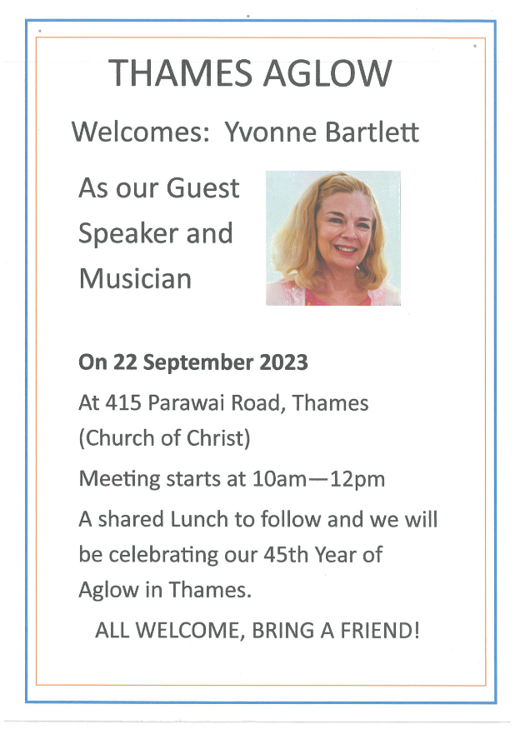

Exciting discussions at the Combined Pastors meeting this week

Following on from the seminar with Peter Lyndon-James, the churches are in discussion about how we can long term help people with addictions and housing in this area and coordinate the responses of individual churches.
We are talking about a float in the Christmas Parade and are looking for ideas.
There will be a Light party (alternative to Halloween) on the 31st October, probably at Elim but involving all the churches.
The next Combined night service will be on Sunday 5 November (a week later to accommodate the guest speaker) at Salvation Army
-----------------------------------------------------------
Pastoral Visiting Team

Lynette Mill, Helen Whittaker, Bev Gibson, Elizabeth Jones, Des and Mercia Barton and Brent and Berwyn Mason. If they visit you, they are visiting on behalf of the church.

The Global Mission Prayer Group

Formerly known as Baptist Missionary Fellowship (BMF) is restarting and is looking for new people to join them in the monthly prayer time. They are considering changing the day and time to suit others. Please contact Elizabeth Jones if you are interested.
------------------------------------------------
Alpha Marriage Course

It has been suggested that we run an Alpha Marriage course here. Is anyone interested in attending one?

The Marriage Course and The Pre-Marriage Course act as a bridge between the church and the local community by recognising the need to go beyond the social, as well as physical, walls of the church to help couples with their relationships. The Marriage Course is designed to be easy for churches to run; with episodes that are available to buy and download online, along with training, guides, and journals. The sessions are completely private, with no group work.

The Marriage Course Topics:
Strengthening Connection The Art of Communication
Resolving Conflict The Power of Forgiveness
The Impact of Family Good Sex
Love in Action
----------------------------------------------------------------
Use of 307

Now that we have 307, we are looking at how it can be used to meet the mission and ministry of the church. We have some ideas but are interested in what others may think.

We are allowing current users of the building to continue to do so, like the Vintage Bottle Club and the Orchid Club, and are considering an after school youth drop in.
Anything else?
----------------------------------------------------------------

