
Pastoral letter #31
Rosters
3 September Greeter Betty & Judith
Sound Bernard & Charleen
Computer Rose
Morning Tea Suze & Andy
Worship leader Chris/Lynette
Kidzone Keri & Mercia
Communion Caroline
----------------------------------------------------
What’s on this week (Wednesday 23 August to Tuesday 22 August)

Wednesday 30th 10am Women’s Group @ Church (lounge)
2pm Home group @ church
Thursday 31st 9.30am Intercessors group in our church auditorium
12.15pm New believers’ group
Sunday 3rd 9.30am Preservice prayer in 305
10am Worship service
Tuesday 5th 10am Tararu home group
Midday Tasty Tuesday
3pm Lifestylers home group
7pm Coast home group
7pm Hillbillies home group
--------------------------------------------------------
Our old pews now are being used at the new Ngaruawahia Baptist Church. They are averaging 23 people a Sunday.
-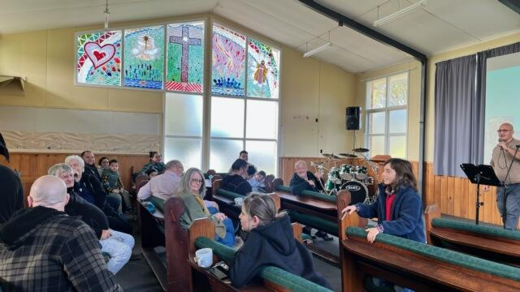
-----------------------------------------------------
Daily Bible Verse Apparently many people are not set up for receiving a group text.

Request from Bronwyn Dyer:

our son is struggling to get a job in Auckland. He is looking at the trades, plumbing, building etc.
Would it be possible to ask the congregation if anyone has a friend or relative in Auckland who would like to take on an apprentice? He's a hard worker, great people skills and has done electrical work before.
--------------------------------------------------
Fathers Day Poem

Little blessings from the father heart of God,
Unexpectedly, around the corner,
Surprised by wonder and delight,
god shows his love in these little ways.

Only God could do this, only he would care,
Our concerns matter to him, almighty God!
With the whole universe to watch over, little me and little you
Are valued highly in the sight of Father god.

Little blessings that he bestows on us,
Answered prayers that take us by surprise,
Needs, that are needs to us, he understands,
And we receive gifts of love from our father’s hand.

Blessings, that we should never take for granted,
Gifts that we wholeheartedly thank him for,
Treasures, like pearls on a golden chain,
To be taken out and reflected on when times get hard.

Love is proved in actions more than words,
Love is taking care of the one beloved,
Love delights to bring a smile to the face and joy to the heart,
Love flows from the father’s heart to us.

https://aheartfullofsong.wordpress.com/2020/04/14/poem-blessings-from-the-father-heart-of-god/

I know that for some, celebrations such as Mother’s or Father's Day are not a time of celebration but of lament; for people are estranged from their parent, or who have no contact with their children, or have lost a parent or child, or those who cannot be parents for whatever reason. Remember that we have a Father in heaven who is so much more than any human parent could be, and that Father has his arms out and welcomes you into his arms with love. Celebrate that you are a child of God.
-------------------------------------------------------
Baptist Hui in November at Manukau Baptist Church 2-4 November

Earlybird registrations close on 4 September.
We have 3 voting delegate places (me + 2)
But others can attend as well for the full 3 days or for one of the days
Register at hui.baptist.nz/
--------------------------------------------------------

Home groups and activity groups
Tararu 10am Tuesday weekly at Elizabeth Jones’ (Jenny B)
Lifestylers 2pm Tuesdays weekly at Peter Moyes’ (Lynette)
Coast 7pm Tuesdays fortnightly at McLaren’s (Colin)
Meal at 5.30pm
Hikutaia 7pm Tuesdays fortnightly at Shaz & Bernards (Puriri) (Shane)
Intercessors 9.30am Thursdays weekly in our church auditorium (Colin)
New Beginnings 12.15pm Thursdays weekly in church lounge (Shaz & Chris)

Hillbillies 7pm Tuesdays fortnightly at various (Chris)
Called Hillbillies, not because of our banjo playing, but because most live on the hills.
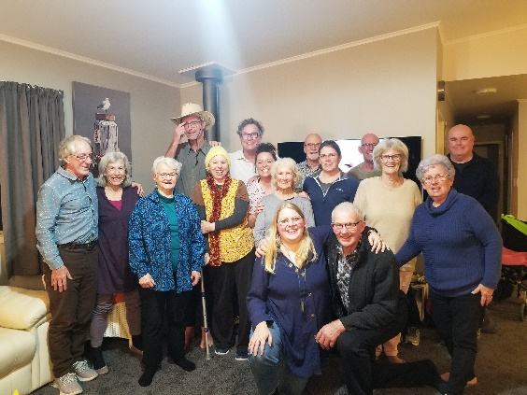

Womens knitting 10am Wednesdays weekly in the Church Lounge, facilitated by Kathie & Pam
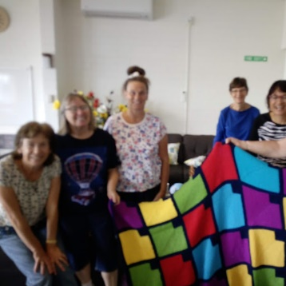
Wednesday 2pm Wednesdays weekly in the Church Lounge, facilitated by Chris
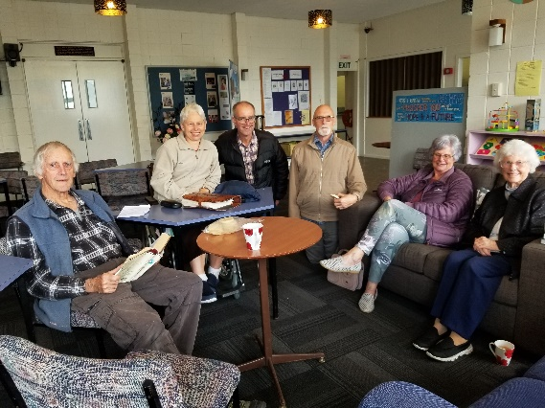
------------------------------------------------------
Computer and Sound techs for Sundays

Thank you Sarah Green for joining the computer on Sunday morning team

Living Well Trust news

Welcome to Amanda Goldfinch (our “new” administrator). She works Wednesdays and Thursdays, attends Equippers and cooks of our Tuesday Community Meal.


Welcome also to Linny de Guerre, our new Youth Worker, who will be with us one day a week until December, working on the Manahau programme in primary schools.


Our Foodbank has been extremely busy giving out food parcels. Items required include: Weetbix, tinned beans, tinned spaghetti, tinned fruit, boxes of soup.

Look for the news article in the Valley Profile this week about our work.
-------------------------------------------------------
Pastoral Visiting Team

Lynette Mill, Helen Whittaker, Bev Gibson, Elizabeth Jones, Des and Mercia Barton and Brent and Berwyn Mason. If they visit you, they are visiting on behalf of the church.
----------------------------------------------------

