 Pastoral letter #27
Rosters
6 August Greeter Andy & Herman
Sound Bernard
Computer Terri
Morning Tea Betty & Judith
Worship leader Shaz
Kidzone Frances McLaren
----------------------------------------------------
What’s on this week (Wednesday 2 August to Tuesday 8 August)

Wednesday 2nd 10am Women’s Group @ Church
2pm Home group @ church
Thursday 3rd 9.30am Intercessors group in our church auditorium
Midday New believers group
6pm LWT meeting
Sunday 6th 9.30am Pre service prayer in 305
10am Worship service
11.30am Church members meeting
Tuesday 8th 10am Tararu home group
Midday Tasty Tuesday
2pm Lifestylers home group
7pm Coast homegroup (Meal at 5.30pm)
7pm Hillbillies home group
--------------------------------------------------------
Pastoral visitors

I need helpers who are willing to join a team to be pastoral visitors to the people associated with the church. Thank you to the 5 who have offered but to ease the load, I need more helpers please.
It is not an onerous task, just visiting and being a listening ear. Not a counsellor, just a friendly face from the church.

Sound techs and Computer operators for Sunday worship services

With Lisa now in Romania, Levi heading to Brazil and Sarah heading back home to Germany this month, we need more people to do the “back of the room” stuff which makes the worship services flow. Training will be given.

---------------------------------------------------------
Peter Lyndon-James

The leadership of Elim, Salvation Army and us at the Baptists have invited Peter to speak at Thames on the 12th September to the churches and public about the dangers of Meth.

Put it in your calendar and see who else you can invite.

After 26 years as an addict, drug dealer and criminal, Peter turned his life around to create Australia’s largest and toughest rehab. Housing over 150 residents at no cost to the community, Peter has upended everything we know about addiction and rehabilitation. Through his own harrowing experiences of family trauma, incarceration and addiction, Peter’s seminars paint a picture of huge obstacles with the promise of hope that is put into practice every day. As Australia and the world suffer the worst drug epidemic in history with prescription addiction and illegal drug addiction causing equal amounts of damage to the community – it is welcome relief to hear about a method that has helped restore so many men, women and families. Beyond the realm of addiction and life-controlling issues, Peter’s insight into the human heart is something that will genuinely change your life and create a new way of communicating with yourself and those around you.

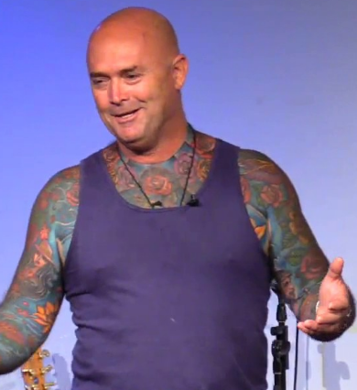
More Night services?

It was suggested at the last Elders meeting that we have our 5pm night services fortnightly rather than once a month, but in order to do that, I need people who are able to give a short testimony or homily or sermon. There is so much life experience and church experience in this congregation that I would like to tap into. If you think that is you, can you let me know please.
--------------------------------------------------------------
Home groups and activity groups
Tararu 10am Tuesday weekly at Elizabeth Jones’ (Jenny B)
Lifestylers 2pm Tuesdays weekly at Peter Moyes’ (Lynette)
Coast 7pm Tuesdays fortnightly at Colin & Frances McL (Colin)
Meal at 5.30pm
Hikutaia 7pm Tuesdays fortnightly at Shaz & Bernards (Puriri) (Shane)
Hillbillies 7pm Tuesdays fortnightly at various (Chris)
Womens knitting 10am Wednesday weekly in the Church Lounge (Kathie & Pam)
Wednesday 2pm Wednesday weekly in the Church Lounge (Chris)
Intercessors 9.30am Thursdays weekly in our church auditorium (Colin)
New Beginnings 12.15pm Thursdays weekly in church lounge (Shaz & Chris)
-------------------------------------------------------
The back room

Also known as the Kidzone room is now set up for meetings, with couches and comfy chairs and a smart TV connected to the internet (and connectable by HDMI to a laptop) and a work table

If you have a meeting planned and would like to use that room, please book it with the church receptionist so we don’t double book.
-------------------------------------------------------
Hireage of our lounge and meeting room

Both the lounge and the back room are available for hire for outside organisations at $40 per half day. It needs to be booked through the church receptionist.
-------------------------------------------------------
Christian Savings Annual Conference

Tickets are going and we now have a line-up of our panellists confirmed!
The panel discussion will be facilitated by Chris Clarke, and it will be a helpful opportunity to receive insights and inspiration by showcasing real-life examples and success stories.
Our panellists include:
Auckland (6th Sep, 2023)
• Windsor Park Baptist Church
• Oxford Terrace Baptist Church
Go to our website for more information about our panels and to purchase tickets! www.christiansavings.co.nz/conference-2023
This conference is designed to help church and charity members, such as trustees, elders and officers better understand their governance duties.
Ticket prices range from $25 to $80, which includes the cost of the food and beverage provided throughout the day. We also encourage group attendance, so we are offering 1 free ticket when you buy 4 others.
----------------------------------------------------------
From Lisa on her way to Romania

Here’s some more pictures from Bulgaria and Austria. Pt 1.
The only Katt cafe in Bulgaria.
And a church in Bulgaria.
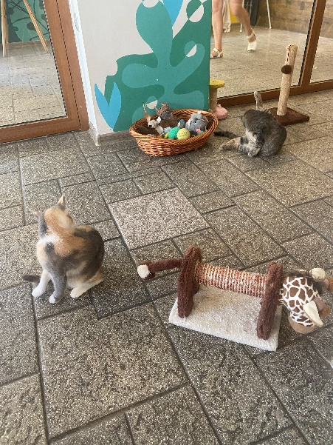

Lisa would love to hear from you. Lisa Matheson lisa.l.matheson@gmail.com
-----------------------------------------------------------
Living Well Trust News:

We had recent support from St George’s community Choir, with food items generously being donated by choir members and the audience at their Street Requiem performance. Here are two of our volunteers in the Foodbank – Tammy and Lynley, who enjoy the camaraderie of the Foodbank – collecting items, repacking items and packing food boxes. Food items currently needed: Packet soups, tinned spaghetti, salt, muesli bars, rice 500g /rice risotto/Ben’s original rice. Thanks to all who continue to support us. – Caroline LWT Manager
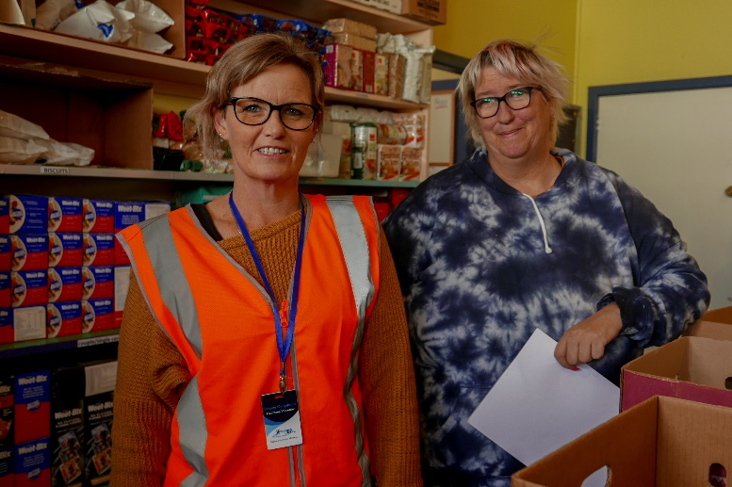

Sorry about people not getting their pastoral letter last week by email. I changed operating systems on a new computer, and it did not perform as I expected.
Hopefully you get this one.

