
Pastoral letter #41
Rosters
19 November Greeter Philip and Dianne Watson
Sound ???
Computer Rose
Morning Tea Trevor and Joe
Worship leader Josh
Kidzone Keri & Foster
Communion Frances H
----------------------------------------------------
What’s on this week (Wednesday 8 November to Tuesday 14 November)

Wednesday 10am Women’s Group @ Church (lounge)
2pm Home group @ church
Thursday 9.30am Intercessors group in our auditorium
12.15pm New believers’ group
Sunday 19th 9.30am Preservice prayer in 305
10am Worship service
Tuesday 14th 10am Tararu home group
Midday Tasty Tuesday
2pm Lifestylers home group
6pm LWT AGM
-------------------------------------------------
LWT AGM

At 6pm, Tuesday the 21st of November. Light refreshments provided afterwards (and it shouldn’t be long).
-Keri
---------------------------------------------------
Praying with our global whānau: Israel and Palestine

From Arotahi:
We ask you this week again to pray with Baptists across Israel and the Palestinian Territories.
This includes the Association of Baptist Churches in Israel with 17 Baptist churches and the Council of Local Evangelical Churches in the Holy Land representing 13 Baptist churches in the Palestinian Territories, including a Baptist church in Gaza.
As a Baptist family we are one in Christ. Let us join in prayer to support our wider global community who are suffering. Let us follow paths of peace making that unequivocally reject terrorism or any acts that target civilians, include dehumanizing language, or limit human rights on the basis of ethnicity or faith. In response to our Baptist leaders’ request, let us generously stand together in prayerful support.
-------------------------------------------------------------


Salvation Army State of our community

We’re excited to announce and invite you to the launch of The Salvation Army #39
“State of our Community Report”.

The report has been compiled by The Salvation Army’s Social Policy and
Parliamentary Unit based on a community survey research project conducted in
June and July of this year. This survey was a micro-level project, which focused
on drilling down into Thames and hearing from the locals about their community.
We believe you will get value out of hearing the findings and would love it if you,
and others who you believe may be interested, will be able to attend.

• The Salvation Army Thames 23 November 2023 10:00 am

Refreshments will follow the launch of the Report and a time of Q&A. For catering
purposes, can you please RSVP to thames.corps@salvationarmy.org.nz
Hospice Waikato remembrance service.

Sunday 26 November 2023, 2pm Thames Union Parish (St James church), Thames.
We encourage you to bring photos or other mementos to place with our candles as we remember our loved ones. Refreshments will be served following the service.
To register your attendance please phone Hospice on 07 859 1260 by Wednesday 15 November.
-------------------------------------------------------
Church AGM

The Church AGM is on 26 November. David Gibson would like to have the ministry reports by 11th November if possible.
--------------------------------------------------
Waikato Baptist Association AGM

On Sunday 3 December at 4pm at Cambridge Baptist Church
All welcome to attend.
Whiria Kids Fundraising bike ride

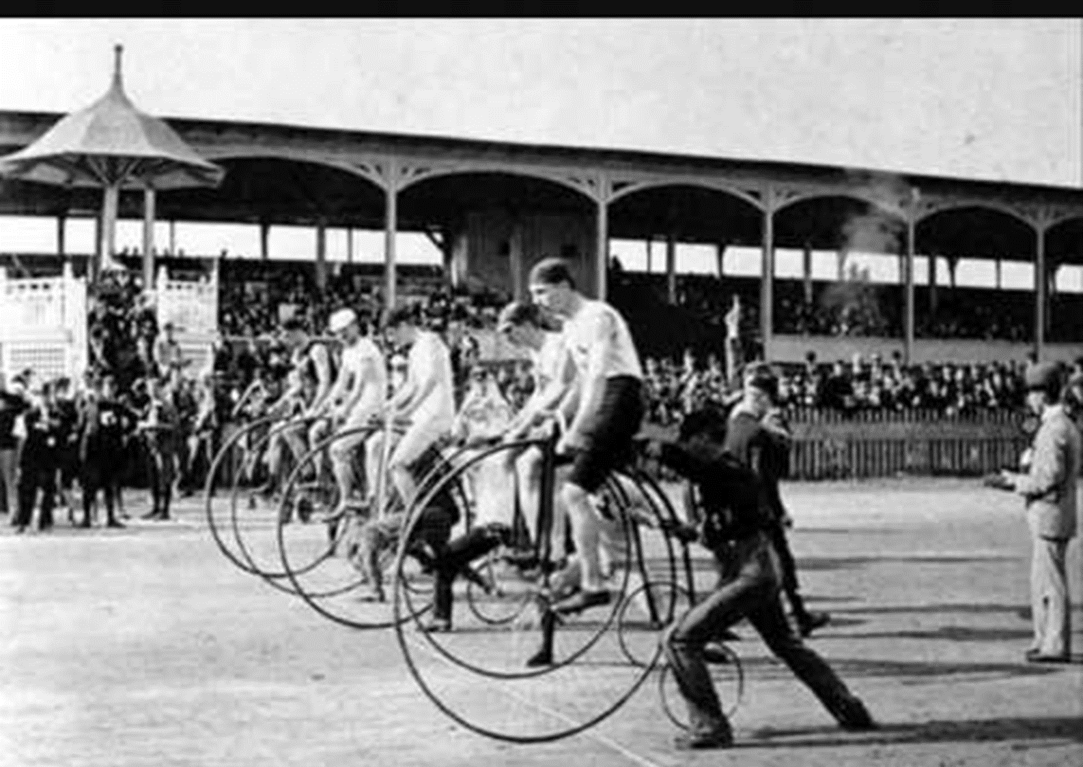
2 December
The Rail Trail from Thames to Paeroa
Others converging on Paeroa from Waihi and Te Aroha
Raising funds for Whiria Kids
Get sponsored and have a go.
-------------------------------------------------------
An outreach to children idea

Thinking outside the box about our lack of children in the church. Maybe the concept is Go, not Come.

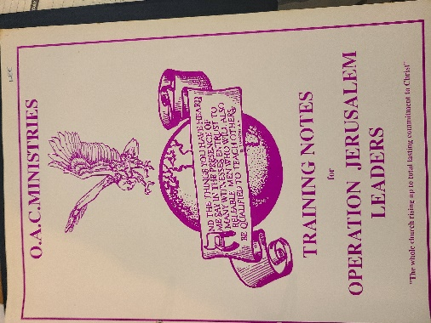
Many years ago, I ran a Christmas holiday beach mission to Waihi Beach for Tokoroa Baptist called OAC Operation Jerusalem where we ran a daily program at both Waihi Beach motor camp and Bowentown motor camp, for an hour a day. I still have the training manual, games and activities we ran.

Before I approach Dickson Motor Camp and Te Puru motor camp about permission to do so there, I am interested in who is keen to be involved.

Secondly, could we run a similar program once a month on a Sunday at the Hauraki terrace reserve over summer?
-------------------------------------------------------
Foodbank

Thank you all for your donations to the Foodbank. Clients are very grateful for what we give them. We would love tinned items - particularly sweetcorn and pasta sauce - but not chickpeas as people are unsure how to use them! Also packs of razors, deodorant, toothbrushes and toothpaste. Ngaa Mihi, Caroline.
-------------------------------------------------------
Pastoral Visiting Team

Lynette Mill, Helen Whittaker, Bev Gibson, Elizabeth Jones, Des and Mercia Barton and Brent and Berwyn Mason. If they visit you, they are visiting on behalf of the church.
-----------------------------------------------------------
Home groups and activity groups
Tararu 10am Tuesday weekly at Elizabeth Jones’ (Jenny B)
Lifestylers 2pm Tuesdays weekly at Peter Moyes’ (Lynette)
Coast 7pm Tuesdays fortnightly at McLaren’s (Colin)
Looking for new members
Hikutaia in recess at the moment
Hillbillies 7pm Tuesdays fortnightly at various (Chris)
Womens knitting 10am Wednesdays weekly in the Church Lounge (Kathie & Pam)
Wednesday 2pm Wednesdays weekly in the Church Lounge (Chris)
Intercessors 9.30am Thursdays weekly in the church auditorium (Colin)
New People Foundation group 12.15pm Thursdays in the church auditorium (Chris & Shaz)
------------------------------------------------------------
From CBM

At 11.47pm on Friday 3 November, a 6.4 magnitude earthquake hit the Jajarkot district in northwestern Nepal, the largest earthquake to hit Nepal since 2015.
Over 150 people are known to have died with some 500 more people injured and thousands more losing their homes.
cbm has two programmes operating in the area across Eye Health and Orthopaedic Rehabilitation and are pleased to report that all cbm partner staff are safe. However, there is much damage and suffering in the remote communities with whom our partners work.
There is widespread destruction of homes, buildings, power, and communication services making the search for survivors more difficult.

You can make an immediate difference by providing urgent life-saving essentials to people in urgent need, including giving people with disabilities access to vital services.

Use of 307

The Elders have listened to people who have suggested uses for 307 and have agreed to a layout, which would see part of it portioned off for the LWT Youth offices, a small private meeting room (for use by 4-5 people at a time), and a larger area for meetings, activities and use by external agencies as required.

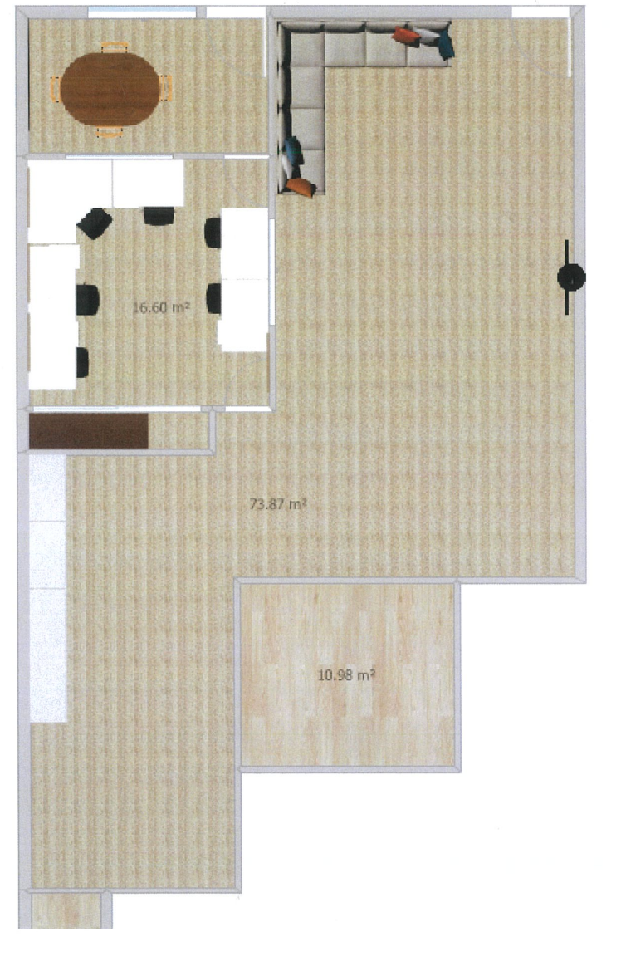
The right is the road frontage. The area sectioned off for the youth office be from the pillar to the wall and replacing the area of the stage currently there. There are separate doors to the youth/meeting and the main meeting areas, but both have access to the kitchen and toilets. There will be lockable cabinets for the external groups to keep their paraphernalia.
------------------------------------------------------
Coming Home project update

This is the project spearheaded by Sonja Merz and I about finding a solution to some of the issues around town. The seminar by Peter Lyndon-James earlier in the year has helped gel our ideas.

It is often touted that this project is about homelessness but it actually isn’t.

Homelessness, addiction, some mental health outcomes, and relationship difficulties arise from a deeper cause, often trauma in childhood. So, to deal with only one of these symptoms of a deeper issue is like sticking a band aid on a boil. It needs a holistic approach.

The Closer to Home project is looking at a home with wrap around services, to help in the transformation of the person. It is only for people who are sick of their circumstances and want to change. That is the first part of transformation. It is for ‘horses who want to drink.’

It is anticipated that initially it would only cater for 2-3 people in Thames, as we get our understanding and ability up to speed.
