Pastoral letter #14
Rosters
23 April Greeter Des & Mercia
Sound Peter
Computer Terri/Nicole
Morning Tea Doris
Worship leader Lynette/Chris
Kidzone NO
----------------------------------------------------------
What’s on this week (Wednesday 19th to Tuesday 18th)

Wednesday 19th 2pm Home group @ church
7pm Worship leaders meeting @ Lynettes
Thursday 20th 9.30am Intercessors group in our church auditorium
Sunday 23rd 9.30am Pre service prayer in 305
10am Worship service
Tuesday 25th ANZAC Day
---------------------------------------------------------
Your Family Heritage Dinner
Thames Baptist Church 5.30pm Saturday 29 April
Dress in your family heritage costume. Please bring a dish from your heritage.
A taonga/treasured possession to tell us about eg. family tapestry/legend/Christening gown.
Email your heritage photographs to Levi for a slideshow during the dinner.
Levi Dyer levidyer20@gmail.com
Enquiriers to Elizabeth Jones 021 1709167 or Frances Hellendoorn 021 2805471

Dress in the costume of your family heritage
Bring a dish from your culture/heritage
Give or email their photos to Levi
Bring along a taonga to tell us about
We will be praying for the nations.

Mine are blacksmiths from Innerswick, Scotland and agricultural labourers from Fosbury, Wiltshire. Lardy cake anyone? (photo of my great grandfather)

Have lunch with someone after church

We all eat lunch so why not invite a couple (or person) you do not know home to share your meal after church. If you don’t trust your cooking skills, take them to lunch in a café after church.

The religious system of his day kept the multitude out, but Jesus welcomed them all into his kingdom. Anyone could come. They still can. That is the gospel of the Beatitudes. - Dallas Willard

Thames Combined Worship Service

Always on the 5th Sunday of the month
Sunday 30th April at 5pm at the Thames Baptist Church in Mary Street.
Guest speakers
Steve and Robyn Whittle from Te Aroha

“Our passion is to see people coming into a personal relationship with Jesus Christ and being transformed into everything God has created them to be. Near the end of 1990 we had a powerful encounter with Jesus Christ and he radically changed us! May God Bless you.” Steve and Robyn Whittle
Speaking on their testimony and transformation.

Come along, bring a friend, bring two!
Join with the wider Christian family in our area to celebrate our Saviour.
----------------------------------------------------------

Anyone have a spare Smart TV?

Kidzone would like a Smart TV for their room so they can get onto the Internet fro songs and activities. Has anyone got a spare one lying around?
----------------------------------------------------------
Home groups and activity groups

Tararu 10am Tuesday weekly at Elizabeth Jones’ (Jenny)
Lifestylers 2pm Tuesdays weekly at Peter Moyes’ (Lynette)
Coast 7pm Tuesdays fortnightly at Betty Holmes’ (Colin)
Hikutaia 7pm Tuesdays fortnightly at Shaz & Bernards (Puriri) (Shane)
Hillbillies 7pm Tuesdays fortnightly at various (Chris)
Womens knitting 10am Wednesday weekly in the Church Lounge (Kathie & Pam)
Wednesday 2pm Wednesday weekly in the Church Lounge (Chris)
Intercessors 9.30am Thursdays weekly in our church auditorium (Colin)
--------------------------------------------------------

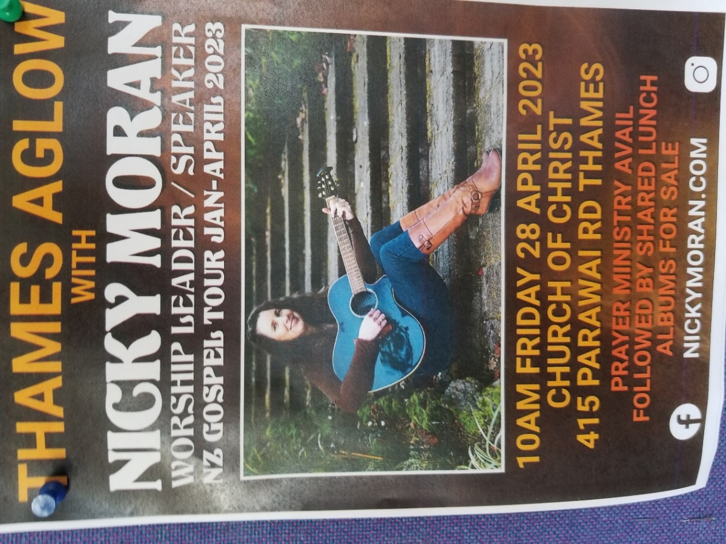
------------------------------------------------------------
Devotional thought from Frances Hellendoorn

On Easter Saturday I swam around Leisure Island at Mt Maunganui in my last race this season in the New Zealand Open Water Swim Series. I came 79th out of 103 in the 1.25km distance using my arms only. I loved it. I like being out in the deeper water. I wondered how I would go swimming out through the 7ft surf but a lot of internal skills saw me through. As I was swimming these swimming lessons came into my mind.
Swimming Lessons
• Don't look at the size of the wave, lest you become afraid. The wave will pass.
• In the trough when you can't see anything bring to mind the vision you have set before you.
• Remember the skill and strength God placed in you.
• Breathe deeply, relax, enjoy the adventure and appreciate the beauty around you.
• Stay in the field where you are safe and supported.
• Periodically check that you are in line for the finishing posts and imagine the cheers from those who have gone before you cheering you through.
• Diligently keep your form and disciplines right to the end.
-----------------------------------------------------------------
Remember the sacrifice of our forebears this ANZAC Day 25th

All of us in our family history have had family who have fought in the World Wars and other overseas conflicts and there were those who did not return. Please take time to thank God for their commitment and in some cases their ultimate sacrifice.

5.45am: Dawn Parade - from Cochrane Street, along Pollen Street, right into Walter Street, left into Service Lane 8 to Thames War Memorial Civic Centre.
6.00am: Dawn service at Thames War Memorial Civic Centre, followed by breakfast at the Thames Workingmen’s Club.

9.45am: Civic Parade - from Sealey Street, along Pollen Street, left into Walter Street, left into Service Lane 8 to Thames War Memorial Civic Centre.
10:00am: Service at Thames War Memorial Civic Centre.

All descendants of returned service personnel are welcome to participate in the parades.
Returned service personnel are asked to wear their medals and decorations.
Descendants of returned service personnel marching in the parades are asked to wear medals on the right upper portion of their apparel.

I remember my great uncle Colin Watt, 3rd Engineer Officer, Merchant Navy, who died at age 27 years when his ship was torpedoed by U boat 123 in the Atlantic; and my great uncle Francis who was in the Field Ambulance Corp in the Hampshire Regiment and died at Gallipoli, aged 20 years
------------------------------------------------------------------
New People Lunch

Every so often, the Elders put on a lunch for people new to the church to them to get to know us and vice versa and to understand our church, its vision and so forth. There are no hooks, just a free lunch and conversation.

The next one will be on Sunday 21 May after church.

If you have not attended one of these (and we have not had one since COVID hit on 2022), let me know and I will add you to the invitees.
------------------------------------------------------------------
Request from Samanda for the Narnia Camp this week

Samanda is looking for people who can sew 30-40 capes for the camp this week. She has the material, just needs the sew-ers.
-----------------------------------------------------------------

